GMT_1091_JT

<https://drive.google.com/drive/folders/1hAJMGFqjQWpSZ0iD6HpBtztzuzcGH8Ms>



<https://docs.generic-mapping-tools.org/6.1/tutorial.html>

W2

user@SKYUSER-O4EJDHA ~

$ ls

______________________________________________________________________________________

user@SKYUSER-O4EJDHA ~

$ ls -a

. .. .bash_history .bash_profile .bashrc .inputrc .profile

 ______________________________________________________________________________________

user@SKYUSER-O4EJDHA ~

$ vi ttt.txt

 ______________________________________________________________________________________

user@SKYUSER-O4EJDHA ~

$ pwd

/home/user

 ______________________________________________________________________________________

user@SKYUSER-O4EJDHA ~

$ df

檔案系統 1K-區段 已用 可用 已用% 掛載點

C:/cygwin64 249424360 212930988 36493372 86% /

D: 7888888 2783284 5105604 36% /cygdrive/d

E: 1953382396 101761300 1851621096 6% /cygdrive/e

______________________________________________________________________________________

user@SKYUSER-O4EJDHA ~

$ cd e:/GMT_1091

______________________________________________________________________________________

user@SKYUSER-O4EJDHA /cygdrive/e/GMT_1091

$ psbasemap -R10/70/-3/8 -JX5i/4i -B10/1:."Myfirstplot": -P > plot.ps

 ______________________________________________________________________________________

user@SKYUSER-O4EJDHA /cygdrive/e/GMT_1091

$ psbasemap -R10/70/-3/8 -JX5i/4i -B10/1:."my first figure": -P > plot.ps

 ______________________________________________________________________________________

user@SKYUSER-O4EJDHA /cygdrive/e/GMT_1091

$ psbasemap -R10/70/-3/8 -JX5i/4i -B10/1:."my first figure": -P > plot.ps

 ______________________________________________________________________________________

user@SKYUSER-O4EJDHA /cygdrive/e/GMT_1091

$ psbasemap -R20/50/-3/8 -JX5i/4i -B10/1:."my first figure": -P > plot.ps

 ______________________________________________________________________________________

user@SKYUSER-O4EJDHA /cygdrive/e/GMT_1091

$ psbasemap -R20/50/-3/8 -JX5i/4i -B10/1:"my first figure": -P > plot.ps

 ______________________________________________________________________________________

user@SKYUSER-O4EJDHA /cygdrive/e/GMT_1091

$ psbasemap -R20/50/0/8 -JX5i/4i -B5/2:.My_first_figure: -P > plot.ps

 ______________________________________________________________________________________

user@SKYUSER-O4EJDHA /cygdrive/e/GMT_1091

$ psbasemap -R20/50/-3/8 -JX5i/4i -B10/1:."time(hr)":/1:temperature: -P > plot.ps

______________________________________________________________________________________

user@SKYUSER-O4EJDHA /cygdrive/e/GMT_1091

$ psbasemap -R20/50/-3/8 -JX5i/4i -B10:."time(hr)":/1:temperature: -P > plot.ps

______________________________________________________________________________________

user@SKYUSER-O4EJDHA /cygdrive/e/GMT_1091

$ psbasemap -R20/50/-3/8 -JX5i/4i -B10:"time(hr)":/1:temperature: -P > plot.ps

______________________________________________________________________________________

user@SKYUSER-O4EJDHA /cygdrive/e/GMT_1091

$ psbasemap -R1/10000/1e20/1e25 -JX9il/6il -B2:"wavelength (m)":/a1pf3:"power(W)":wsne > plot.ps

______________________________________________________________________________________

user@SKYUSER-O4EJDHA /cygdrive/e/GMT_1091

$ psbasemap -R1/10000/1e20/1e25 -JX9il/6il -B2:"wavelength (m)":/a1pf3:"power(W)":WS > plot.ps

______________________________________________________________________________________

user@SKYUSER-O4EJDHA /cygdrive/e/GMT_1091

$ psbasemap -R1/10000/1e20/1e25 -JX9il/6il -B2:"wavelength (m)":/a1pf3:"power(W)":WS -P > plot.ps

______________________________________________________________________________________

user@SKYUSER-O4EJDHA /cygdrive/e/GMT_1091

$ psbasemap -R1/10000/1e20/1e25 -JX9il/6il -B2:"wavelength (m)":/a1pf5:"power(W)":WS -P > plot.ps

______________________________________________________________________________________

user@SKYUSER-O4EJDHA /cygdrive/e/GMT_1091

$ psbasemap -R1/10000/1e20/1e25 -JX9il/6il -B2:"wavelength(m)":/a1pf2:"power(W)":WS -P > plot.ps

______________________________________________________________________________________

user@SKYUSER-O4EJDHA /cygdrive/e/GMT_1091

$ psbasemap -R20/50/-3/8 -JX5i/4i -Ba10f3:."time(hr)":/1:temperature: -P > plot.ps

______________________________________________________________________________________

user@SKYUSER-O4EJDHA /cygdrive/e/GMT_1091

$ psbasemap -R20/50/0/8 -JX5i/4i -Ba10f3:."time(hr)":/1:temperature:WSNE -P > plot.ps

 ______________________________________________________________________________________

user@SKYUSER-O4EJDHA /cygdrive/e/GMT_1091

$ psbasemap -R20/50/0/8 -JX5i/4i -Ba10f3:."time(hr)":/1:temperature: -P > plot.ps

 ______________________________________________________________________________________

user@SKYUSER-O4EJDHA /cygdrive/e/GMT_1091

$ psbasemap -R20/50/0/8 -JX5i/4i -Ba10f3:."time(hr)":/1:temperature:WNe -P > plot.ps

 ______________________________________________________________________________________

user@SKYUSER-O4EJDHA /cygdrive/e/GMT_1091

$ psbasemap -R20/50/0/8 -JX5i/4i -Ba10f3:."time(hr)":/1:temperature:WNe -P > plot.ps

______________________________________________________________________________________

W3 (128GB USB)

user@meicc-006 ~

$ ls

c1 ttt.txt

______________________________________________________________________________________

user@meicc-006 ~

$ ls -a

. .bash_history .bashrc .profile c1

.. .bash_profile .inputrc .ttt.txt.swp ttt.txt

______________________________________________________________________________________

user@meicc-006 ~

$ cd E:\GMT_1091_JT

______________________________________________________________________________________

user@meicc-006 /cygdrive/e/GMT_1091_JT

$ vi ttt.txt

______________________________________________________________________________________

user@meicc-006 /cygdrive/e/GMT_1091_JT

$ vi ttt.txt

______________________________________________________________________________________

user@meicc-006 /cygdrive/e/GMT_1091_JT

$ psbasemap -R1/10000/1e20/1e25 -JX9il/6il -B2:"Wavelength (m)":/a1pf3:"Power (W)":WS > plot.ps

______________________________________________________________________________________

user@meicc-006 /cygdrive/e/GMT_1091_JT

$ psbasemap -R1/10000/1e20/1e25 -JX9il/6il -B1:"Wavelength (m)":/a1pf3:"Power (W)":WS > plot.ps

______________________________________________________________________________________

user@meicc-006 /cygdrive/e/GMT_1091_JT

$ psbasemap -R0/12/0/1 -JX3/0.4 -Ba4f2g1:"Frequency percentage":S -P > plot_1.ps

______________________________________________________________________________________

user@meicc-006 /cygdrive/e/GMT_1091_JT

$ psbasemap -R0/12/0/1 -JX6i/0.4 -Ba4f2g1:"Frequency percentage":S -P > plot_1.ps

______________________________________________________________________________________

user@meicc-006 /cygdrive/e/GMT_1091_JT

$ psbasemap -R0/12/0/1 -JX6i/0.4 -Ba4f2:"Frequency percentage":S -P > plot_1.ps

______________________________________________________________________________________

user@meicc-006 /cygdrive/e/GMT_1091_JT

$ psbasemap -R0/12/0/1 -JX6i/0.4 -Ba4f2g1:"Frequency percentage":S -P > plot_1.ps

______________________________________________________________________________________

user@meicc-006 /cygdrive/e/GMT_1091_JT

$ psbasemap -R0/12/0/1 -JX6i/0.4 -Ba4f2g1:Frequency_percentage:S -P > plot_1.ps

______________________________________________________________________________________

user@meicc-006 /cygdrive/e/GMT_1091_JT

$ psbasemap -R0/12/0/1 -JX6i/0.4i -Ba4f2g1:Frequency_percentage:S -P > plot_1.ps

______________________________________________________________________________________

user@meicc-006 /cygdrive/e/GMT_1091_JT

$ psbasemap -R0/12/0/1 -JX6i/0.4i -Ba4f2g1:Frequency_percentage:NS -P > plot_1.ps

______________________________________________________________________________________

user@meicc-006 /cygdrive/e/GMT_1091_JT

$ psbasemap -R0/12/0/1 -JX6i/0.4i -Ba4f2g1:"A Rule":S -P > plot_1.ps

______________________________________________________________________________________

user@meicc-006 /cygdrive/e/GMT_1091_JT

$ psbasemap -R0/12/0/1 -JX6i/0.4i -Ba4f2g1:"A Rule"::.Title:S -P > plot_1.ps

______________________________________________________________________________________

user@meicc-006 /cygdrive/e/GMT_1091_JT

$ psbasemap -R0/12/0/1 -JX6i/0.4i -Ba4f2g1:"A Rule"::.Title:WSNE -P > plot_1.ps

______________________________________________________________________________________

user@meicc-006 /cygdrive/e/GMT_1091_JT

$ psbasemap -R0/12/0/1 -JX6i/0.4i -Ba4f2g1:"A Rule"::.Ya_Ya:WSNE -P > plot_1.ps

______________________________________________________________________________________

user@meicc-006 /cygdrive/e/GMT_1091_JT

$ psbasemap -R0/12/0/1 -JX6i/0.4i -Ba4f2g1:"A Rule"::."YaYa":WSNE -P > plot_1.ps

______________________________________________________________________________________

user@meicc-006 /cygdrive/e/GMT_1091_JT

$ psbasemap -R0/12/0/1 -JX6i/0.4i -Ba4f2g1:"A Rule"::."YaYa":S -P > plot_1.ps

______________________________________________________________________________________

user@meicc-006 /cygdrive/e/GMT_1091_JT

$ psbasemap -R0/12/0/1 -JX6i/0.4i -Ba4f2g1:"A Rule"::."Ya Ya":S -P > plot_1.ps

______________________________________________________________________________________

user@meicc-006 /cygdrive/e/GMT_1091_JT

$ psbasemap -R0/12/0/1 -JX6i/0.4i -Ba4f2g1:"A Rule"::=-f:S -P > plot_1.ps

______________________________________________________________________________________

user@meicc-006 /cygdrive/e/GMT_1091_JT

$ psbasemap -R0/12/0/1 -JX6i/0.4i -Ba4f2g1:"A Rule"::=-Ya:S -P > plot_1.ps

______________________________________________________________________________________

user@meicc-006 /cygdrive/e/GMT_1091_JT

$ psbasemap -R0/12/0/1 -JX6i/0.4i -Ba4f2g1:"A Rule"::=-我是單位:S -P > plot_1.ps

______________________________________________________________________________________

user@meicc-006 /cygdrive/e/GMT_1091_JT

$ psbasemap -R0/12/0/1 -JX6i/0.4i -Ba4f2g1:"A Rule"::=F:S -P > plot_1.ps

______________________________________________________________________________________

user@meicc-006 /cygdrive/e/GMT_1091_JT

$ psbasemap -R0/12/0/1 -JX6i/0.4i -Ba4f2g1:"A Rule"::,a:S -P > plot_1.ps

______________________________________________________________________________________

user@meicc-006 /cygdrive/e/GMT_1091_JT

$ psbasemap -R0/12/0/1 -JX6i/0.4i -Ba4f2g1:"A Rule"::,%:S -P > plot_1.ps

______________________________________________________________________________________

user@meicc-006 /cygdrive/e/GMT_1091_JT

$ psbasemap -R0/12/0/1 -JX6i/0.4i -Ba4f2g1:"A Rule"::=DD::,%:S -P > plot_1.ps

______________________________________________________________________________________

user@meicc-006 /cygdrive/e/GMT_1091_JT

$ psbasemap -R0/12/0/1 -JX6i/0.4i -Ba4f2g1:"A Rule"::=ha::,j:S -P > plot_1.ps

______________________________________________________________________________________

user@meicc-006 /cygdrive/e/GMT_1091_JT

$ psbasemap -R0/12/0/1 -JX6i/0.4i -Ba4f2g1:"A Rule"::."Ya 00781035"::=ha::,j:S -P > plot_1.ps

______________________________________________________________________________________

user@meicc-006 /cygdrive/e/GMT_1091_JT

$ ls -a

. '?.ps'  GMT_record.docx plot.pdf  plot_1.ps

.. gmt.history plot.log  plot.ps  ttt.txt

______________________________________________________________________________________

user@meicc-006 /cygdrive/e/GMT_1091_JT

$ psbasemap -R1/10/0/10 -Jx1.5il/0.15i -B10g3/a2f1g2wsne -P > plot_2.ps

______________________________________________________________________________________

user@meicc-006 /cygdrive/e/GMT_1091_JT

$ psbasemap -R1/10/0/10 -Jx1.5il/0.15i -B10g3/a2f1g2wsne -P > plot_2.ps

______________________________________________________________________________________

user@meicc-006 /cygdrive/e/GMT_1091_JT

$ psbasemap -R1/10/0/10 -Jx1.5il/0.15i -B10g3/a2f1g2wsne -P > plot_2.ps

______________________________________________________________________________________

user@meicc-006 /cygdrive/e/GMT_1091_JT

$ psbasemap -R1/10/0/10 -Jx1.5il/0.15i -B10g3/a2f1g2WSne -P > plot_2.ps

______________________________________________________________________________________

user@meicc-006 /cygdrive/e/GMT_1091_JT

$ psbasemap -R1/100/0/10 -Jx1.5il/0.15i -B10g3/a2f1g2WSne -P > plot_2.ps

______________________________________________________________________________________

user@meicc-006 /cygdrive/e/GMT_1091_JT

$ psbasemap -R1/100/0/10 -JX1.5il/0.15i -B10g3/a2f1g2WSne -P > plot_2.ps

______________________________________________________________________________________

user@meicc-006 /cygdrive/e/GMT_1091_JT

$ psbasemap -R1/100/0/10 -Jx1.5il/0.15i -B10g3/a2f1g2WSne -P > plot_2.ps

______________________________________________________________________________________

user@meicc-006 /cygdrive/e/GMT_1091_JT

$ psbasemap -R1/100/0/10 -Jx1.5il/0.15i -B10g3l/a2f1g2WSne -P > plot_2.ps

______________________________________________________________________________________

user@meicc-006 /cygdrive/e/GMT_1091_JT

$ psbasemap -R1/100/0/10 -Jx1.5il/0.15i -B10g3l/a2f1g2lWSne -P > plot_2.ps

______________________________________________________________________________________

user@meicc-006 /cygdrive/e/GMT_1091_JT

$ psbasemap -R1/100/0/100 -Jx1.5il/0.15i -B10g3l/a2f1g2lWSne -P > plot_2.ps

______________________________________________________________________________________

user@meicc-006 /cygdrive/e/GMT_1091_JT

$ psbasemap -R1/100/0/100 -Jx1.5il/0.15i -B10g3l/a2f1g3lWSne -P > plot_2.ps

______________________________________________________________________________________

user@meicc-006 /cygdrive/e/GMT_1091_JT

$ psbasemap -R1/100/0/10 -Jx1.5il/0.15i -B10g3l/a2f1g2lWSne -P > plot_2.ps

______________________________________________________________________________________

user@meicc-006 /cygdrive/e/GMT_1091_JT

$ psbasemap -R1/100/0/10 -Jx1.5il/0.15i -B10g3l/a4f1g2WSne -P > plot_2.ps

______________________________________________________________________________________

user@meicc-006 /cygdrive/e/GMT_1091_JT

$ psbasemap -R1/100/0/10 -Jx1.5il/0.15i -B10g3l/a2f1g2WSne -P > plot_2.ps

______________________________________________________________________________________

user@meicc-006 /cygdrive/e/GMT_1091_JT

$ psbasemap -R1/100/0/10 -Jx1.5il/0.15i -B10g3p/a2f1g2WSne -P > plot_2.ps

______________________________________________________________________________________

user@meicc-006 /cygdrive/e/GMT_1091_JT

$ psbasemap -R1/100/0/10 -Jx1.5il/0.15i -B10g3p/a2f1g2:=f::,%:WSne -P > plot_2.ps

______________________________________________________________________________________

user@meicc-006 /cygdrive/e/GMT_1091_JT

$ pscoast -R-90/-70/0/20 -JM6i -B5g5 -Gchocolate -P > map_1.ps

______________________________________________________________________________________

user@meicc-006 /cygdrive/e/GMT_1091_JT

$ pscoast -R270/290/0/20 -JM6i -B5g5 -Gchocolate -P > map_1.ps

______________________________________________________________________________________

user@meicc-006 /cygdrive/e/GMT_1091_JT

$ pscoast -R119/124/21/27 -JM6i -B5g5 -Gchocolate -P > map_1.ps

______________________________________________________________________________________

user@meicc-006 /cygdrive/e/GMT_1091_JT

$ pscoast -R104/124/7/27 -JM6i -B5g5 -Gchocolate -P > map_1.ps

______________________________________________________________________________________

user@meicc-006 /cygdrive/e/GMT_1091_JT

$ pscoast -R104/124/7/27 -JM6i -B5g5 -Gblack -P > map_1.ps

______________________________________________________________________________________

user@meicc-006 /cygdrive/e/GMT_1091_JT

$ pscoast -R104/124/7/27 -JM6i -B5g5 -Gblue -P > map_1.ps

______________________________________________________________________________________

user@meicc-006 /cygdrive/e/GMT_1091_JT

$ pscoast -R104/124/7/27 -JM6i -B5g5 -Gpurple -P > map_1.ps

______________________________________________________________________________________

user@meicc-006 /cygdrive/e/GMT_1091_JT

$ pscoast -R104/124/7/27 -JM6i -B5g5 -Gpurple -W0.25p -P > map_1.ps

______________________________________________________________________________________

user@meicc-006 /cygdrive/e/GMT_1091_JT

$ pscoast -R104/124/7/27 -JM6i -B5g5 -Gpurple -W5p -P > map_1.ps

______________________________________________________________________________________

user@meicc-006 /cygdrive/e/GMT_1091_JT

$ pscoast -R104/124/7/27 -JM6i -B5g5 -Gpurple -W1.5p -P > map_1.ps

______________________________________________________________________________________

user@meicc-006 /cygdrive/e/GMT_1091_JT

$ pscoast -R104/124/7/27 -JM6i -B5g5 -Gpurple -W1.5p -I -P > map_1.ps

pscoast [ERROR]: Syntax error: -I option takes at least one argument

______________________________________________________________________________________

user@meicc-006 /cygdrive/e/GMT_1091_JT

$ pscoast -R104/124/7/27 -JM6i -B5g5 -Gpurple -W1.5p -Iblue -P > map_1.ps

______________________________________________________________________________________

user@meicc-006 /cygdrive/e/GMT_1091_JT

$ pscoast -R104/124/7/27 -JM6i -B5g5 -Gpurple -W1.5p -Scyan -P > map_1.ps

______________________________________________________________________________________

user@meicc-006 /cygdrive/e/GMT_1091_JT

$ pscoast -R104/124/7/27 -JM6i -B5g5 -Gpurple -W1.5p -Scyan -Dh -P > map_1.ps

______________________________________________________________________________________

user@meicc-006 /cygdrive/e/GMT_1091_JT

$ pscoast -R104/124/7/27 -JM6i -B5g5 -Ggray -W1.5p -Scyan -Df -P > map_1.ps

______________________________________________________________________________________

user@meicc-006 /cygdrive/e/GMT_1091_JT

$ pscoast -R104/124/7/27 -JM6i -B5g5 -Ggrey -W1.5p -Scyan -Df -P > map_1.ps

______________________________________________________________________________________

user@meicc-006 /cygdrive/e/GMT_1091_JT

$ pscoast -R104/124/7/27 -JM6i -B5g5 -Ggrey -W1.5p -Scyan -Df -N -P > map_1.ps

pscoast [ERROR]: Syntax error: -N option takes at least one argument

______________________________________________________________________________________

user@meicc-006 /cygdrive/e/GMT_1091_JT

$ pscoast -R104/124/7/27 -JM6i -B5g5 -G0.2/0.2/0.2 -W1.5p -Scyan -Df -P > map_1.ps

______________________________________________________________________________________

user@meicc-006 /cygdrive/e/GMT_1091_JT

$ pscoast -R104/124/7/27 -JM6i -B5g5 -G0.7/0.7/0.7 -W1.5p -Scyan -Df -P > map_1.ps

______________________________________________________________________________________

user@meicc-006 /cygdrive/e/GMT_1091_JT

$ pscoast -R104/124/7/27 -JM6i -B5g5 -G1/1/1 -W1.5p -Scyan -Df -P > map_1.ps

______________________________________________________________________________________

user@meicc-006 /cygdrive/e/GMT_1091_JT

$ pscoast -R104/124/7/27 -JM6i -B5g5 -G20/20/20 -W1.5p -Scyan -Df -P > map_1.ps

______________________________________________________________________________________

user@meicc-006 /cygdrive/e/GMT_1091_JT

$ pscoast -R104/124/7/27 -JM6i -B5g5 -G100/100/100 -W1.5p -Scyan -Df -P > map_1.ps

______________________________________________________________________________________

user@meicc-006 /cygdrive/e/GMT_1091_JT

$ pscoast -R104/124/7/27 -JM6i -B5g5 -G0/0/0 -W1.5p -Scyan -Df -P > map_1.ps

______________________________________________________________________________________

user@meicc-006 /cygdrive/e/GMT_1091_JT

$ pscoast -R104/124/7/27 -JM6i -B5g5 -G70/70/70 -W1.5p -Scyan -Df -P > map_1.ps

______________________________________________________________________________________

user@meicc-006 /cygdrive/e/GMT_1091_JT

$ pscoast -R104/124/7/27 -JM6i -B5g5 -G250/250/250 -W1.5p -Scyan -Df -P > map_1.ps

______________________________________________________________________________________

user@meicc-006 /cygdrive/e/GMT_1091_JT

$ pscoast -R104/124/7/27 -JM6i -B5g5 -G200/200/200 -W1.5p -Scyan -Df -P > map_1.ps

______________________________________________________________________________________

user@meicc-006 /cygdrive/e/GMT_1091_JT

$ pscoast -R104/124/7/27 -JM6i -B5g5 -G200/200/200 -W1.2/0/0/255 -Scyan -Df -P > map_1.ps

______________________________________________________________________________________

user@meicc-006 /cygdrive/e/GMT_1091_JT

$ pscoast -R104/124/7/27 -JM6i -B5g5 -G200/200/200 -W1.2/0/0/255,- -Scyan -Df -P > map_1.ps

______________________________________________________________________________________

user@meicc-006 /cygdrive/e/GMT_1091_JT

$ pscoast -R104/124/7/27 -JM6i -B5g5 -G200/200/200 -Wthinnest,- -Scyan -Df -P > map_1.ps

______________________________________________________________________________________

user@meicc-006 /cygdrive/e/GMT_1091_JT

$ pscoast -R104/124/7/27 -JM6i -B5g5 -G200/200/200 -Wthinnest,0/0/0,- -Scyan -Df -P > map_1.ps

______________________________________________________________________________________

user@meicc-006 /cygdrive/e/GMT_1091_JT

$ pscoast -R104/124/7/27 -JM6i -B5g5 -G200/200/200 -Wthinnest,0/0/255,- -Scyan -Df -P > map_1.ps

______________________________________________________________________________________

user@meicc-006 /cygdrive/e/GMT_1091_JT

$ pscoast -R104/124/7/27 -JM6i -B5g5 -G200/200/200 -Wthinnest,255/0/0,- -Scyan -Df -P > map_1.ps

______________________________________________________________________________________

user@meicc-006 /cygdrive/e/GMT_1091_JT

$ pscoast -R104/124/7/27 -JM6i -B5g5 -G200/200/200 -Wthinnest,0/0/0 -Scyan -Df -P > map_1.ps

______________________________________________________________________________________

W4 (128GB USB)

1.4.1 Linear projection

1.4.2 Logarithmic projection

1.4.3 Mercator projection

user@meicc-006 ~

$ cd E:\GMT_1091_JT

user@meicc-006 /cygdrive/e/GMT_1091_JT

$ df

檔案系統 1K-區段 已用 可用 已用% 掛載點

C:/cygwin64 233835516 107084712 126750804 46% /

E: 118078240 1466592 116611648 2% /cygdrive/e

user@meicc-006 /cygdrive/e/GMT_1091_JT

$ cd e:

user@meicc-006 /cygdrive/e

$ cd GMT_1091_JT

user@meicc-006 /cygdrive/e/GMT_1091_JT

$ pscoast -R104/124/7/27 -JM6i -B5g5 -G200/200/200 -Wthinnest,255/0/0,- -Scyan -Df -P > map_1.ps

user@meicc-006 /cygdrive/e/GMT_1091_JT

$ pscoast -R104/124/7/27 -JM6i -B5g5 -G200/200/200 -Wthinnest,0/0/0,- -Scyan -Df -P > map_1.ps

user@meicc-006 /cygdrive/e/GMT_1091_JT

$ pscoast -R105/125/7/27 -JM6i -B5g5 -G200/200/200 -Wthinnest,0/0/0,- -Scyan -Df -P > map_1.ps

user@meicc-006 /cygdrive/e/GMT_1091_JT

$ pscoast -R105/125/7/27 -JM6i -B5g5 -G200/200/200 -W1.5/0/0/0,- -Scyan -Df -P > map_1.ps

user@meicc-006 /cygdrive/e/GMT_1091_JT

$ pscoast -R105/125/7/27 -JM6i -B5g5 -W0.1 -A0.5 -G200/200/200 -Wthinnest,0/0/0,- -Scyan -Df -P > map_1.ps

user@meicc-006 /cygdrive/e/GMT_1091_JT

$ pscoast -R105/125/7/27 -JM6i -B5g5 -W0.1 -A5 -G200/200/200 -Wthinnest,0/0/0,- -Scyan -Df -P > map_1.ps

user@meicc-006 /cygdrive/e/GMT_1091_JT

$ pscoast -R105/125/7/27 -JM6i -B5g5 -W0.1 -A100 -G200/200/200 -Wthinnest,0/0/0,- -Scyan -Df -P > map_1.ps

user@meicc-006 /cygdrive/e/GMT_1091_JT

$ pscoast -R105/125/7/27 -JM6i -B5g5 -W0.1 -A10 -G200/200/200 -Wthinnest,0/0/0,- -Scyan -Df -P > map_1.ps

user@meicc-006 /cygdrive/e/GMT_1091_JT

$ pscoast -R105/125/7/27 -JM6i -B5g5 -W0.1 -A200 -G200/200/200 -Wthinnest,0/0/0,- -Scyan -Df -P > map_1.ps

user@meicc-006 /cygdrive/e/GMT_1091_JT

$ pscoast -R105/125/7/27 -JM6i -B5g5 -W0.1 -A100 -G200/200/200 -Wthinnest,0/0/0,- -Scyan -Df -P > map_1.ps

user@meicc-006 /cygdrive/e/GMT_1091_JT

$ pscoast -R105/125/7/27 -JM6i -B5g5 -W0.1 -A200 -G200/200/200 -Wthinnest,0/0/0,- -Scyan -Df -P > map_1.ps

user@meicc-006 /cygdrive/e/GMT_1091_JT

$ pscoast -R105/125/7/27 -JM6i -B5g5 -W0.1 -A2 -G200/200/200 -Wthinnest,0/0/0,- -Scyan -Df -P > map_1.ps

user@meicc-006 /cygdrive/e/GMT_1091_JT

$ pscoast -R105/125/7/27 -JM6i -B5g5 -W0.1 -A200 -G200/200/200 -Wthinnest,0/0/0,- -Scyan -Df -P > map_1.ps

user@meicc-006 /cygdrive/e/GMT_1091_JT

$ pscoast -R105/125/7/27 -JM6i -B5g5 -W1 -A250 -G200/200/200 -Wthinnest,0/0/0,- -Scyan -Df -P > map_1.ps

user@meicc-006 /cygdrive/e/GMT_1091_JT

$ pscoast -R105/125/7/27 -JM6i -B5g5 -W5 -A25000 -G200/200/200 -Wthinnest,0/0/0,- -Scyan -Df -P > map_1.ps

user@meicc-006 /cygdrive/e/GMT_1091_JT

$ pscoast -R105/125/7/27 -JM6i -B5g5 -W1 -A25 -G200/200/200 -Wthinnest,0/0/0,- -Scyan -Df -P > map_1.ps

user@meicc-006 /cygdrive/e/GMT_1091_JT

$ pscoast -R105/125/7/27 -JM6i -B5g5 -W1 -A2 -G200/200/200 -Wthinnest,0/0/0,- -Scyan -Df -P > map_1.ps

user@meicc-006 /cygdrive/e/GMT_1091_JT

$ pscoast -R115/125/7/27 -JM6i -B5g5 -W1 -G200/200/200 -Wthinnest,0/0/0,- -Scyan -Df -P > map_1.ps

user@meicc-006 /cygdrive/e/GMT_1091_JT

$ pscoast -R105/125/7/27 -JM6i -B5g5 -W1 -A2 -G200/200/200 -Wthinnest,0/0/0,- -Scyan -Df -P > map_1.ps

user@meicc-006 /cygdrive/e/GMT_1091_JT

$ pscoast -R115/125/20/30 -JM6i -B5g5 -W1 -G200/200/200 -Wthinnest,0/0/0,- -Scyan -Df -P > map_1.ps

user@meicc-006 /cygdrive/e/GMT_1091_JT

$ pscoast -R105/125/7/27 -JM6i -B5g5 -W1 -A20154741 -G200/200/200 -Wthinnest,0/0/0,- -Scyan -Df -P > map_1.ps

user@meicc-006 /cygdrive/e/GMT_1091_JT

$ pscoast -R115/125/20/30 -JM6i -B5g5 -G200/200/200 -W1,0/0/0,- -Scyan -Df -P > map_1.ps

user@meicc-006 /cygdrive/e/GMT_1091_JT

$ pscoast -R115/125/20/30 -JM6i -B5g5 -G200/200/200 -W1,0/0/0 -Scyan -Df -P > map_1.ps

user@meicc-006 /cygdrive/e/GMT_1091_JT

$ pscoast -R115/125/20/30 -JM6i -B5g5 -G200/200/200 -Wthinnest,0/0/0 -Scyan -Df -P > map_1.ps

user@meicc-006 /cygdrive/e/GMT_1091_JT

$ pscoast -R119/121/22/25 -JM6i -B5g5 -G200/200/200 -W1,0/0/0 -Scyan -Df -P > map_1.ps

user@meicc-006 /cygdrive/e/GMT_1091_JT

$ pscoast -R119/121/22/25 -JM6i -B5g5 -G200/200/200 -Wthinnest,0/0/0 -Scyan -Df -P > map_1.ps

user@meicc-006 /cygdrive/e/GMT_1091_JT

$ pscoast -R119/121/22/25 -JM6i -B5g5 -G200/200/200 -Wthinnest,0/0/0 -Scyan -Dc -P > map_1.ps

user@meicc-006 /cygdrive/e/GMT_1091_JT

$ pscoast -R119/121/22/25 -JM6i -B5g5 -G200/200/200 -Wthinnest,0/0/0 -Scyan -Dh -P > map_1.ps

user@meicc-006 /cygdrive/e/GMT_1091_JT

$ pscoast -R119/121/22/25 -JM6i -B5g5 -G200/200/200 -Wthinnest,0/0/0 -Scyan -Df -P > map_1.ps

user@meicc-006 /cygdrive/e/GMT_1091_JT

$ pscoast -R120/122/25/27 -JM6i -B5g5 -G200/200/200 -Wthinnest,0/0/0 -Scyan -Df -P > map_1.ps

user@meicc-006 /cygdrive/e/GMT_1091_JT

$ pscoast -R121/122/24.5/27 -JM6i -B5g5 -G200/200/200 -Wthinnest,0/0/0 -Scyan -Df -P > map_1.ps

user@meicc-006 /cygdrive/e/GMT_1091_JT

$ pscoast -R121/122/24.5/27 -JM6i -B5g0.5 -G200/200/200 -Wthinnest,0/0/0 -Scyan -Df -P > map_1.ps

user@meicc-006 /cygdrive/e/GMT_1091_JT

$ pscoast -R121/122/24.5/27 -JM6i -B0.5g0.5 -G200/200/200 -Wthinnest,0/0/0 -Scyan -Df -P > map_1.ps

user@meicc-006 /cygdrive/e/GMT_1091_JT

$ pscoast -R121/122/24.5/25.5 -JM6i -B0.5g0.5 -G200/200/200 -Wthinnest,0/0/0 -Scyan -Df -P > map_1.ps

user@meicc-006 /cygdrive/e/GMT_1091_JT

$ pscoast -R121.5/122.5/24.5/25.5 -JM6i -B0.5g0.5 -G200/200/200 -Wthinnest,0/0/0 -Scyan -Df -P > map_1.ps

user@meicc-006 /cygdrive/e/GMT_1091_JT

$ pscoast -R121.5/122.5/24.5/25.5 -JM6i -Ia -B0.5g0.5 -G200/200/200 -Wthinnest,0/0/0 -Scyan -Df -P > map_1.ps

user@meicc-006 /cygdrive/e/GMT_1091_JT

$ pscoast -R120/122.5/24.5/25.5 -JM6i -Ia -B0.5g0.5 -G200/200/200 -Wthinnest,0/0/0 -Scyan -Df -P > map_1.ps

user@meicc-006 /cygdrive/e/GMT_1091_JT

$ pscoast

gmt pscoast [core] 6.0.0 [64-bit] [MP] - Plot continents, countries, shorelines,

rivers, and borders

usage: gmt pscoast -J<args> [-A<min_area>[/<min_level>/<max_level>][+a[g|i][s|S]

][+r|l][+p<percent>]] [-B<args>]

[-R<west>/<east>/<south>/<north>[/<zmin>/<zmax>][+r]] [-C[<feature>/]<fi

ll>]

[-D<resolution>][+f] [-E<code1,code2,...>[+l|L][+g<fill>][+p<pen>][+r|R[

<incs>]]] [-G[<fill>]]

[-F[+c<clearance(s)>][+g<fill>][+i[[<gap>/]<pen>]][+p[<pen>]][+r[<radius

>]][+s[<dx>/<dy>/][<fill>]]]

[-I<feature>[/<pen>]] [-K]

[-L[g|j|J|n|x]<refpoint>+c[<slon>/]<slat>+w<length>[e|f|M|n|k|u][+a<alig

n>][+f][+j<justify>][+l[<label>]][+o<dx>[/<dy>]][+u]]

[-M] [-N<feature>[/<pen>]] [-O] [-P] [-Q] [-S<fill>]

[-Td[g|j|J|n|x]<refpoint>+w<width>[+f[<level>]][+j<justify>][+l<w,e,s,n>

][+o<dx>[/<dy>]]]

[-Tm[g|j|J|n|x]<refpoint>+w<width>[+d[<dec>[/<dlabel>]]][+i<pen>][+j<jus

tify>][+l<w,e,s,n>][+p<pen>][+t<ints>][+o<dx>[/<dy>]]]

[-U[<label>][+c][+j<just>][+o<dx>/<dy>]] [-V[<level>]] [-W[<feature>/][<

pen>]]

[-X[a|c|f|r]<xshift>[<unit>]] [-Y[a|c|f|r]<yshift>[<unit>]] [-bo[<ncol>]

[t][w][+l|b]] [-do<nodata>]

[-p[x|y|z]<azim>[/<elev>[/<zlevel>]][+w<lon0>/<lat0>[/<z0>][+v<x0>/<y0>]

] [-t<transp>] [-:[i|o]] [--PAR=<value>]

-J Select map proJection. (<scale> in cm/degree, <width> in cm)

Append +dh for map height, +du for max (upper) or +dl for min (lower)

map dimension [+dw for width].

Azimuthal projections set -Rg unless polar aspect or -R<...>r is set.

-Ja|A<lon0>/<lat0>[/<hor>]/<scl (or <radius>/<lat>)|<width> (Lambert

Azimuthal EA)

-Jb|B<lon0>/<lat0>/<lat1>/<lat2>/<scl>|<width> (Albers Conic EA)

-Jcyl_stere|Cyl_stere/[<lon0>/[<lat0>/]]<lat1>/<lat2>/<scl>|<width> (

Cylindrical Stereographic)

-Jc|C<lon0>/<lat0><scl>|<width> (Cassini)

-Jd|D<lon0>/<lat0>/<lat1>/<lat2>/<scl>|<width> (Equidistant Conic)

-Je|E<lon0>/<lat0>[/<horizon>]/<scl (or <radius>/<lat>)|<width> (Azi

muthal Equidistant)

-Jf|F<lon0>/<lat0>[/<horizon>]/<scl (or <radius>/<lat>)|<width> (Gno

monic)

-Jg|G<lon0>/<lat0>/<scl (or <radius>/<lat>)|<width> (Orthographic)

-Jg|G[<lon0>/]<lat0>[/<horizon>|/<altitude>/<azimuth>/<tilt>/<twist>/

<Width>/<Height>]/<scl>|<width> (General Perspective)

-Jh|H[<lon0>/]<scl>|<width> (Hammer-Aitoff)

-Ji|I[<lon0>/]<scl>|<width> (Sinusoidal)

-Jj|J[<lon0>/]<scl>|<width> (Miller)

-Jkf|Kf[<lon0>/]<scl>|<width> (Eckert IV)

-Jks|Ks[<lon0>/]<scl>|<width> (Eckert VI)

-Jl|L<lon0>/<lat0>/<lat1>/<lat2>/<scl>|<width> (Lambert Conformal Con

ic)

-Jm|M[<lon0>/[<lat0>/]]<scl>|<width> (Mercator)

-Jn|N[<lon0>/]<scl>|<width> (Robinson projection)

-Jo|O (Oblique Mercator). Specify one of three definitions:

-Jo|O[a|A]<lon0>/<lat0>/<azimuth>/<scl>|<width>

-Jo|O[b|B]<lon0>/<lat0>/<lon1>/<lat1>/<scl>|<width>

-Jo|Oc|C<lon0>/<lat0>/<lonp>/<latp>/<scl>|<width>

-Jpoly|Poly/[<lon0>/[<lat0>/]]<scl>|<width> ((American) Polyconic)

-Jq|Q[<lon0>/[<lat0>/]]<scl>|<width> (Equidistant Cylindrical)

-Jr|R[<lon0>/]<scl>|<width> (Winkel Tripel)

-Js|S<lon0>/<lat0>/[<horizon>/]<scl> (or <slat>/<scl> or <radius>/<la

t>)|<width> (Stereographic)

-Jt|T<lon0>/[<lat0>/]<scl>|<width> (Transverse Mercator)

-Ju|U[<zone>/]<scl>|<width> (UTM)

-Jv|V<lon0>/<scl>|<width> (van der Grinten)

-Jw|W<lon0>/<scl>|<width> (Mollweide)

-Jy|Y[<lon0>/[<lat0>/]]<scl>|<width> (Cylindrical Equal-area)

-Jp|P[a]<scl>|<width>[/<origin>][r|z] (Polar [azimuth] (theta,radius)

)

-Jx|X<x-scl>|<width>[d|l|p<power>|t|T][/<y-scl>|<height>[d|l|p<power>

|t|T]] (Linear, log, and power projections)

(See psbasemap for more details on projection syntax)

-JZ|z For z component of 3-D projections. Same syntax as -JX|x, i.e.

,

-Jz|Z<z-scl>|<height>[d|l|p<power>|t|T] (Linear, log, and power proje

ctions)

-R Specify the min/max coordinates of your data region in user units.

Use dd:mm[:ss] for regions given in arc degrees, minutes [and seconds

].

Use -R<xmin/xmax/ymin/ymax>+<unit> for regions given in projected coo

rdinates.

with <unit> selected from e|f|k|M|n|u.

Use [yyy[-mm[-dd]]]T[hh[:mm[:ss[.xxx]]]] format for time axes.

Append +r if -R specifies the coordinates of the lower left and

upper right corners of a rectangular area.

Use -R<gridfile> to use its limits (and increments if applicable).

Use -Rg and -Rd as shorthands for -R0/360/-90/90 and -R-180/180/-90/9

0.

Derive region from closed polygons from the Digital Chart of the Worl

d (DCW):

Append a comma-separated list of ISO 3166 codes for countries to se

t region, i.e.,

<code1>,<code2>,... etc., using the 2-character ISO country codes (

see pscoast -E+l for list).

To select a state of a country (if available), append .state, e.g,

US.TX for Texas.

To select a whole continent, give =AF|AN|AS|EU|OC|NA|SA as <code>.

Use +r to modify the region from polygon(s): Append <inc>, <xinc>/<

yinc>, or <winc>/<einc>/<sinc>/<ninc>

to round region to these multiples; use +R to extend region by thos

e increments instead [0].

OPTIONS:

-A Place limits on coastline features from the GSHHG data base.

Features smaller than <min_area> (in km^2) or of levels (0-4) outside

the min-max levels

will be skipped [0/4 (4 means lake inside island inside lake)].

Select +a and one or two codes to control how Antarctica is handled:

Add g to use shelf ice grounding line for Antarctica coastline, or

Add i to use ice/water front for Antarctica coastline [Default].

Add s to skip Antarctica (all data south of 60S) [use all], or

Add S to skip anything BUT Antarctica (all data north of 60S) [use

all].

Append +r to only get riverlakes from level 2, or +l to only get lake

s [both].

Append +p<percent> to exclude features whose size is < <percent>% of

the full-resolution feature [use all].

-B Specify both (1) basemap frame settings and (2) axes parameters.

(1) Frame settings are modified via an optional single invocation of

-B[<axes>][+g<fill>][+n][+o<lon>/<lat>][+t<title>]

(2) Axes parameters are specified via one or more invocations of

-B[p|s][x|y|z]<intervals>[+a<angle>][+l<label>][+p<prefix>][+u<un

it>]

<intervals> is composed of concatenated [<type>]<stride>[<unit>][l|p]

sub-strings

See psbasemap man page for more details and examples of all settings.

-C<fill> Set separate color for lakes and riverlakes [Default is same as

ocean]. Specify <fill> as one of:

1) <gray> or <red>/<green>/<blue>, all in the range 0-255;

2) <c>/<m>/<y>/<k> in range 0-100%;

3) <hue>-<sat>-<val> in ranges 0-360, 0-1, 0-1;

4) any valid color name;

5) P|p<pattern>[+b<color>][+f<color>][+r<dpi>];

Give <pattern> number from 1-90 or a filename, optionally add +r<d

pi> [300].

Optionally, use +f,+b to change fore- or background colors (set -

for transparency).

For PDF fill transparency, append @<transparency> in the range 0-100

[0 = opaque].

Alternatively, set custom fills below. Repeat the -C option as neede

d.

l = Lakes.

r = River-lakes.

-D Choose one of the following resolutions:

a - auto: select best resolution given map scale.

f - full resolution (may be very slow for large regions).

h - high resolution (may be slow for large regions).

i - intermediate resolution.

l - low resolution [Default].

c - crude resolution, for busy plots that need crude continent outlin

es only.

Append +f to use a lower resolution should the chosen one not be avai

lable [abort].

-E Apply different fill or outline to specified list of countries.

Based on closed polygons from the Digital Chart of the World (DCW).

Append comma-separated list of ISO 3166 codes for countries to plot,

i.e.,

<code1>,<code2>,... etc., using the 2-character country codes.

To select a state of a country (if available), append .state, e.g, US

.TX for Texas.

To select a whole continent, use =AF|AN|AS|EU|OC|NA|SA as <code>.

Append +l to just list the countries and their codes [no plotting tak

es place].

Use +L to see states/territories for Australia, Brazil, Canada, and t

he US.

Append +p<pen> to draw outline [none] and +g<fill> to fill [none].

One of +p|g must be specified to plot; if -M is in effect we just get

the data.

Repeat -E to give different groups of items their own pen/fill settin

gs.

-F Specify a rectangular panel behind the map scale or rose.

Without further options: draw border around the scale panel (using MA

P_FRAME_PEN)

[Default is no border].

Append +c<clearance> where <clearance> is <gap>, <xgap/ygap>, or <lga

p/rgap/bgap/tgap> [4p].

Note: For a map inset the default clearance is zero.

Append +g<fill> to set the fill for the scale panel [Default is no fi

ll].

Append +i[[<gap>/]<pen>] to add a secondary inner frame boundary [Def

ault gap is 2p].

Append +p[<pen>] to draw the border and optionally change the border

pen [thicker,black].

Append +r[<radius>] to plot rounded rectangles instead [Default radiu

s is 6p].

Append +s[<dx>/<dy>/][<shade>] to plot a shadow behind the scale pane

l [Default is 4p/-4/gray50].

If using both -L and -T, use -Fl and -Ft.

-G<fill> Paint or clip "dry" areas. Specify <fill> as one of:

1) <gray> or <red>/<green>/<blue>, all in the range 0-255;

2) <c>/<m>/<y>/<k> in range 0-100%;

3) <hue>-<sat>-<val> in ranges 0-360, 0-1, 0-1;

4) any valid color name;

5) P|p<pattern>[+b<color>][+f<color>][+r<dpi>];

Give <pattern> number from 1-90 or a filename, optionally add +r<d

pi> [300].

Optionally, use +f,+b to change fore- or background colors (set -

for transparency).

For PDF fill transparency, append @<transparency> in the range 0-100

[0 = opaque].

6) c to issue clip paths for land areas.

-I Draw rivers. Specify feature and optionally append pen [Default for

all levels: default,black].

<pen> is a comma-separated list of three optional items in the order:

<width>[c|i|p], <color>, and <style>[c|i|p].

<width> >= 0.0 sets pen width (default units are points); alternative

ly a pen

name: Choose among faint, default, or [thin|thick|fat][er|est], o

r obese.

<color> = (1) <gray> or <red>/<green>/<blue>, all in range 0-255,

(2) <c>/<m>/<y>/<k> in 0-100% range,

(3) <hue>-<sat>-<val> in ranges 0-360, 0-1, 0-1,

(4) any valid color name.

<style> = (1) pattern of dashes (-) and dots (.), scaled by <width>.

(2) "dashed", "dotted", "dashdot", "dotdash", or "solid".

(3) <pattern>[:<offset>]; <pattern> holds lengths (default

unit points)

of any number of lines and gaps separated by underscore

s.

The optional <offset> shifts elements from start of the

line [0].

For PDF stroke transparency, append @<transparency> in the range 0-10

0% [0 = opaque].

Choose from the features below. Repeat the -I option as many times a

s needed.

0 = Double-lined rivers (river-lakes).

1 = Permanent major rivers.

2 = Additional major rivers.

3 = Additional rivers.

4 = Minor rivers.

5 = Intermittent rivers - major.

6 = Intermittent rivers - additional.

7 = Intermittent rivers - minor.

8 = Major canals.

9 = Minor canals.

10 = Irrigation canals.

Alternatively, specify preselected river groups:

a = All rivers and canals (0-10).

A = All rivers and canals except river-lakes (1-10).

r = All permanent rivers (0-4).

R = All permanent rivers except river-lakes (1-4).

i = All intermittent rivers (5-7).

c = All canals (8-10).

-K Allow for more plot code to be appended later.

-L Draw a map scale at specified reference point.

Positioning is specified via one of four coordinate systems:

Use -Lg to specify <refpoint> with map coordinates.

Use -Lj or -LJ to specify <refpoint> with 2-char justification code

(BL, MC, etc).

Use -Ln to specify <refpoint> with normalized coordinates in 0-1 ra

nge.

Use -Lx to specify <refpoint> with plot coordinates.

All except -Lx require the -R and -J options to be set.

Use J if item should be placed outside the map frame and j if inside.

Append 2-char +j<justify> code to associate that anchor point on the

map scale with <refpoint>.

If +j<justify> is not given then <justify> will default to the same a

s <refpoint> (with -Lj),

or the mirror opposite of <refpoint> (with -LJ), or MC (else).

Optionally, append +o<dx>[/<dy>] to offset map scale from <refpoint>

in direction implied by <justify> [0/0].

Use +c<slat> (with central longitude) or +c<slon>/<slat> to specify s

cale origin for geographic projections.

Set scale length with +w<length> and (for geo projection) append a un

it from e|f|k|M|n|u [km].

Several modifiers are optional:

Add +f to draw a "fancy" scale [Default is plain].

By default, the scale label equals the distance unit name and is plac

ed on top [+at]. Use the +l<label>

and +a<align> mechanisms to specify another label and placement (t,b,

l,r). For the fancy scale,

+u appends units to annotations while for plain scale it uses unit ab

breviation instead of name as label.

To get a vertical scale instead for Cartesian plots, append +v.

-M Dump a multisegment ASCII (or binary, see -bo) file to standard outpu

t. No plotting occurs.

Specify one of -E, -I, -N, or -W.

-N Draw boundaries. Specify feature and optionally append pen [Default

for all levels: default,black].

<pen> is a comma-separated list of three optional items in the order:

<width>[c|i|p], <color>, and <style>[c|i|p].

<width> >= 0.0 sets pen width (default units are points); alternative

ly a pen

name: Choose among faint, default, or [thin|thick|fat][er|est], o

r obese.

<color> = (1) <gray> or <red>/<green>/<blue>, all in range 0-255,

(2) <c>/<m>/<y>/<k> in 0-100% range,

(3) <hue>-<sat>-<val> in ranges 0-360, 0-1, 0-1,

(4) any valid color name.

<style> = (1) pattern of dashes (-) and dots (.), scaled by <width>.

(2) "dashed", "dotted", "dashdot", "dotdash", or "solid".

(3) <pattern>[:<offset>]; <pattern> holds lengths (default

unit points)

of any number of lines and gaps separated by underscore

s.

The optional <offset> shifts elements from start of the

line [0].

For PDF stroke transparency, append @<transparency> in the range 0-10

0% [0 = opaque].

Choose from the features below. Repeat the -N option as many times a

s needed.

1 = National boundaries.

2 = State boundaries within the Americas.

3 = Marine boundaries.

a = All boundaries (1-3).

-O Set Overlay plot mode, i.e., append to an existing plot.

-P Set Portrait page orientation [OFF].

-Q Terminate previously set clip-paths.

-S<fill> Paint of clip "wet" areas. Specify <fill> as one of:

1) <gray> or <red>/<green>/<blue>, all in the range 0-255;

2) <c>/<m>/<y>/<k> in range 0-100%;

3) <hue>-<sat>-<val> in ranges 0-360, 0-1, 0-1;

4) any valid color name;

5) P|p<pattern>[+b<color>][+f<color>][+r<dpi>];

Give <pattern> number from 1-90 or a filename, optionally add +r<d

pi> [300].

Optionally, use +f,+b to change fore- or background colors (set -

for transparency).

For PDF fill transparency, append @<transparency> in the range 0-100

[0 = opaque].

6) c to issue clip paths for water areas.

-T Draw a north-pointing map rose at specified reference point.

Choose between a directional (-Td) or magnetic (-Tm) rose.

Both share most modifiers for locating and sizing the rose.

Positioning is specified via one of four coordinate systems:

Use -Td|mg to specify <refpoint> with map coordinates.

Use -Td|mj or -Td|mJ to specify <refpoint> with 2-char justificatio

n code (BL, MC, etc).

Use -Td|mn to specify <refpoint> with normalized coordinates in 0-1

range.

Use -Td|mx to specify <refpoint> with plot coordinates.

All except -Td|mx require the -R and -J options to be set.

Use J if item should be placed outside the map frame and j if inside.

Append 2-char +j<justify> code to associate that anchor point on the

map rose with <refpoint>.

If +j<justify> is not given then <justify> will default to the same a

s <refpoint> (with -Td|mj),

or the mirror opposite of <refpoint> (with -Td|mJ), or MC (else).

Optionally, append +o<dx>[/<dy>] to offset map rose from <refpoint> i

n direction implied by <justify> [0/0].

Set the diameter of the rose with modifier +w<width>.

Several modifiers are optional:

Add labels with +l, which places the letters W, E, S, N at the cardin

al points.

Optionally, append comma-separated west, east, south, north labels

instead.

Directional rose: Add +f to draws a "fancy" rose [Default is plain].

Optionally, add <level> of fancy rose: 1 draws E-W, N-S directions

[Default],

2 adds NW-SE and NE-SW, while 3 adds WNW-ESE, NNW-SSE, NNE-SSW, and

ENE-WSW directions.

Magnetic compass rose: Optional add +d<dec>[/<dlabel>], where <dec>

is the

magnetic declination and <dlabel> is an optional label for the magn

etic compass needle.

If +d does not include <dlabel> we default to "delta = <declination

>".

Set <dlabel> to "-" to disable the declination label.

Append +p<pen> to draw outline of secondary (outer) circle [no circ

le].

Append +i<pen> to draw outline of primary (inner) circle [no circle

].

Append +t<pint>[/<sint>] to override default primary and secondary

annotation/tick interval(s) [30/5/1].

If the North label = '*' then a north star is plotted instead of the

label.

-U Plot GMT Unix System Time stamp [and optionally appended text or comm

and line].

You may also set the justification point and the relative position of

stamp

[+jBL+o-54p/-54p]. Add +c to have the command line plotted [OFF].

-V Change the verbosity level (currently v).

Choose among 6 levels; each level adds more messages:

q - Quiet, not even fatal error messages.

n - Normal verbosity: only error messages.

c - Also produce compatibility warnings [Default when no -V is used

].

v - Verbose progress messages [Default when -V is used].

l - Long verbose progress messages.

d - Debugging messages.

-W Draw shorelines. Append pen [Default for all levels: default,black].

<pen> is a comma-separated list of three optional items in the order:

<width>[c|i|p], <color>, and <style>[c|i|p].

<width> >= 0.0 sets pen width (default units are points); alternative

ly a pen

name: Choose among faint, default, or [thin|thick|fat][er|est], o

r obese.

<color> = (1) <gray> or <red>/<green>/<blue>, all in range 0-255,

(2) <c>/<m>/<y>/<k> in 0-100% range,

(3) <hue>-<sat>-<val> in ranges 0-360, 0-1, 0-1,

(4) any valid color name.

<style> = (1) pattern of dashes (-) and dots (.), scaled by <width>.

(2) "dashed", "dotted", "dashdot", "dotdash", or "solid".

(3) <pattern>[:<offset>]; <pattern> holds lengths (default

unit points)

of any number of lines and gaps separated by underscore

s.

The optional <offset> shifts elements from start of the

line [0].

For PDF stroke transparency, append @<transparency> in the range 0-10

0% [0 = opaque].

Alternatively, set custom pens below. Repeat the -W option as many t

imes as needed.

1 = Coastline.

2 = Lake shores.

3 = Island in lakes shores.

4 = Lake in island in lake shores.

When feature-specific pens are used, those not set are deactivated.

-X -Y Shift origin of plot to (<xshift>, <yshift>).

Prepend r for shift relative to current point (default), prepend a fo

r temporary

adjustment of origin, prepend f to position relative to lower left co

rner of page,

prepend c for offset of center of plot to center of page.

For overlays (-O), the default setting is [r0], otherwise [f2.54c].

-bo For binary output; append <type>[w][+l|b]; <type> = c|u|h|H|i|I|l|L|

f|D..

Prepend <n> for the number of columns for each <type>.

-do Replace any NaNs in output data with <nodata>.

-p Select a 3-D pseudo perspective view. Append the

<azimuth>/<elevation> of the viewpoint [180/90].

When used with -Jz|Z, optionally add /<zlevel> for frame level [botto

m of z-axis].

Prepend x or y to plot against the ?all??x = level or y = level [z].

Optionally, append +w<lon0>/<lat0>[/<z0>] to specify a fixed coordina

te point

or +v<x0>/<y0> for a fixed projected point [region center and page ce

nter].

For a plain rotation about the z-axis, give rotation angle only

and optionally use +w or +v to select location of axis [plot origin].

-t Set the layer transparency from 0-100 [Default is 0; opaque].

Requires conversion to PDF or raster formats.

-^ (or -) Print short synopsis message.

-+ (or +) Print longer synopsis message.

-? (or no arguments) Print this usage message.

--PAR=<value> Temporarily override GMT default setting(s) (repeatable).

(See gmt.conf man page for GMT default parameters).

user@meicc-006 /cygdrive/e/GMT_1091_JT

$ pscoast -R102.5/122.5/5.5/25.5 -JM6i -Ia -B0.5g0.5 -G200/200/200 -Wthinnest,0/0/0 -Scyan -Df -P > map_1.ps

user@meicc-006 /cygdrive/e/GMT_1091_JT

$ pscoast -R102.5/122.5/5.5/25.5 -JM6i -Ia -B5g5 -G200/200/200 -Wthinnest,0/0/0 -Scyan -Df -P > map_1.ps

user@meicc-006 /cygdrive/e/GMT_1091_JT

$ pscoast -R102.5/122.5/5.5/25.5 -JM6i -Ia -L-105/7/10/500 -B5g5 -G200/200/200 -Wthinnest,0/0/0 -Scyan -Df -P > map_1.ps

user@meicc-006 /cygdrive/e/GMT_1091_JT

$ pscoast -R102.5/122.5/5.5/25.5 -JM6i -Ia -L-105/7/10/500m -B5g5 -G200/200/200 -Wthinnest,0/0/0 -Scyan -Df -P > map_1.ps

pscoast [COMPATIBILITY]: Distance unit m is deprecated; use M for statute miles

user@meicc-006 /cygdrive/e/GMT_1091_JT

$ pscoast -R102.5/122.5/5.5/25.5 -JM6i -Ia -Lf-105/7/10/500m -B5g5 -G200/200/200 -Wthinnest,0/0/0 -Scyan -Df -P > map_1.ps

pscoast [COMPATIBILITY]: Distance unit m is deprecated; use M for statute miles

user@meicc-006 /cygdrive/e/GMT_1091_JT

$ pscoast -R102.5/122.5/5.5/25.5 -JM6i -Ia -Lf-105/7/10/500 -B5g5 -G200/200/200 -Wthinnest,0/0/0 -Scyan -Df -P > map_1.ps

user@meicc-006 /cygdrive/e/GMT_1091_JT

$ pscoast -R102.5/122.5/5.5/25.5 -JM6i -Ia -Lf105/7/10/500 -B5g5 -G200/200/200 -Wthinnest,0/0/0 -Scyan -Df -P > map_1.ps

user@meicc-006 /cygdrive/e/GMT_1091_JT

$ pscoast -R102.5/122.5/5.5/25.5 -JM6i -Lf105/7/10/500 -B5g5 -G200/200/200 -Wthinnest,0/0/0 -Scyan -Df -P > map_1.ps

user@meicc-006 /cygdrive/e/GMT_1091_JT

$ pscoast -R102.5/122.5/5.5/25.5 -JM6i -Lf105/7/10/500k -B5g5 -G200/200/200 -Wthinnest,0/0/0 -Scyan -Df -P > map_1.ps

user@meicc-006 /cygdrive/e/GMT_1091_JT

$ pscoast -R102.5/122.5/5.5/25.5 -JM6i -Lf105/7/10/500m -B5g5 -G200/200/200 -Wthinnest,0/0/0 -Scyan -Df -P > map_1.ps

pscoast [COMPATIBILITY]: Distance unit m is deprecated; use M for statute miles

user@meicc-006 /cygdrive/e/GMT_1091_JT

$ pscoast -R102.5/122.5/5.5/25.5 -JM6i -Lf105/7/10/500n -B5g5 -G200/200/200 -Wthinnest,0/0/0 -Scyan -Df -P > map_1.ps

user@meicc-006 /cygdrive/e/GMT_1091_JT

$ pscoast -R102.5/122.5/5.5/25.5 -JM6i -Lf110/7/10/500n -B5g5 -G200/200/200 -Wthinnest,0/0/0 -Scyan -Df -P > map_1.ps

user@meicc-006 /cygdrive/e/GMT_1091_JT

$ pscoast -R102.5/122.5/5.5/25.5 -JM6i -L110/7/10/500n -B5g5 -G200/200/200 -Wthinnest,0/0/0 -Scyan -Df -P > map_1.ps

user@meicc-006 /cygdrive/e/GMT_1091_JT

$ pscoast -R102.5/122.5/5.5/25.5 -JM6i -L110/7/10/500m -B5g5 -G200/200/200 -Wthinnest,0/0/0 -Scyan -Df -P > map_1.ps

pscoast [COMPATIBILITY]: Distance unit m is deprecated; use M for statute miles

user@meicc-006 /cygdrive/e/GMT_1091_JT

$ pscoast -R102.5/122.5/5.5/25.5 -JM6i -Lf110/7/10/500+lkm -B5g5 -G200/200/200 -Wthinnest,0/0/0 -Scyan -Df -P > map_1.ps

user@meicc-006 /cygdrive/e/GMT_1091_JT

$ pscoast -R102.5/122.5/5.5/25.5 -JM6i -Lf110/7/10/500+lkm+jt -B5g5 -G200/200/200 -Wthinnest,0/0/0 -Scyan -Df -P > map_1.ps

user@meicc-006 /cygdrive/e/GMT_1091_JT

$ pscoast -R102.5/122.5/5.5/25.5 -JM6i -Lf110/7/10/500+lkm+jb -B5g5 -G200/200/200 -Wthinnest,0/0/0 -Scyan -Df -P > map_1.ps

user@meicc-006 /cygdrive/e/GMT_1091_JT

$ pscoast -R102.5/122.5/5.5/25.5 -JM6i -Lf110/8/10/500+lkm+jb -B5g5 -G200/200/200 -Wthinnest,0/0/0 -Scyan -Df -P > map_1.ps

user@meicc-006 /cygdrive/e/GMT_1091_JT

$ pscoast -R102.5/122.5/5.5/25.5 -JM6i -Lf110/8/10/500+lkm+jt -B5g5 -G200/200/200 -Wthinnest,0/0/0 -Scyan -Df -P > map_1.ps

user@meicc-006 /cygdrive/e/GMT_1091_JT

$ pscoast -R102.5/122.5/5.5/25.5 -JM6i -Lf110/8/20/500+lkm+jt -B5g5 -G200/200/200 -Wthinnest,0/0/0 -Scyan -Df -P > map_1.ps

user@meicc-006 /cygdrive/e/GMT_1091_JT

$ pscoast -R102.5/122.5/5.5/25.5 -JM6i -Lf110/8/0/500+lkm+jt -B5g5 -G200/200/200 -Wthinnest,0/0/0 -Scyan -Df -P > map_1.ps

user@meicc-006 /cygdrive/e/GMT_1091_JT

$ pscoast -R102.5/122.5/5.5/25.5 -JM6i -Lf110/8/60/500+lkm+jt -B5g5 -G200/200/200 -Wthinnest,0/0/0 -Scyan -Df -P > map_1.ps

user@meicc-006 /cygdrive/e/GMT_1091_JT

$ pscoast -R102.5/122.5/5.5/25.5 -JM6i -Lf110/8/10/500+lkm+jt -B5g5 -G200/200/200 -Wthinnest,0/0/0 -Scyan -Df -P > map_1.ps

1.4.4 Albers projection

user@meicc-006 ~

$ cd e

-bash: cd: e: No such file or directory

user@meicc-006 ~

$ df

檔案系統 1K-區段 已用 可用 已用% 掛載點

C:/cygwin64 233835516 107633332 126202184 47% /

E: 118078240 1466432 116611808 2% /cygdrive/e

user@meicc-006 ~

$ cd e:/GMT_1091_JT

user@meicc-006 /cygdrive/e/GMT_1091_JT

$ pccoast -R-130/-70/24/52 -JB-100/35/33/45/6i -B10g5:."Conic Projection": -N1/thickest -N2/thinnest -A500 -Ggray -Wthinnest -P > map_W4.ps

-bash: pccoast：命令找不到

user@meicc-006 /cygdrive/e/GMT_1091_JT

$ pscoast -R-130/-70/24/52 -JB-100/35/33/45/6i -B10g5:."Conic Projection": -N1/thickest -N2/thinnest -A500 -Ggray -Wthinnest -P > map_W4.ps

1.4.5 Orthographic projection

user@meicc-006 /cygdrive/e/GMT_1091_JT

$ pscoast -R0/360/-90/90 -JG120/30/6i -Bg30/g15 -Ggray -A50 -Df -SDarkTurquoise -P > map_W4.ps

user@meicc-006 /cygdrive/e/GMT_1091_JT

$ pscoast -R0/360/-90/90 -JG0/30/6i -Bg30/g15 -Ggray -A50 -Df -SDarkTurquoise -P > map_W4.ps

1.4.6 Eckert IV and VI projection

user@meicc-006 /cygdrive/e/GMT_1091_JT

$ pscoast -R0/360/-90/90 -JKs120/9i -B60g30/30g15 -Ggray -A50 -Df -SDarkTurquoise -Wthinnest -P > map_W4.ps

user@meicc-006 /cygdrive/e/GMT_1091_JT

$ pscoast -R0/360/-90/90 -JKs120/9i -B60g30/30g15 -Ggray -A5000 -Df -SDarkTurquoise -Wthinnest -P > map_W4.ps

$ pscoast -R106/123/5/23 -JM6i -B5g5 -G200/200/200 -Wthinnest,0/0/0 -Scyan -Df -P > map_W4_HW.ps

user@meicc-006 /cygdrive/e/GMT_1091_JT

$ pscoast -R106/123/5/23 -JM6i -B5g5 -G200/200/200 -Wthinnest,0/0/0 -SDarkturquoise -Df -P > map_W4_HW.ps

user@meicc-006 /cygdrive/e/GMT_1091_JT

$ pscoast -R106/123/5/23 -JM6i -B5g5 -Lf105/12.5/10/100+lkm+jt -G200/200/200 -Wthinnest,0/0/0 -SDarkturquoise -Df -P > map_W4_HW.ps

user@meicc-006 /cygdrive/e/GMT_1091_JT

$ pscoast -R106/123/5/23 -JM6i -B5g5 -Lf105/12.5/10/500+lkm+jt -G200/200/200 -Wthinnest,0/0/0 -SDarkturquoise -Df -P > map_W4_HW.ps

user@meicc-006 /cygdrive/e/GMT_1091_JT

$ pscoast -R106/123/5/23 -JM6i -B5g5 -Lf115/10/10/500+lkm+jt -G200/200/200 -Wthinnest,0/0/0 -SDarkturquoise -Df -P > map_W4_HW.ps

user@meicc-006 /cygdrive/e/GMT_1091_JT

$ pscoast -R106/123/5/23 -JM6i -B5g5 -Lf110/5/10/500+lkm+jt -G200/200/200 -Wthinnest,0/0/0 -SDarkturquoise -Df -P > map_W4_HW.ps

user@meicc-006 /cygdrive/e/GMT_1091_JT

$ pscoast -R106/123/5/23 -JM6i -B5g5 -Lf108/7.5/10/500+lkm+jt -G200/200/200 -Wthinnest,0/0/0 -SDarkturquoise -Df -P > map_W4_HW.ps

user@meicc-006 /cygdrive/e/GMT_1091_JT

$ pscoast -R106/123/5/23 -JM6i -B5g5 -Lf110/7.5/10/500+lkm+jt -G200/200/200 -Wthinnest,0/0/0 -SDarkturquoise -Df -P > map_W4_HW.ps

user@meicc-006 /cygdrive/e/GMT_1091_JT

$ pscoast -R106/123/5/23 -JM6i -B5g5 -Lf110/7.5/10/200+lkm+jt -G200/200/200 -Wthinnest,0/0/0 -SDarkturquoise -Df -P > map_W4_HW.ps

user@meicc-006 /cygdrive/e/GMT_1091_JT

$ pscoast -R106/123/5/23 -JM6i -B5g5 -Lf110/7.5/10/300+lkm+jt -G200/200/200 -Wthinnest,0/0/0 -SDarkturquoise -Df -P > map_W4_HW.ps

user@meicc-006 /cygdrive/e/GMT_1091_JT

$ pscoast -R106/123/5/23 -JM6i -B5g5 -Lf110/7.5/15/300+lkm+jt -G200/200/200 -Wthinnest,0/0/0 -SDarkturquoise -Df -P > map_W4_HW.ps

user@meicc-006 /cygdrive/e/GMT_1091_JT

$ pscoast -R106/123/5/23 -JM6i -B5g5 -Lf110/7.5/14/300+lkm+jt -G200/200/200 -Wthinnest,0/0/0 -SDarkturquoise -Df -P > map_W4_HW.ps

user@meicc-006 /cygdrive/e/GMT_1091_JT

$ pscoast -R106/123/5/23 -JM6i -B5g5 -Lf110/7.5/14/500+lkm+jt -G200/200/200 -Wthinnest,0/0/0 -SDarkturquoise -Df -P > map_W4_HW.ps

user@meicc-006 /cygdrive/e/GMT_1091_JT

$ pscoast -R106/123/5/23 -JM6i -B5g5 -Lf110/7.5/14/300+lkm+jt -G200/200/200 -Wthinnest,0/0/0 -SDarkturquoise -Df -P > map_W4_HW.ps

user@meicc-006 /cygdrive/e/GMT_1091_JT

$ gmtset FORMAT_GEO_MAP = ddd:mm:ssF

設定畫圖格式(有經緯標號)

user@meicc-006 /cygdrive/e/GMT_1091_JT

$ pscoast -R106/123/5/23 -JM6i -B5g5 -Lf105/12.5/14/300+lkm+jt -G200/200/200 -Wthinnest,0/0/0 -SDarkturquoise -Df -P > map_W4_HW.ps

user@meicc-006 /cygdrive/e/GMT_1091_JT

$ pscoast -R106/123/5/23 -JM6i -B5g5 -Lf108/12.5/14/300+lkm+jt -G200/200/200 -Wthinnest,0/0/0 -SDarkturquoise -Df -P > map_W4_HW.ps

user@meicc-006 /cygdrive/e/GMT_1091_JT

$ pscoast -R106/123/5/23 -JM6i -B5g5 -Lf107/12.5/14/300+lkm+jt -G200/200/200 -Wthinnest,0/0/0 -SDarkturquoise -Df -P > map_W4_HW.ps

user@meicc-006 /cygdrive/e/GMT_1091_JT

$ pscoast -R106/123/5/23 -JM6i -B5g5 -Lf107.5/12.5/14/300+lkm+jt -G200/200/200 -Wthinnest,0/0/0 -SDarkturquoise -Df -P > map_W4_HW.ps

user@meicc-006 /cygdrive/e/GMT_1091_JT

$ pscoast -R106/123/5/23 -JM6i -B5g5 -Lf107.5/12.75/14/300+lkm+jt -G200/200/200 -Wthinnest,0/0/0 -SDarkturquoise -Df -P > map_W4_HW.ps

user@meicc-006 /cygdrive/e/GMT_1091_JT

$ pscoast -R106/123/5/23 -JM6i -B5g5 -Lf107.5/13/14/300+lkm+jt -G200/200/200 -Wthinnest,0/0/0 -SDarkturquoise -Df -P > map_W4_HW.ps

user@meicc-006 /cygdrive/e/GMT_1091_JT

$ pscoast -R106/123/5/23 -JM6i -B5g5 -Lf107.5/13.5/14/300+lkm+jt -G200/200/200 -Wthinnest,0/0/0 -SDarkturquoise -Df -P > map_W4_HW.ps

user@meicc-006 /cygdrive/e/GMT_1091_JT

$ pscoast -R106/123/5/23 -JM6i -B5g5 -Lf107.75/13.5/14/300+lkm+jt -G200/200/200 -Wthinnest,0/0/0 -SDarkturquoise -Df -P > map_W4_HW.ps

user@meicc-006 /cygdrive/e/GMT_1091_JT

$ pscoast -R106/123/5/23 -JM6i -B5g5 -Lf107.7/13.5/14/300+lkm+jt -G200/200/200 -Wthinnest,0/0/0 -SDarkturquoise -Df -P > map_W4_HW.ps

user@meicc-006 /cygdrive/e/GMT_1091_JT

$ pscoast -R106/123/5/23 -JM6i -B5g5 -Lf107.6/13.5/14/300+lkm+jt -G200/200/200 -Wthinnest,0/0/0 -SDarkturquoise -Df -P > map_W4_HW.ps

user@meicc-006 /cygdrive/e/GMT_1091_JT

$ pscoast -R106/123/5/23 -JM6i -B5g5 -Lf107.6/7/14/300+lkm+jt -G200/200/200 -Wthinnest,0/0/0 -SDarkturquoise -Df -P > map_W4_HW.ps

W5 (128GB USB)

gmtset FORMAT_GEO_MAP = ddd:mm:ssF

設定畫圖格式(有經緯標號)

gmtset FORMAT_GEO_MAP = ddd:mm:ss

設定畫圖格式(無經緯標號)

pscoast -R105/125/5/25 -JM15c -B5f2.5 -G200/200/200 -Wthinnest,dashed -P > scs.ps

pscoast -R105/125/5/25 -JM15c -B5f2.5 -Gp100/18 -Wthinnest,dashed -P > scs.ps

-Gp解析度/符號代碼

pscoast -R105/125/5/25 -JM15c -B5f2.5 -Gp100/90:F0/255/0B0/0/0 -Wthinnest,dashed -P > scs.ps

-Gp100/90:F符號顏色B陸地背景色

pscoast -R105/125/5/25 -JM15c -B5f2.5 -Gp100/90:FcyanBgray -Wthinnest,dashed -P > scs.ps

pscoast -R105/125/5/25 -JM15c -B5f2.5 -GP100/89cyanBgray -Wthinnest,dashed -P > scs.ps

P大寫>>>>>背景顏色與符號對調

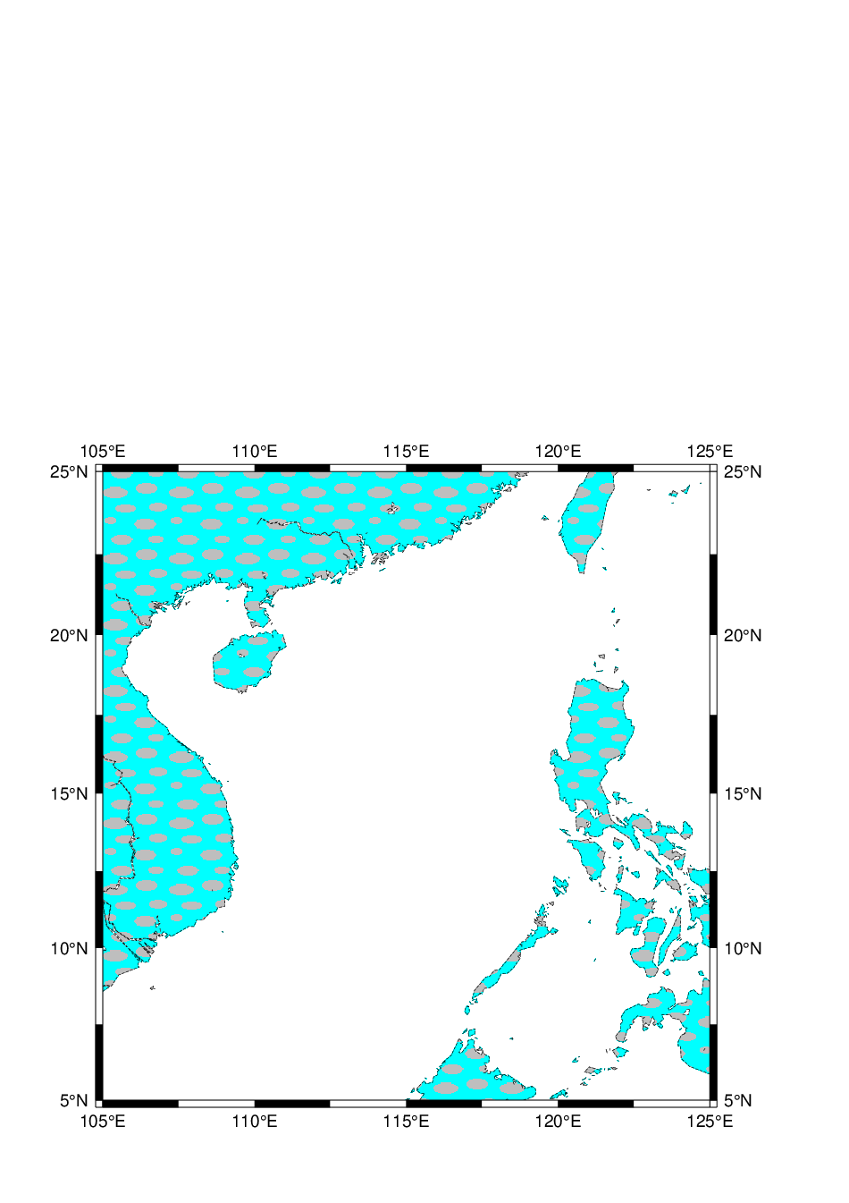

______________________________________________________________________________________

創建一個txt檔 W5_1a.txt

vi W5_1a.txt

minmax W5_1a.txt

psxy W5_1a.txt -R0/10/0/8 -JX15c -B2 -W1,red,dashed -Gcyan -P > W5_1a.ps

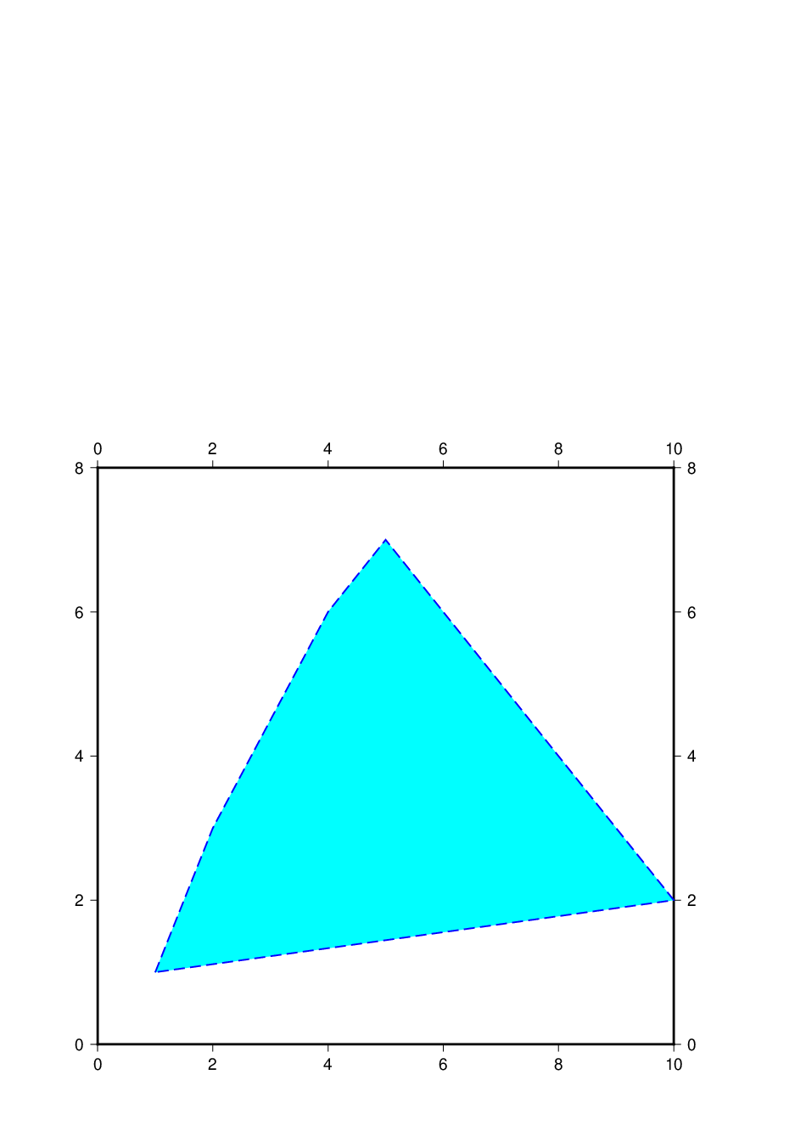

______________________________________________________________________________________

創建一個txt檔 W5_1c.txt

vi W5_1c.txt

minmax W5_1c.txt

psxy W5_1c.txt -R0/15/0/10 -JX15c -B2 -h6 -m3 -W1,0/0/255,dashed -Gcyan -P > W5_1c.ps

psxy W5_1a.txt -R0/10/0/8 -JX15c -B2 -Sa1c -W1,blue -Gblue -P > W5_1a.ps

psxy W5_1a.txt -R0/10/0/8 -JX15c -B2 -Sg2c -W1,blue -Gblue -P > W5_1a.ps

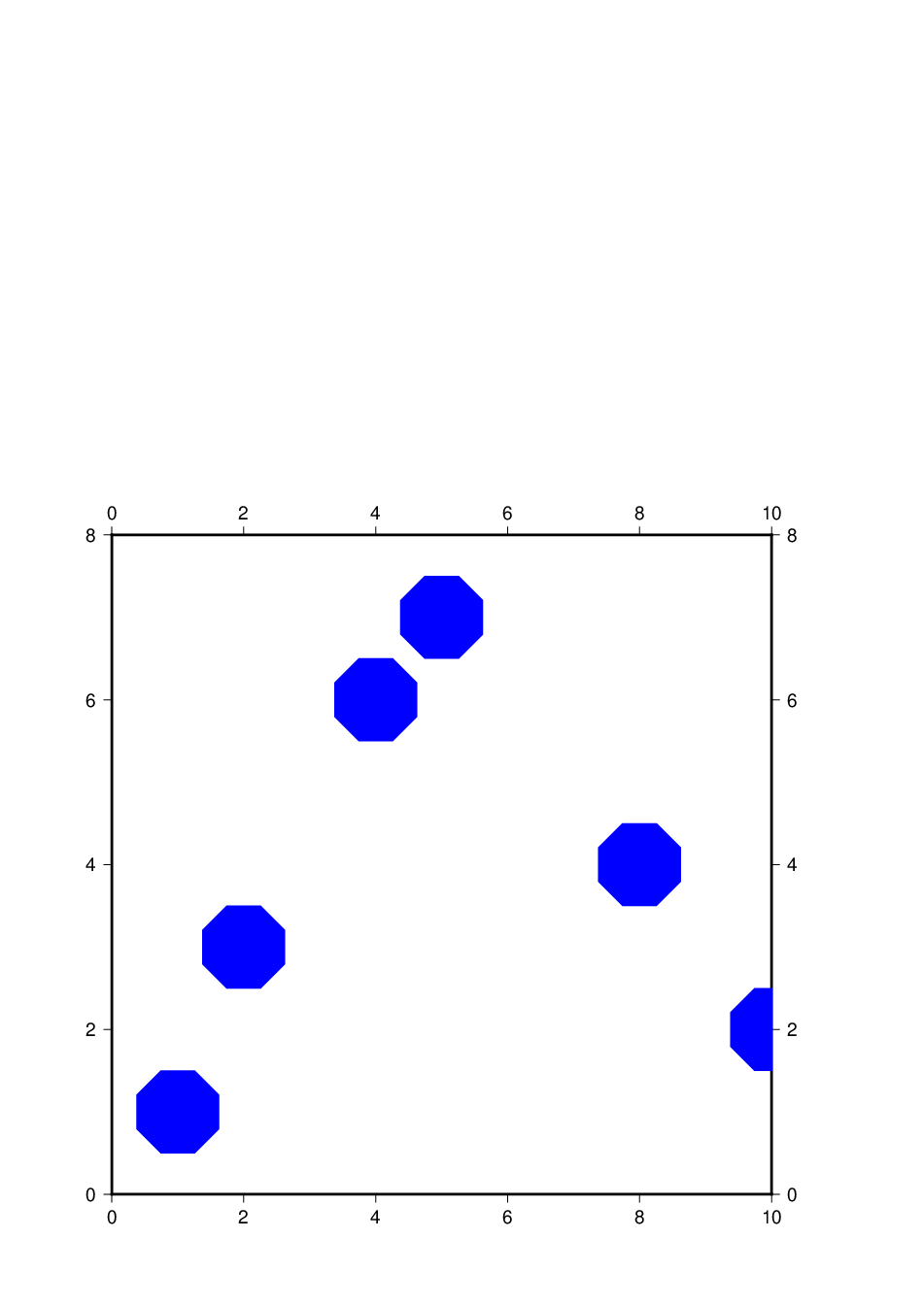

W6 (128GB USB)

1. 在圖上指定的座標位置畫出特定的字串

cat W5_1c.txt

psxy W5_1c.txt -R0/10/0/8 -JX15c -B2:."write a letter":WSne -Sl8/Run%3 -W5,red -Gred -P > W6_1c.ps

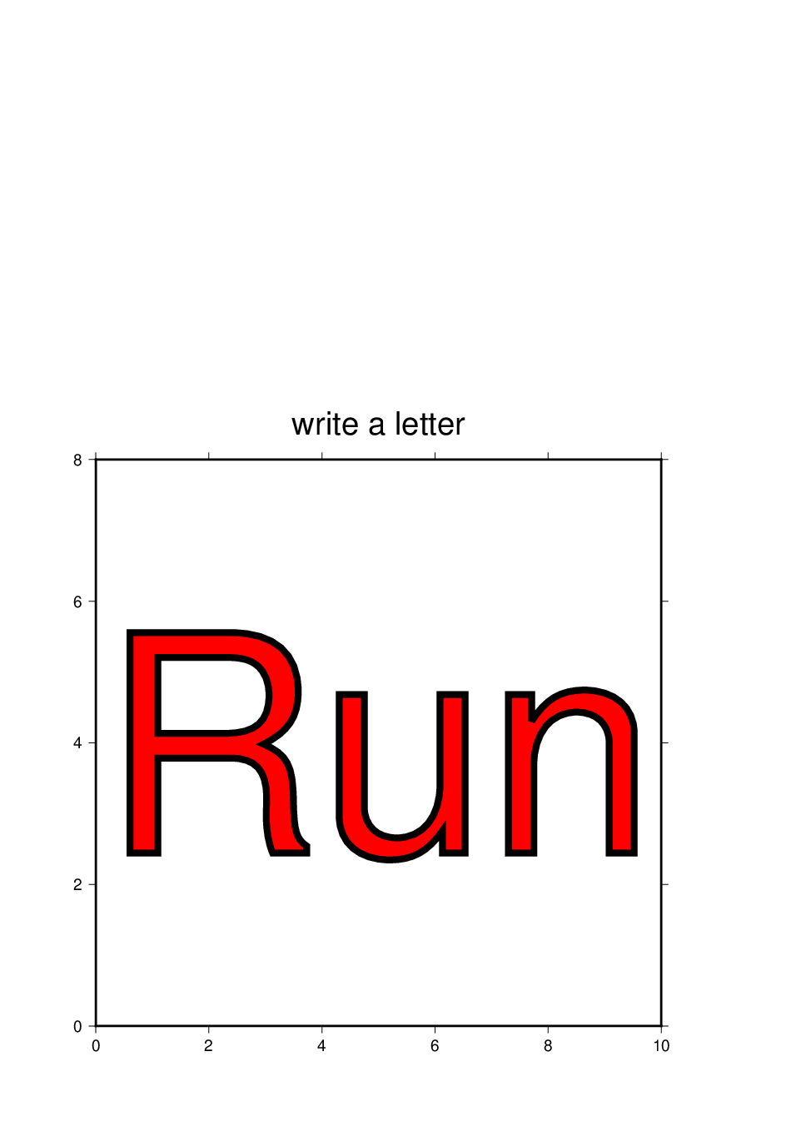

______________________________________________________________________________________

1. 畫一個橢圓

cat W6_1b.txt

(x位置, y位置, 方向, 長軸, 短軸)

psxy W6_1b.txt -R0/15/0/15 -JX15c -Ba1f0 -Se -W3,cyan -G255 > W6_1b.ps

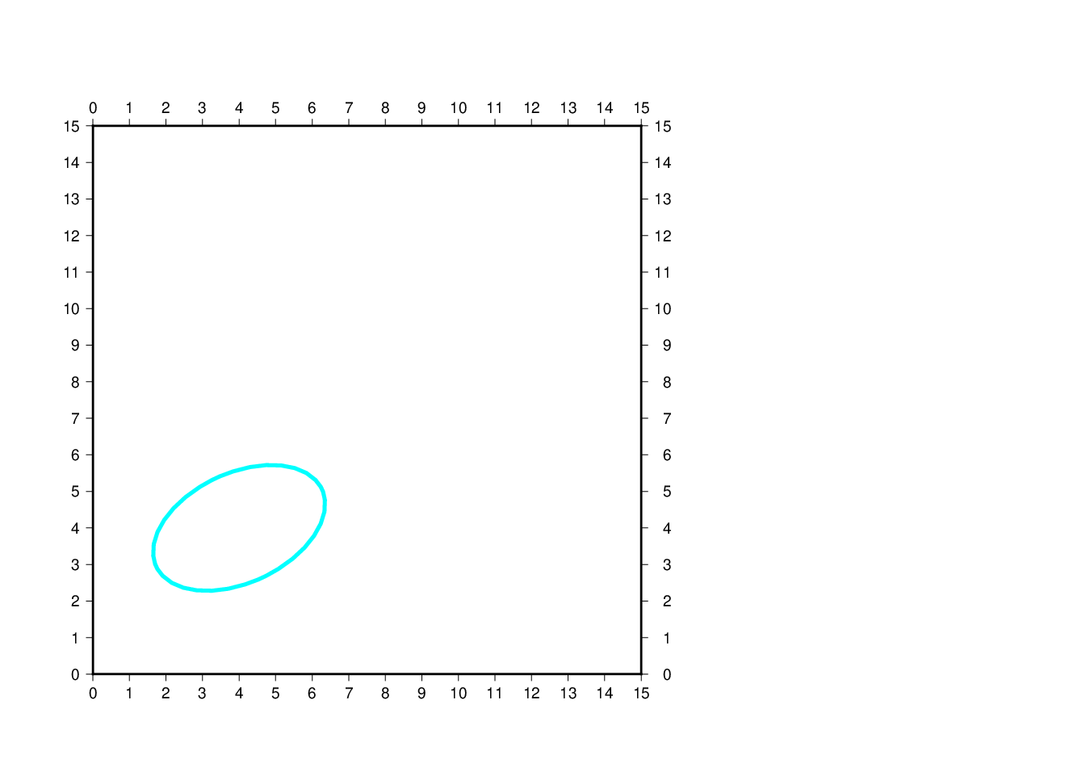

______________________________________________________________________________________

1. 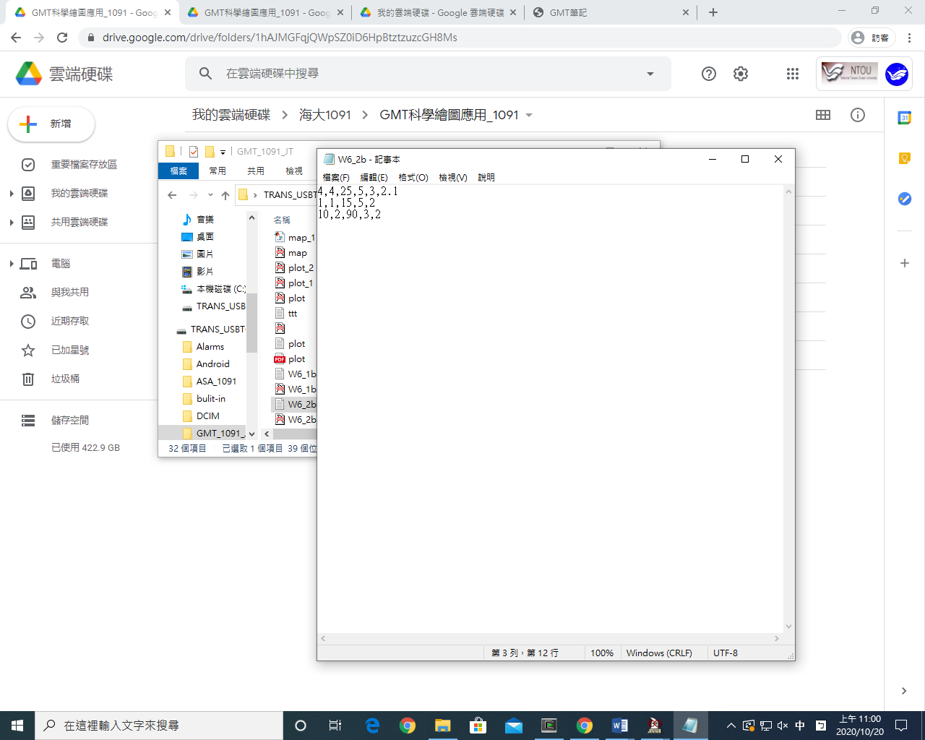畫多個橢圓

W6_2b.txt

psxy W6_2b.txt -R0/15/0/15 -JX15c -Ba1f0.1 -Se -W3,blue -Gcyan > W6_2b.ps

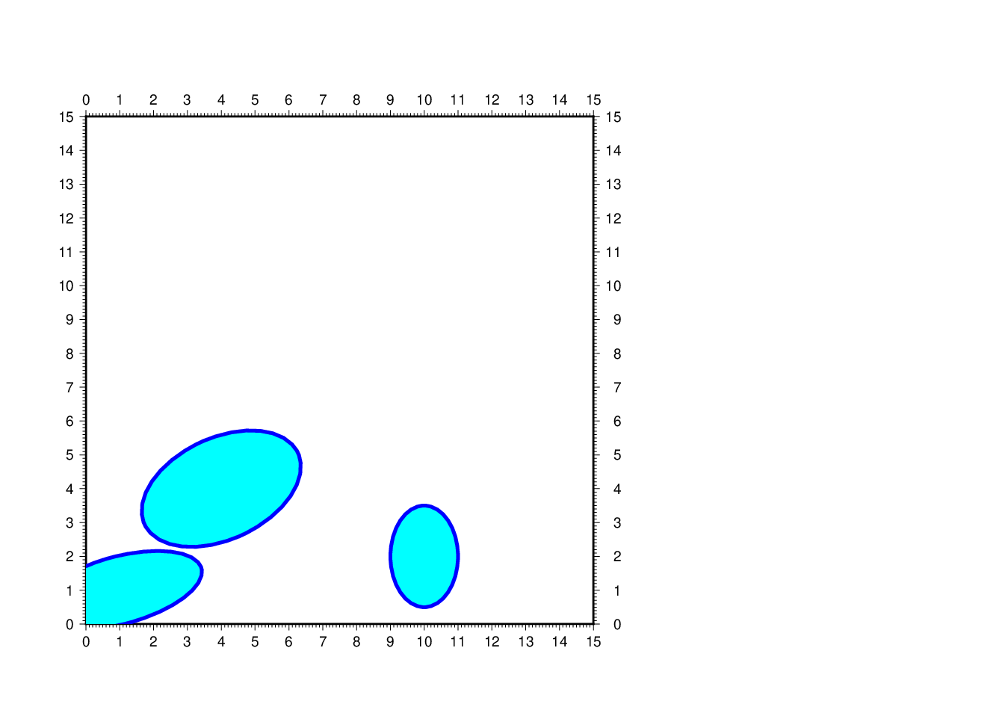

______________________________________________________________________________________

1. 畫bar

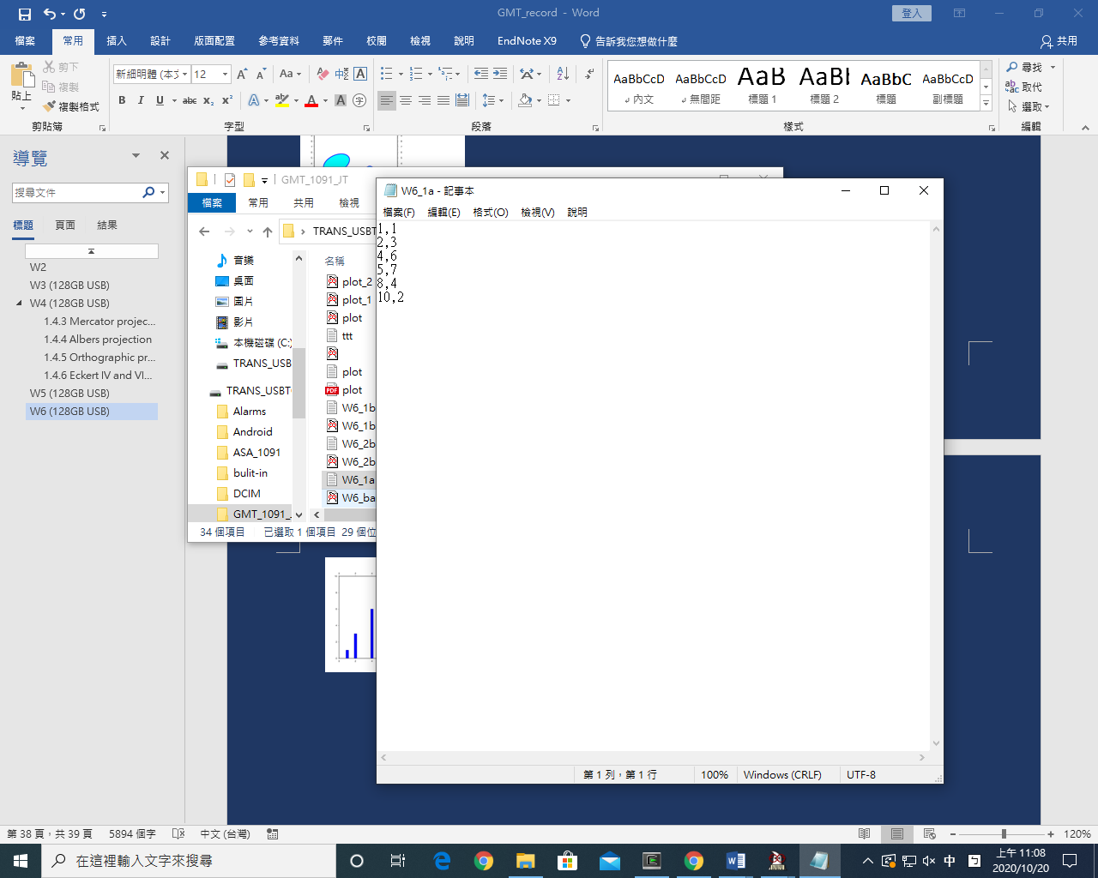W6_1a.txt

psxy W6_1a.txt -R0/10/0/10 -JX15c -B2:WSne -Sb0.5c -W0.25,black -Gblue > W6_bar.ps

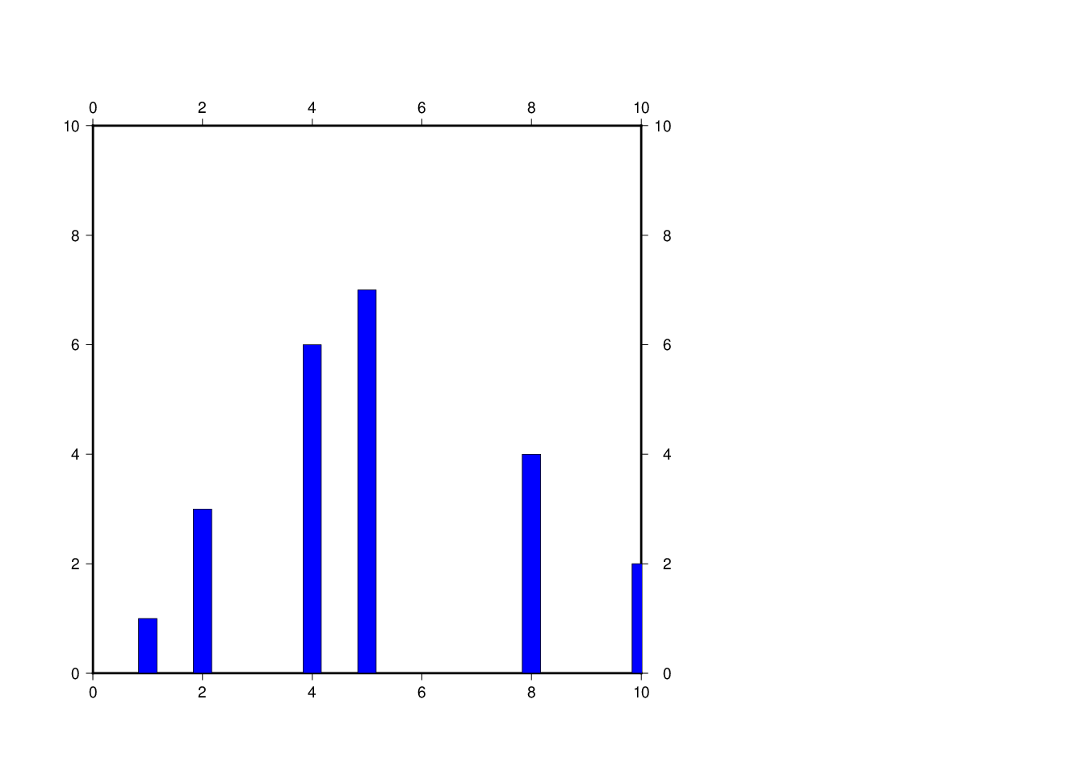

______________________________________________________________________________________

1. Pie

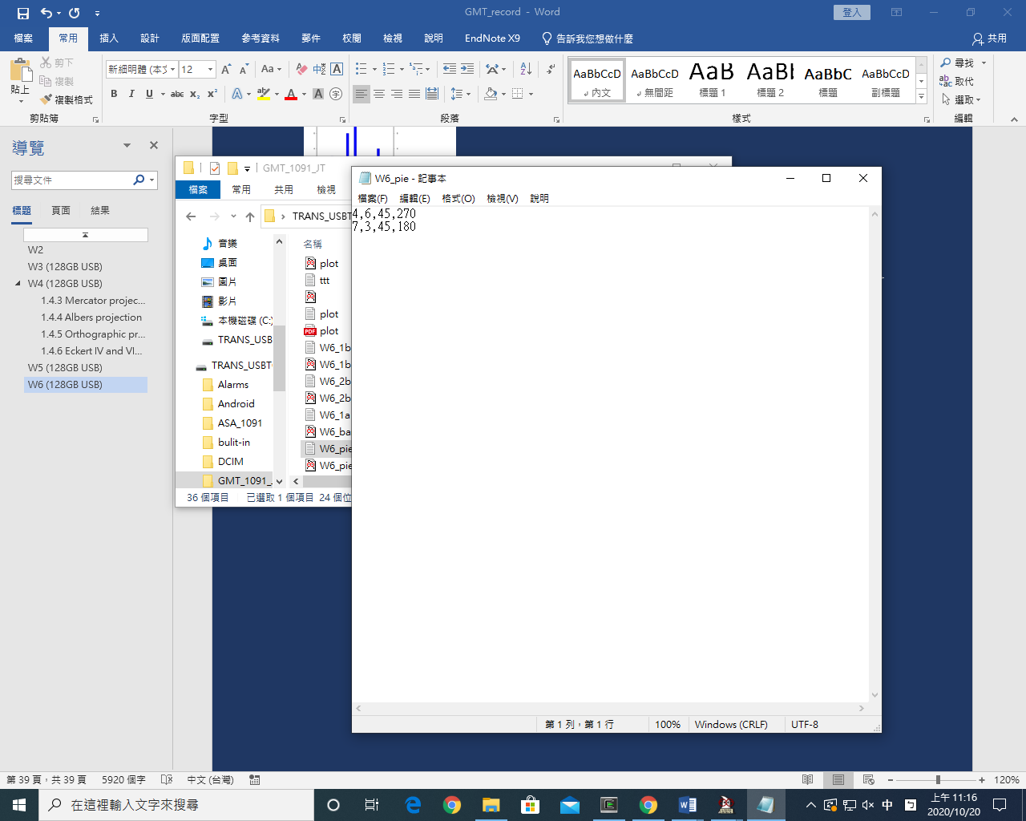W6_pie.txt

psxy W6_pie.txt -R0/10/0/10 -JX15c -B2:."plotting a wedge":WSne -Sw4 -W2,black -Gblue > W6_pie.ps

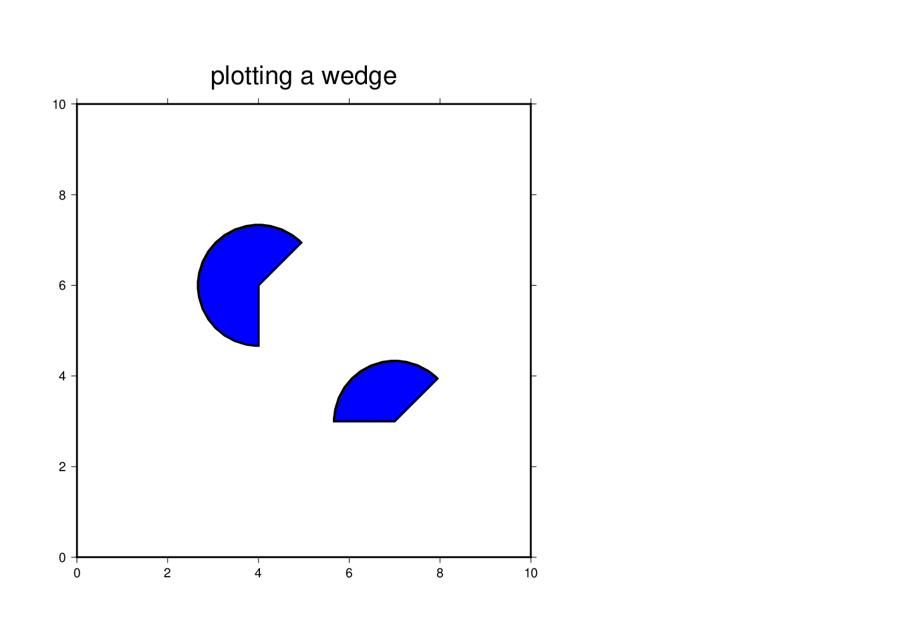

______________________________________________________________________________________

1. 向量圖(Sv) 以東方為0度(逆時針)

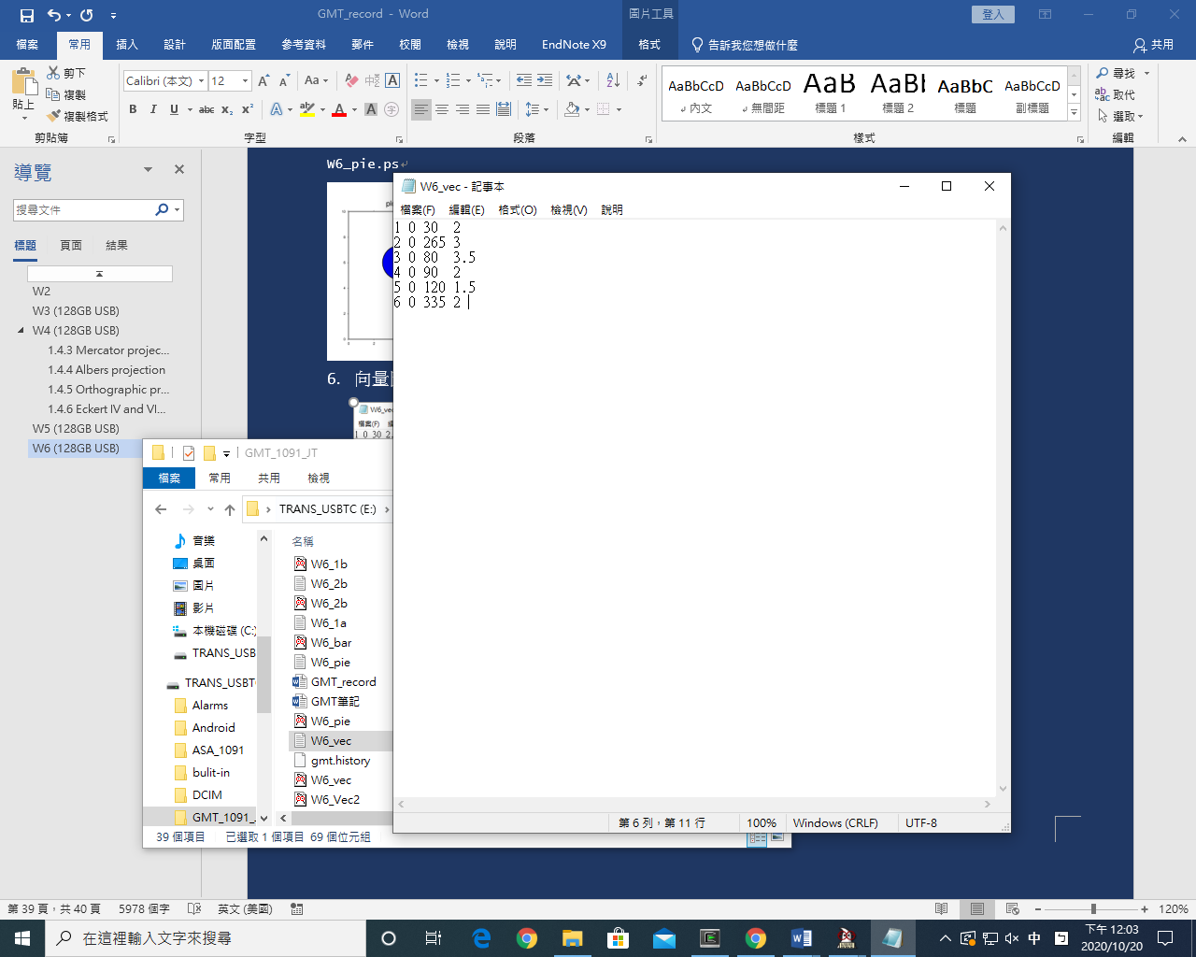

psxy W6_vec.txt -R0/10/-20/20 -JX15c/8c -B2:."plotting a vector":WSne -Sv0.013/0.185c/0.105 -W0.25p,black -Gblue -V > W6_vec.ps

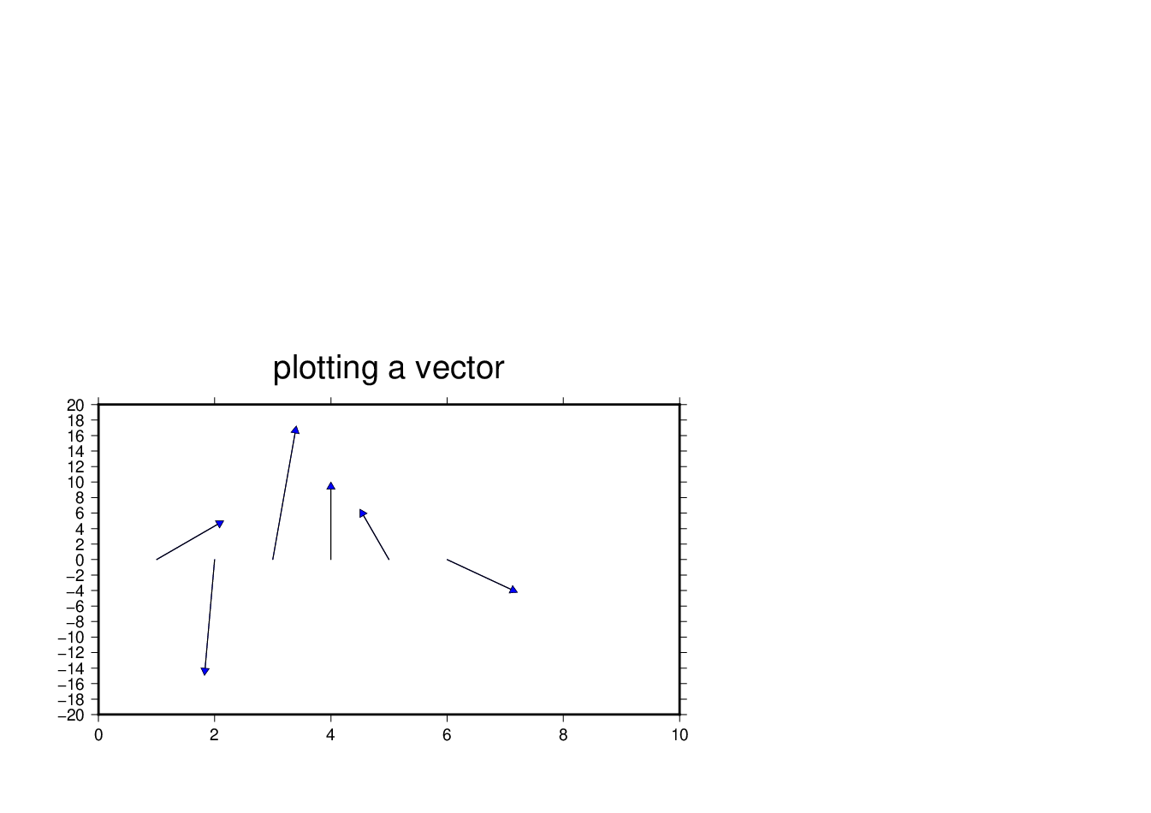

______________________________________________________________________________________

1. 向量圖(SV) 以北方為0度(順時針)



psxy W6_vec.txt -R0/10/-20/20 -JX15c/8c -B2:."plotting a vector":WSne -SV0.013/0.185c/0.105 -W0.25p,black -Gblue -V > W6_Vec2.ps

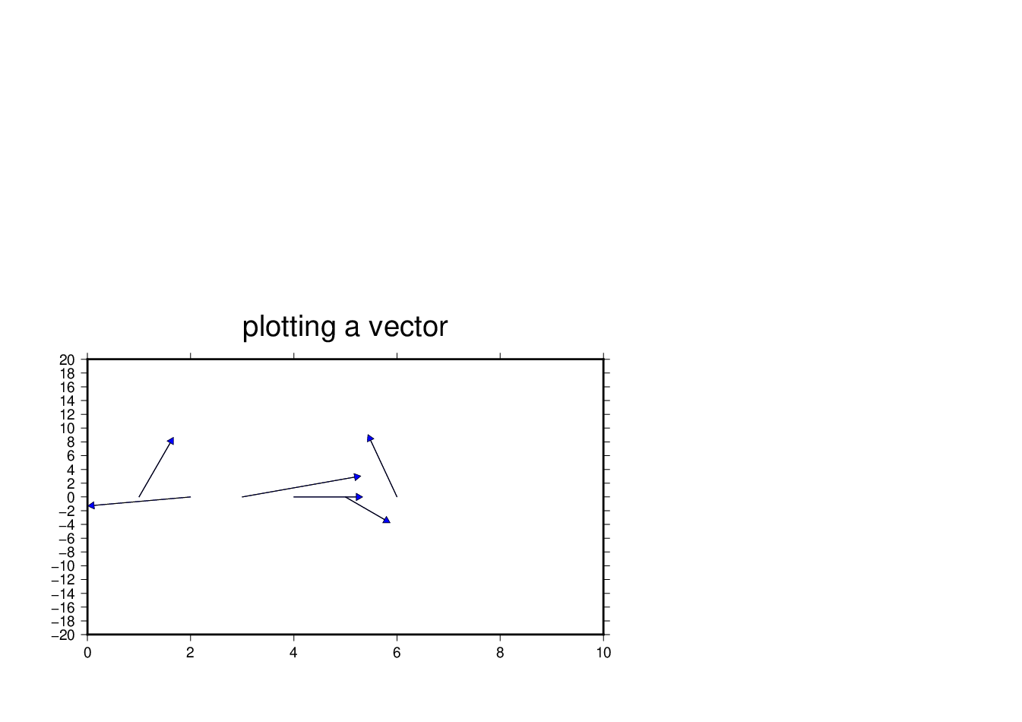

______________________________________________________________________________________

W7 (128GB USB)

user@meicc-006 /cygdrive/e/GMT_1091_JT

$ psxy W7_1.txt -R0/10/-20/20 -JX15c/8c -B2:."vector":WSne -SV0.013/0.185c/0.105 -W0.25p,black -Gblue -V > W7_1.ps

_________________________________________________________________________________________

user@meicc-006 /cygdrive/e/GMT_1091_JT

$ psxy W7_1.txt -R0/10/-20/20 -JX15c/8c -B2:."vector":WSne -SV0.03i/0.12i/0.05i -W0.25p,black -Gblue -V > W7_1.ps

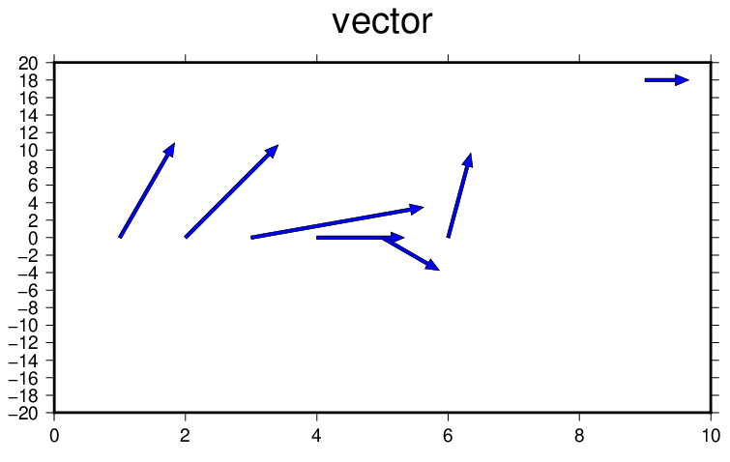

_________________________________________________________________________________________

user@meicc-006 /cygdrive/e/GMT_1091_JT

$ psxy W7_2.txt -R0/10/-20/20 -JX15c/8c -B2:."vector":WSne -SV0.03i/0.12i/0.05i -W0.25p,black -Gblue -V -N> W7_2.ps

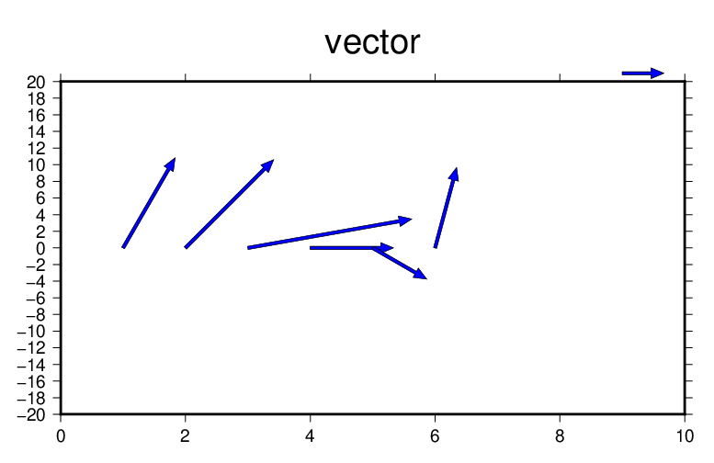

-N : 在圖外顯示符號_________________________________________________________________________________________

user@meicc-006 /cygdrive/e/GMT_1091_JT

$ psxy W7_error.txt -R0/4/0/4 -JX10c -B1:."error bar":WSne -Ss6p -Ey0.3c -Gblack -P > W7_error.ps

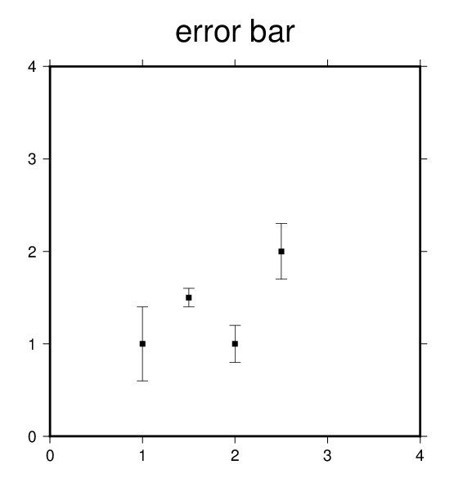

|  |  |
| --- | --- |
| -Ey0.3c | Error bar橫槓是以Ey控制長度 |
| -Ss6p | 方形大小以p (pixel) 前的數字調整 |
|  |  |

_________________________________________________________________________________________

user@meicc-006 /cygdrive/e/GMT_1091_JT

$ psxy W7_error_2.txt -R0/8/0/10 -JX15c -B2:."error bar":WSne -Ss6p -EY0.2c -Gblack -P > W7_error_2.ps

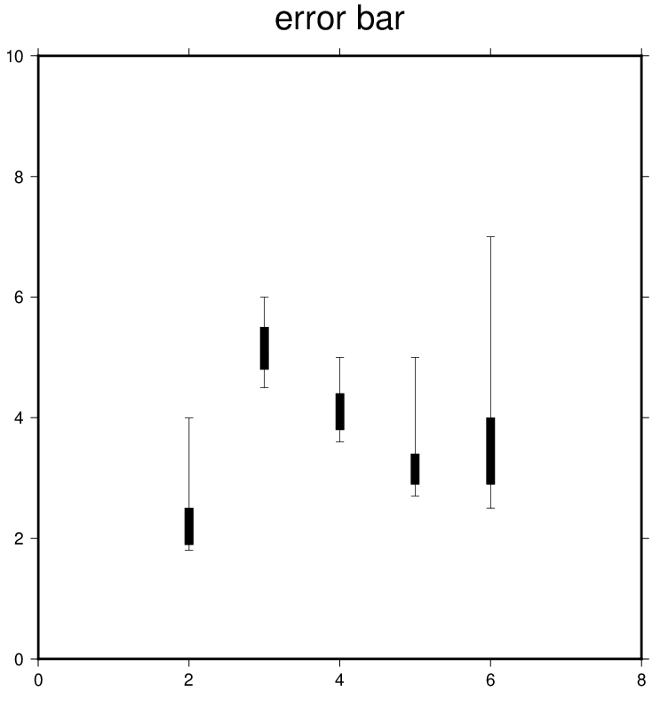

_________________________________________________________________________________________

user@meicc-006 /cygdrive/e/GMT_1091_JT

$ psxy W7_error_2.txt -R0/8/0/10 -JX15c -B2:."error bar":WSne -Sd7p -EY0.1c -Gred -W1,blue -P > W7_error_2.ps

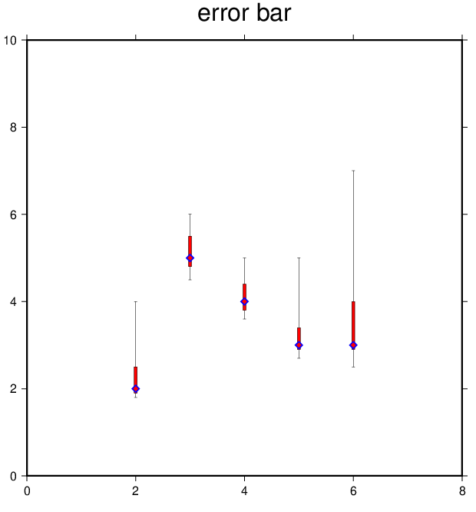

_________________________________________________________________________________________

user@meicc-006 /cygdrive/e/GMT_1091_JT

$ psxy W7_error_2.txt -R0/8/0/10 -JX15c -B2:."error bar":WSne -Sd7p -EY0.1c/purple -Gred -W1,blue -P > W7_error_2.ps

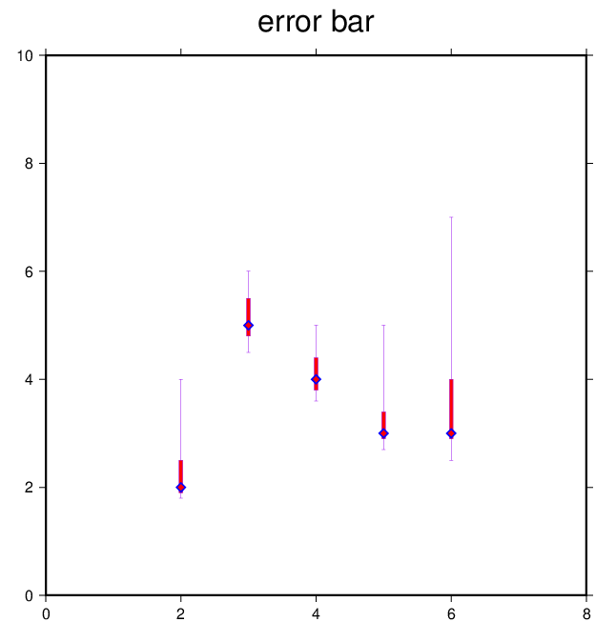

_________________________________________________________________________________________

user@meicc-006 /cygdrive/e/GMT_1091_JT

$ awk '{print $0}' quakes.ngdc.txt

Historical Tsunami Earthquakes from the NGDC Database

Year Mo Da Lat+N Long+E Dep Mag

1987 01 04 49.77 149.29 489 4.1

1987 01 09 39.90 141.68 067 6.8

_____________________________________________________________________________________

user@meicc-006 /cygdrive/e/GMT_1091_JT

$ gawk '{if(NR > 2) print $0}' quakes.ngdc.txt

1987 01 04 49.77 149.29 489 4.1

1987 01 09 39.90 141.68 067 6.8

_________________________________________________________________________________________

user@meicc-006 /cygdrive/e/GMT_1091_JT

$ pscoast -R130/150/35/50 -JM6i -B5 -P -Ggray -Lf134/49/42.5/500 -K > W7_quakes.ps

user@meicc-006 /cygdrive/e/GMT_1091_JT

$ psxy -R -J -O -Cquakes.cpt.txt quakes.d.txt -Sci -Wthinnest >> W7_quakes.ps

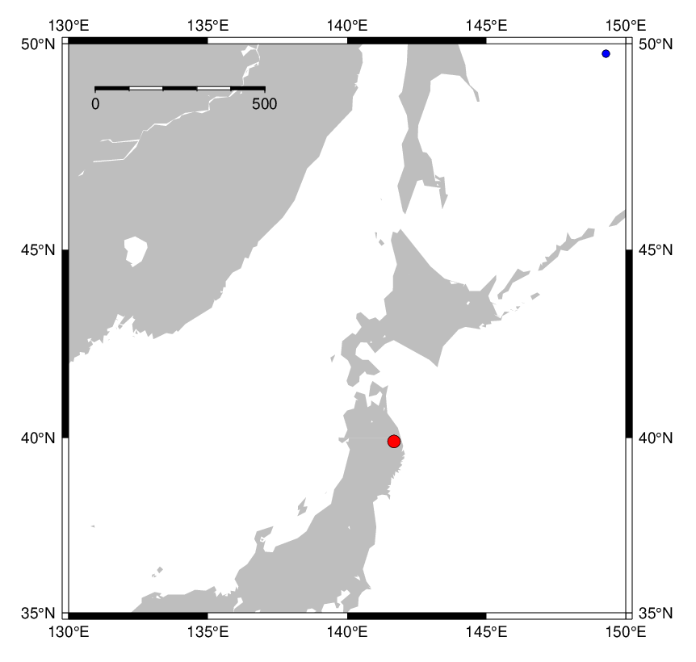

W8 (128GB USB)

user@meicc-006 /cygdrive/e/GMT_1091_JT

$ cat quakes.ngdc.txt

Historical Tsunami Earthquakes from the NGDC Database

Year Mo Da Lat+N Long+E Dep Mag

1987 01 04 49.77 149.29 489 4.1

1987 01 09 39.90 141.68 067 6.8

______________________________________________________________________________________

user@meicc-006 /cygdrive/e/GMT_1091_JT

$ cat quakes.cpt.txt

# color palette for seismicity

#z0 color z1 color

0 red 100 red

100 green 300 green

300 blue 1000 blue

*cpt檔 : 做色階

______________________________________________________________________________________

user@meicc-006 /cygdrive/e/GMT_1091_JT

$ man gawk

______________________________________________________________________________________

user@meicc-006 /cygdrive/e/GMT_1091_JT

$ gawk '{print $0}' quakes.ngdc.txt

Historical Tsunami Earthquakes from the NGDC Database

Year Mo Da Lat+N Long+E Dep Mag

1987 01 04 49.77 149.29 489 4.1

1987 01 09 39.90 141.68 067 6.8

______________________________________________________________________________________user@meicc-006 /cygdrive/e/GMT_1091_JT

$ gawk '{print $0}' quakes.cpt.txt

# color palette for seismicity

#z0 color z1 color

0 red 100 red

100 green 300 green

300 blue 1000 blue

______________________________________________________________________________________

只檢視第一行的資料

user@meicc-006 /cygdrive/e/GMT_1091_JT

$ gawk '{print $1}' quakes.ngdc.txt

Historical

Year

1987

1987

______________________________________________________________________________________

只檢視第二行的資料

user@meicc-006 /cygdrive/e/GMT_1091_JT

$ gawk '{print $2}' quakes.ngdc.txt

Tsunami

Mo

01

01

______________________________________________________________________________________

user@meicc-006 /cygdrive/e/GMT_1091_JT

$ gawk '{print $1" "$3}' quakes.ngdc.txt

Historical Earthquakes

Year Da

1987 04

1987 09

______________________________________________________________________________________

user@meicc-006 /cygdrive/e/GMT_1091_JT

$ gawk '{print $1"\t"$3}' quakes.ngdc.txt

Historical Earthquakes

Year Da

1987 04

1987 09

______________________________________________________________________________________

user@meicc-006 /cygdrive/e/GMT_1091_JT

$ gawk '{if(NR > 1) print $0}' quakes.ngdc.txt

Year Mo Da Lat+N Long+E Dep Mag

1987 01 04 49.77 149.29 489 4.1

1987 01 09 39.90 141.68 067 6.8

NR : 第幾列

______________________________________________________________________________________

user@meicc-006 /cygdrive/e/GMT_1091_JT

$ gawk '{if(NR > 2) print $0}' quakes.ngdc.txt

1987 01 04 49.77 149.29 489 4.1

1987 01 09 39.90 141.68 067 6.8

______________________________________________________________________________________

user@meicc-006 /cygdrive/e/GMT_1091_JT

$ gawk '{print $0}' quakes.cpt.txt

# color palette for seismicity

#z0 color z1 color

0 red 100 red

100 green 300 green

300 blue 1000 blue

______________________________________________________________________________________

user@meicc-006 /cygdrive/e/GMT_1091_JT

$ gawk '{if(NR > 2) print $0}' quakes.ngdc.txt > quakes.d

______________________________________________________________________________________

user@meicc-006 /cygdrive/e/GMT_1091_JT

$ gawk '{print $0}' quakes.d

1987 01 04 49.77 149.29 489 4.1

1987 01 09 39.90 141.68 067 6.8

______________________________________________________________________________________

user@meicc-006 /cygdrive/e/GMT_1091_JT

$ pscoast -R130/150/35/50 -JM6i -B5 -P -Ggray -Lf134/49/42.5/500+ukm -K > w9-1.ps

______________________________________________________________________________________

user@meicc-006 /cygdrive/e/GMT_1091_JT

$ psxy quakes.d -R -J -O -Cquakes.cpt.txt quakes.d.txt -Sci -Wthinnest >> W9-1.ps

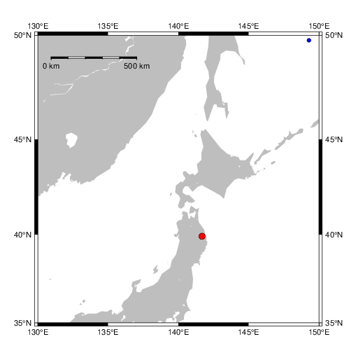

______________________________________________________________________________________

user@meicc-006 /cygdrive/e/GMT_1091_JT

$ gawk '{if(NR > 2) print $5" "$4" "$6" "0.02*$7}' quakes.ngdc.txt > quakes.d

user@meicc-006 /cygdrive/e/GMT_1091_JT

$ pscoast -R130/150/35/50 -JM6i -B5 -P -Ggray -Lf134/49/42.5/500+ukm -K > w9-2.ps

user@meicc-006 /cygdrive/e/GMT_1091_JT

$ psxy quakes.d -R -J -O -Cquakes.cpt.txt quakes.d.txt -Sc0.5 -W1/red >> W9-2.ps

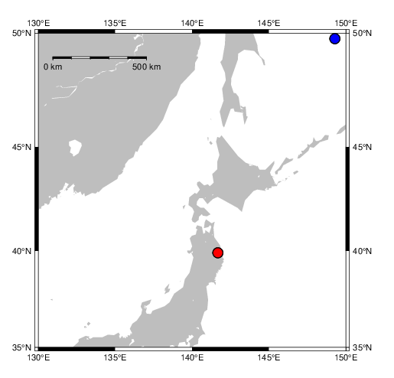

______________________________________________________________________________________

user@meicc-006 /cygdrive/e/GMT_1091_JT

$ gawk '{if(NR > 2) print $5" "$4" "$6" "0.1*$7}' quakes.ngdc.txt > quakes.d

user@meicc-006 /cygdrive/e/GMT_1091_JT

$ pscoast -R130/150/35/50 -JM6i -B5 -P -Ggray -Lf134/49/42.5/500+ukm -K > w9-3.ps

user@meicc-006 /cygdrive/e/GMT_1091_JT

$ psxy quakes.d -R -J -O -Cquakes.cpt.txt quakes.d.txt -Sci -W1/red >> W9-3.ps

Sci : 以第7行(Magnitude)為原點大小依據

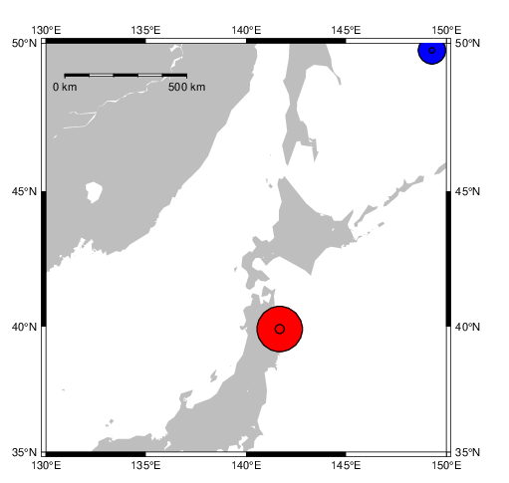

______________________________________________________________________________________

Mid-term (128GB USB)

user@meicc-006 ~

$ cd E:\GMT_1091_JT

user@meicc-006 /cygdrive/e/GMT_1091_JT

$ gawk '{if(NR < 145) print $5}' HP0201a.v1 > w9_u.txt

user@meicc-006 /cygdrive/e/GMT_1091_JT

$ gawk '{if(NR < 145) print $5}' HP0201a.v2 > w9_v.txt

user@meicc-006 /cygdrive/e/GMT_1091_JT

$ gawk '{if(NR > 1) print $1" "$2}' w9_excel_uv.txt > w9_uv.txt

先把u,v行資料合併為一個Excel檔(w9_excel_uv.txt)，再放到以下程式執行。

user@meicc-006 /cygdrive/e/GMT_1091_JT

$ gawk '{print NR,0,atan2($2,$1)*180/3.14159265358 "\t" sqrt($1*$1+$2*$2)}' w9_uv.txt > w9_uv.out

user@meicc-006 /cygdrive/e/GMT_1091_JT

$ psxy W9_uv.out -R0/145/-0.1/0.1 -JX25c/15c -B12:."W9_mid_vector":/0.1::WSne -Sv0.003/0.05/0.05 -W0.25,blue -Gwhite -V -N > W9_result.ps

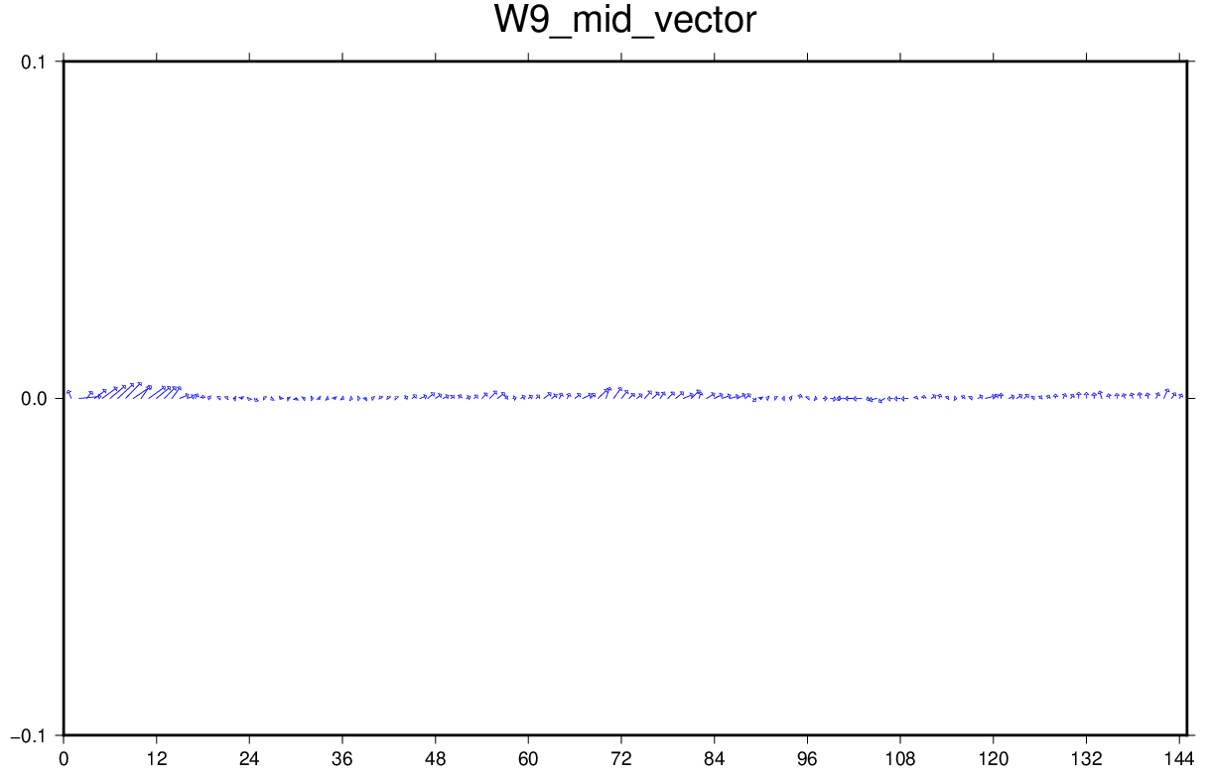

---------------------------------------------------------------------------------------

加上scale bar

user@meicc-006 ~

$ cd E:\GMT_1091_JT

user@meicc-006 /cygdrive/e/GMT_1091_JT

$ gawk '{if(NR < 145) print $5}' HP0201a.v1 > w9_u.txt

user@meicc-006 /cygdrive/e/GMT_1091_JT

$ gawk '{if(NR < 145) print $5}' HP0201a.v2 > w9_v.txt

user@meicc-006 /cygdrive/e/GMT_1091_JT

$ gawk '{if(NR > 1) print $1" "$2}' w9_excel_uv.txt > w9_uv.txt

user@meicc-006 /cygdrive/e/GMT_1091_JT

$ gawk '{print NR,0,atan2($2,$1)*180/3.14159265358 "\t" 5*sqrt($1*$1+$2*$2)}' w9_uv.txt > w9_uv.out

---------------------------------------------------------------------------------------

在w9_uv.out最後一列打上scale bar的位置、角度、大小

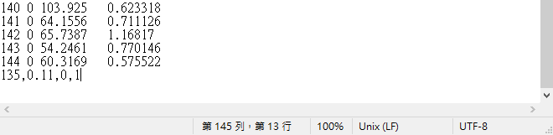

user@meicc-006 /cygdrive/e/GMT_1091_JT

$ psxy W9_uv.out -R0/145/-0.1/0.1 -JX25c/15c -B12:."W9_mid_vector":/0.1::WSne -Sv0.0001/0.05/0.05 -W0.25,blue -Gwhite -V -N > W9_result.ps

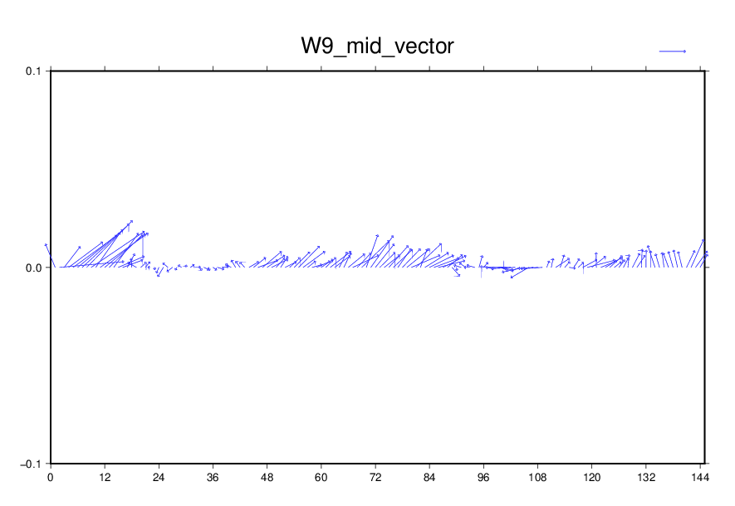

---------------------------------------------------------------------------------------

加上scale bar

user@meicc-006 ~

$ cd E:\GMT_1091_JT

user@meicc-006 /cygdrive/e/GMT_1091_JT

$ gawk '{if(NR < 145) print $5}' HP0201a.v1 > w9_u.txt

user@meicc-006 /cygdrive/e/GMT_1091_JT

$ gawk '{if(NR < 145) print $5}' HP0201a.v2 > w9_v.txt

user@meicc-006 /cygdrive/e/GMT_1091_JT

$ gawk '{if(NR > 1) print $1" "$2}' w9_excel_uv.txt > w9_uv.txt

user@meicc-006 /cygdrive/e/GMT_1091_JT

$ gawk '{print NR,0,atan2($2,$1)*180/3.14159265358 "\t" 5*sqrt($1*$1+$2*$2)}' w9_uv.txt > w9_uv.out

---------------------------------------------------------------------------------------

在w9_uv.out最後一列打上scale bar的位置、角度、大小

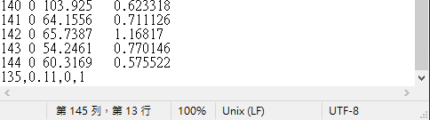

user@meicc-006 /cygdrive/e/GMT_1091_JT

$ psxy W9_uv.out -R-5/150/-0.1/0.1 -JX25c/15c -B12:."W9_mid_vector (arrow bar length, 5 units)":/0.1::WSne -Sv0.0001/0.05/0.05 -W0.25,blue -Gwhite -V -N > W9_result.ps

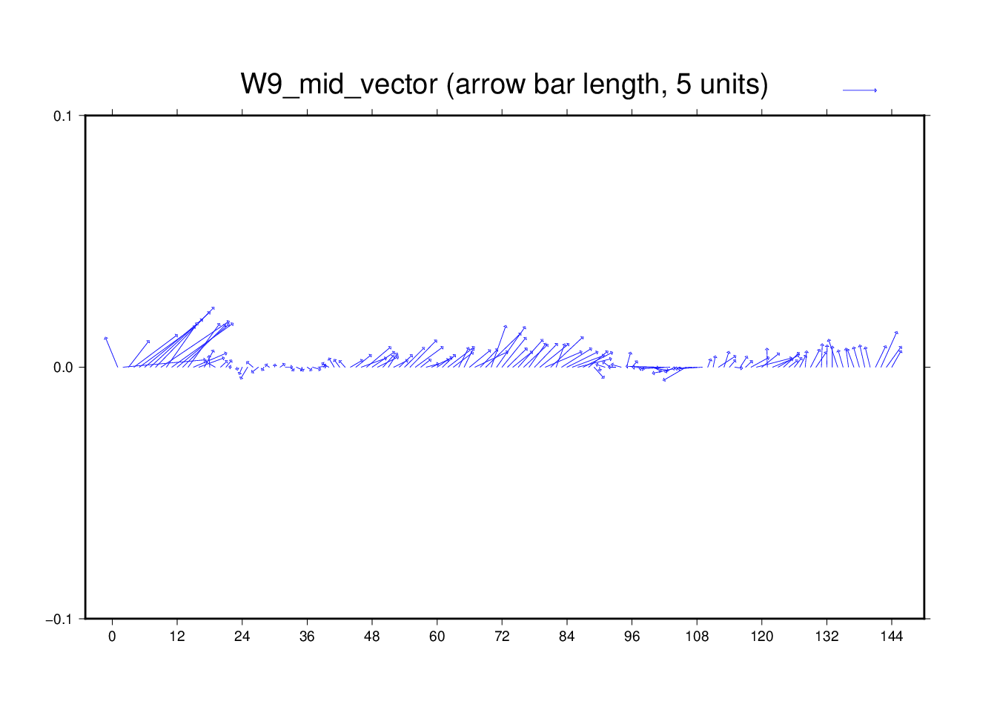

W10 (128GB USB)

user@meicc-006 /cygdrive/e/GMT_1091_JT

$ gawk '{print $0}' quakes.ngdc.txt

Historical Tsunami Earthquakes from the NGDC Database

Year Mo Da Lat+N Long+E Dep Mag

1987 01 04 49.77 149.29 489 4.1

user@meicc-006 /cygdrive/e/GMT_1091_JT

$ gawk '{if(NR > 2) print $0}' quakes.ngdc.txt

1987 01 04 49.77 149.29 489 4.1

1987 01 09 39.90 141.68 067 6.8

user@meicc-006 /cygdrive/e/GMT_1091_JT

$ gawk '{if(NR > 2) print $0}' quakes.ngdc.txt > W10-1.txt

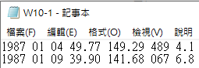

user@meicc-006 /cygdrive/e/GMT_1091_JT

$ cat W10-1.txt

1987 01 04 49.77 149.29 489 4.1

1987 01 09 39.90 141.68 067 6.8

user@meicc-006 /cygdrive/e/GMT_1091_JT

$ gawk '{if(NR > 2) print $2" "$3}' quakes.ngdc.txt

01 04

01 09

user@meicc-006 /cygdrive/e/GMT_1091_JT

$ gawk '{if(NR > 2) print $2" "$7}' quakes.ngdc.txt

01 4.1

01 6.8

---------------------------------------------------------------------------------

轉換角度

user@meicc-006 /cygdrive/e/GMT_1091_JT

$ gawk '{print $0}' W10_ang.txt

1,1

1,1.732

1.732,1

1,0

user@meicc-006 /cygdrive/e/GMT_1091_JT

$ gawk '{print atan2($2,$1)*180/3.14159}' W10_ang.txt

45

59.9993

30.0008

0

user@meicc-006 /cygdrive/e/GMT_1091_JT

$ gawk '{print 1" "atan2($2,$1)*180/3.14159}' W10_ang.txt

1 45

1 59.9993

1 30.0008

1 0

user@meicc-006 /cygdrive/e/GMT_1091_JT

$ gawk '{print atan2($2,$1)*180/3.14159 "\t" sqrt($1*$1+$2*$2)}' W10_ang.txt

45 1.41421

59.99931.99996

30.00081.99996

0 1

user@meicc-006 /cygdrive/e/GMT_1091_JT

$ gawk '{if(NR>2) print $5"\t"$4"\t"$6"\t" $7*0.02}' quakes.ngdc.txt

149.29 49.77 489 0.082

141.68 39.90 067 0.136

user@meicc-006 /cygdrive/e/GMT_1091_JT

$ gawk '{if(NR>2) print $5"\t"$4"\t"$6"\t" $7*0.02}' quakes.ngdc.txt > W10_quakes.d

user@meicc-006 /cygdrive/e/GMT_1091_JT

$ cat W10_quakes.d

149.29 49.77 489 0.082

141.68 39.90 067 0.136

user@meicc-006 /cygdrive/e/GMT_1091_JT

$ cat quakes.cpt.txt

# color palette for seismicity

#z0 color z1 color

0 red 100 red

100 green 300 green

300 blue 1000 blue

user@meicc-006 /cygdrive/e/GMT_1091_JT

$ pscoast -R130/150/35/50 -JM15c -B5 -P -G120 -Lf134/49/42.5/500+ukm -K > W10-map.ps

user@meicc-006 /cygdrive/e/GMT_1091_JT

$ psxy W10_quakes.d -R -J -Cquakes.cpt.txt -Sci -Wthinnest -O >> W10-map.ps

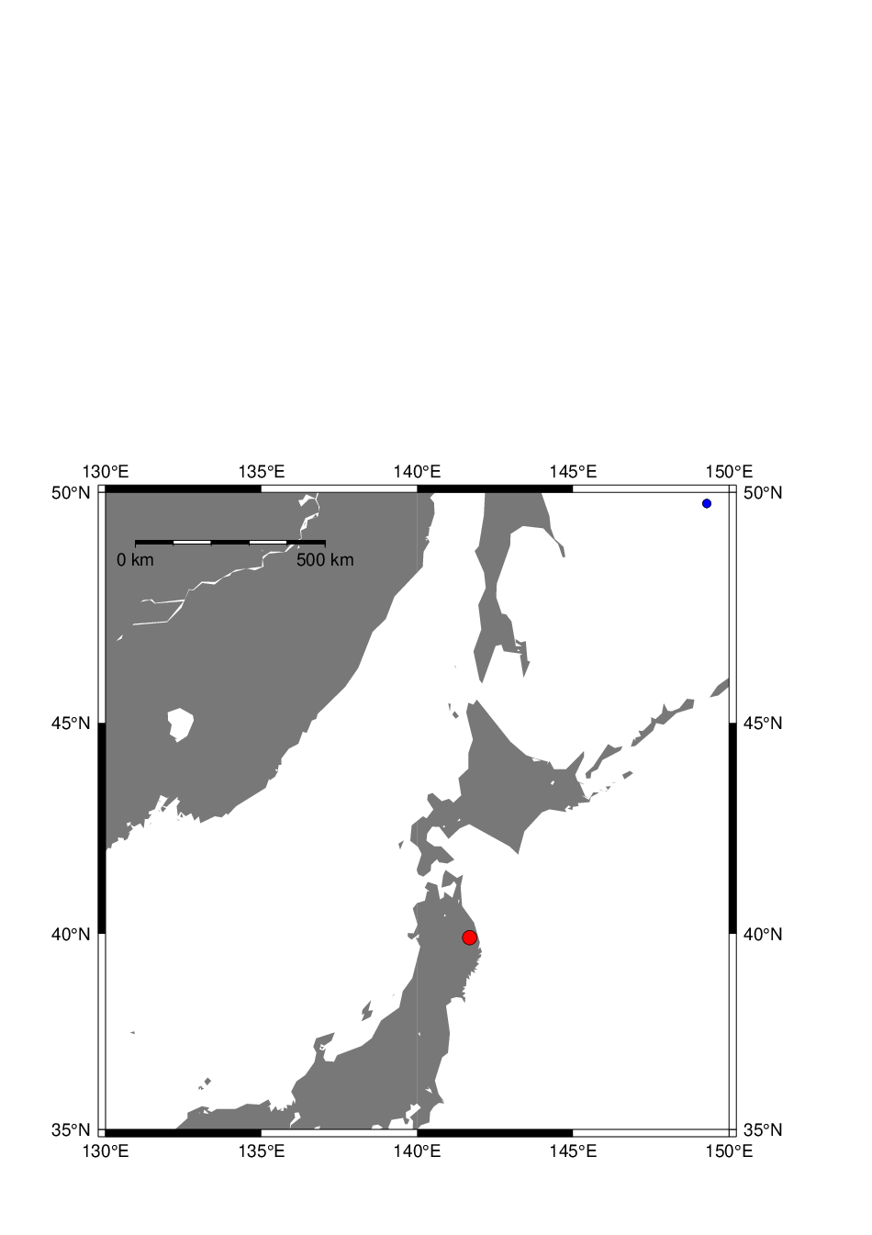

user@meicc-006 /cygdrive/e/GMT_1091_JT

$ pscoast -R130/150/35/50 -JM15c -B5 -P -G120 -Lf134/49/42.5/500+ukm -K > W10-map.ps

user@meicc-006 /cygdrive/e/GMT_1091_JT

$ psxy W10_quakes.d -R -J -Cquakes.cpt.txt -Sdi -Wthinnest -O >> W10-map.ps

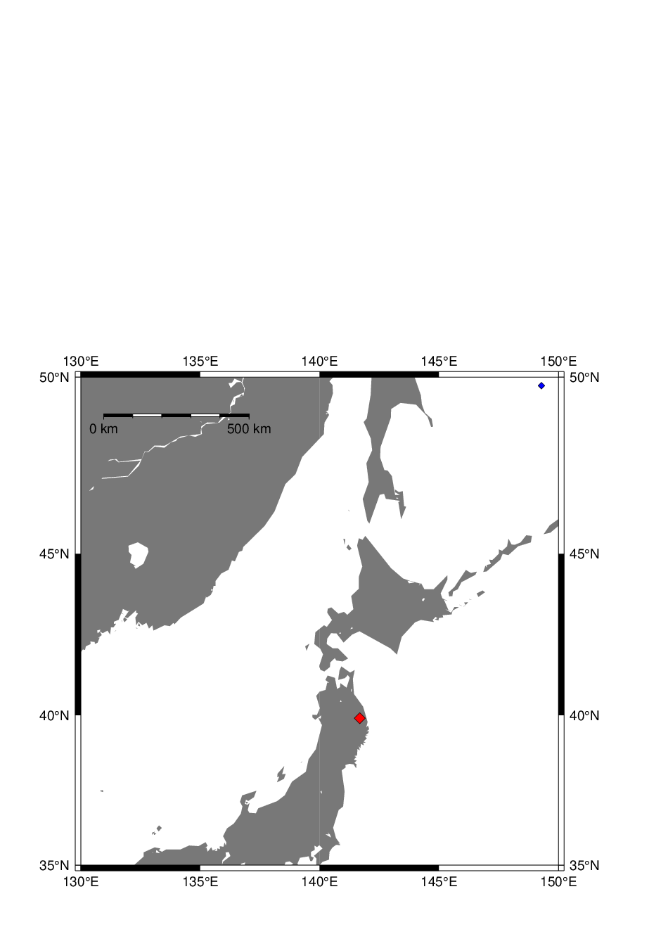

-------------------------------------------------------------------------------------

user@meicc-006 /cygdrive/e/GMT_1091_JT

$ gawk '{if(NR>76) print $1"\t"$5}' sd1.txt

4.000 34.2853

5.000 34.2852

6.000 34.2853

7.000 34.2854

8.000 34.2854

9.000 34.2853

10.000 34.2853

11.000 34.2854

12.000 34.2852

13.000 34.2852

14.000 34.2851

15.000 34.2854

16.000 34.2852

17.000 34.2850

18.000 34.2853

19.000 34.2855

20.000 34.2856

21.000 34.2857

22.000 34.2860

23.000 34.2857

24.000 34.2855

25.000 34.2864

26.000 34.2868

27.000 34.2955

28.000 34.3014

29.000 34.3190

30.000 34.3287

31.000 34.3494

32.000 34.3847

33.000 34.4025

34.000 34.4113

35.000 34.4207

36.000 34.4189

37.000 34.4208

38.000 34.4187

39.000 34.4174

40.000 34.4209

41.000 34.4233

42.000 34.4378

43.000 34.4468

44.000 34.4498

45.000 34.4473

46.000 34.4483

47.000 34.4465

48.000 34.4655

49.000 34.4844

50.000 34.4990

51.000 34.5151

52.000 34.5151

53.000 34.5174

54.000 34.5194

55.000 34.5231

56.000 34.5210

57.000 34.5209

58.000 34.5220

59.000 34.5236

60.000 34.5247

61.000 34.5249

62.000 34.5252

63.000 34.5260

64.000 34.5254

65.000 34.5256

66.000 34.5257

67.000 34.5259

68.000 34.5257

69.000 34.5252

70.000 34.5248

71.000 34.5248

72.000 34.5248

73.000 34.5250

74.000 34.5250

75.000 34.5242

76.000 34.5257

77.000 34.5244

78.000 34.5247

79.000 34.5252

80.000 34.5255

81.000 34.5259

82.000 34.5260

83.000 34.5260

84.000 34.5258

85.000 34.5258

86.000 34.5259

87.000 34.5259

88.000 34.5258

89.000 34.5257

90.000 34.5257

91.000 34.5258

92.000 34.5256

93.000 34.5254

94.000 34.5255

95.000 34.5255

96.000 34.5253

97.000 34.5254

98.000 34.5254

99.000 34.5254

100.00034.5254

101.00034.5253

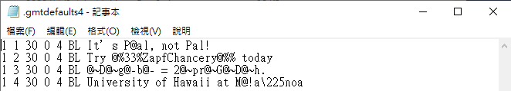

user@meicc-006 /cygdrive/e/GMT_1091_JT

$ pstext .gmtdefaults4.txt -R0/7/0/5 -JX15c -P -B1g1 -GDarkorange > W10-2.ps

pstext [COMPATIBILITY]: Use of old style pstext input is deprecated.

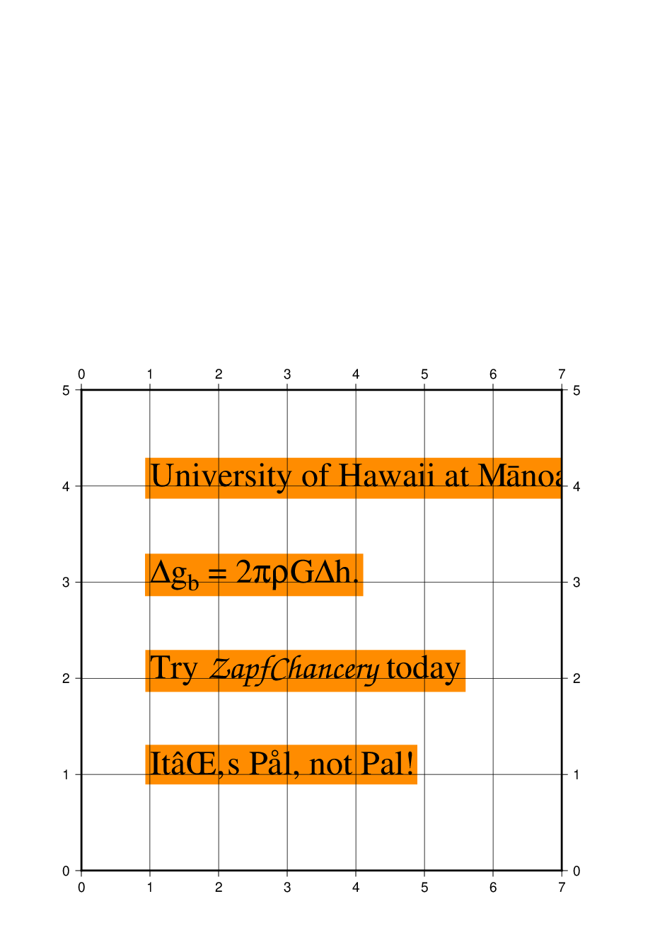

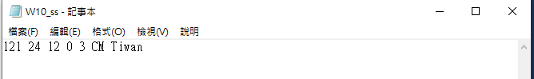

user@meicc-006 /cygdrive/e/GMT_1091_JT

$ pscoast -R105/123/5/25 -JM15c -B4g4 -W1 -G90 -K > W10_ss.ps

user@meicc-006 /cygdrive/e/GMT_1091_JT

$ pstext W10_ss.txt -R -J -B -C0.01/0.01 -W255/255/255 -G255 -O >> W10_ss.ps

pstext [COMPATIBILITY]: Use of old style pstext input is deprecated.

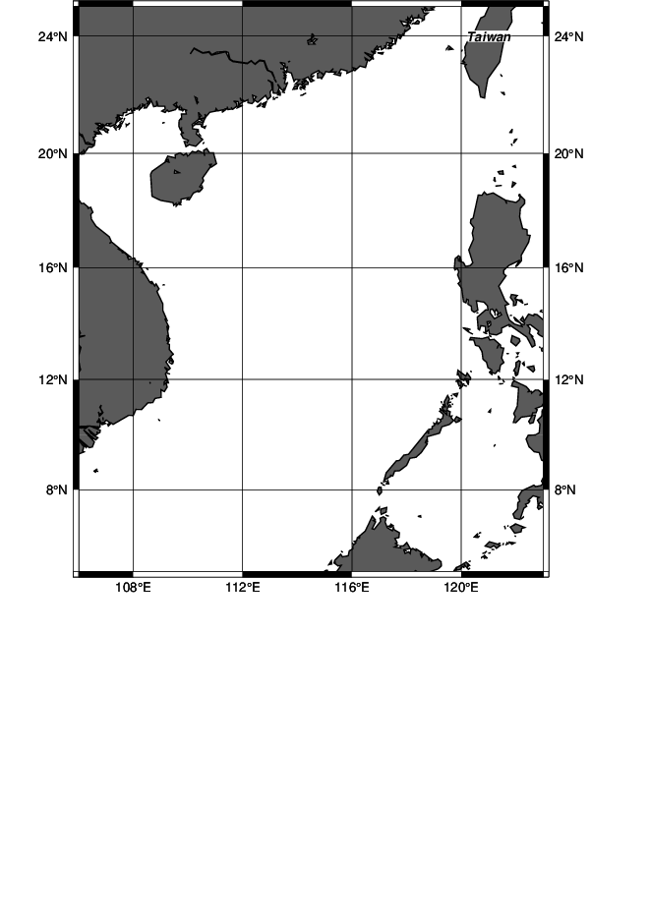

user@meicc-006 /cygdrive/e/GMT_1091_JT

$ pscoast -R106/123/5/25 -JM15c -B4g4 -W1 -G90 -K > W10_ss.ps

user@meicc-006 /cygdrive/e/GMT_1091_JT

$ pstext W10_ss.txt -R -J -B -C0.03/0.03 -W2,blue -G255 -O >> W10_ss.ps

pstext [COMPATIBILITY]: Use of old style pstext input is deprecated.

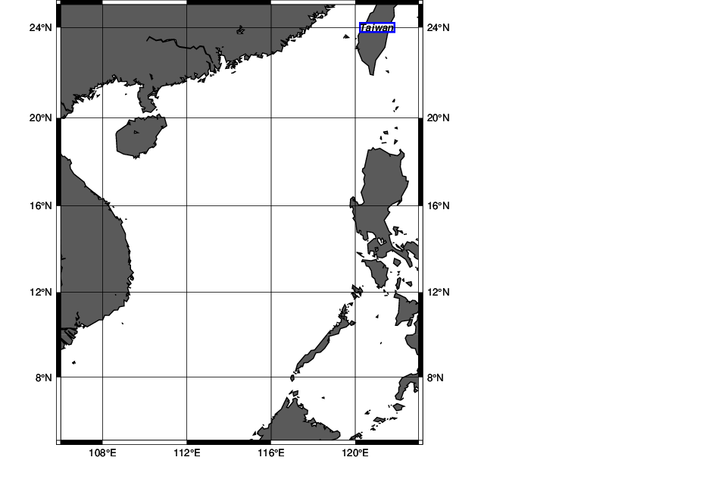

W11 (128GB USB)

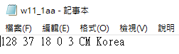 CM:以(中,中)為文字座標中心

(x, y, size, fontno, justify, text)

user@meicc-006 /cygdrive/e/GMT_1091_JT

$ pscoast -R116/134/23/41 -JM15c -B4g4 -W1 -G90 -K > W11_ecs.ps

user@meicc-006 /cygdrive/e/GMT_1091_JT

$ pstext W11_1aa.txt -R -J -C0.02/0.02 -W120/120/120o0.5,cyan -O >> W11_ecs.ps

pstext [COMPATIBILITY]: Use of old style pstext input is deprecated.

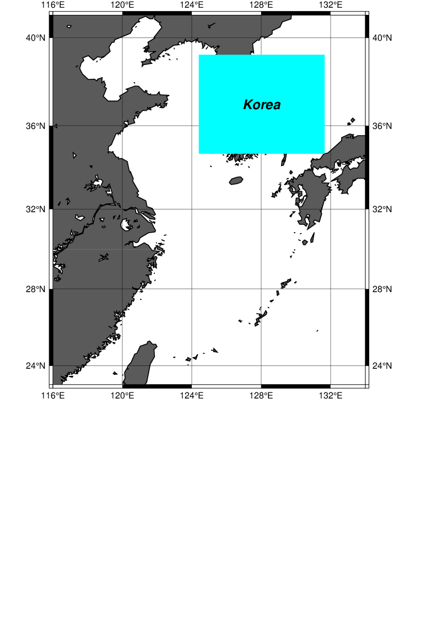

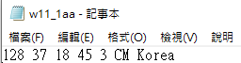把文字傾斜角度從0改為45度

(x, y, size, fontno, justify, text)

字型(fontno)參考 : GMT_Docs.pdf p.190

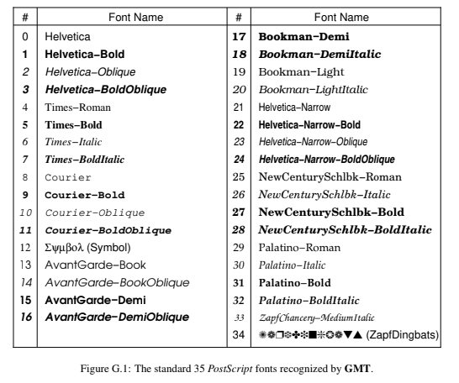

user@meicc-006 /cygdrive/e/GMT_1091_JT

$ pscoast -R116/134/23/41 -JM15c -B4g4 -W1 -G90 -K > W11_ecs.ps

user@meicc-006 /cygdrive/e/GMT_1091_JT

$ pstext W11_1aa.txt -R -J -C0.02/0.02 -W120/120/120 -GDarkred -S5,cyan -O >> W11_ecs.ps

pstext [COMPATIBILITY]: -S option is deprecated; use font pen setting instead.

pstext [COMPATIBILITY]: Use of old style pstext input is deprecated.

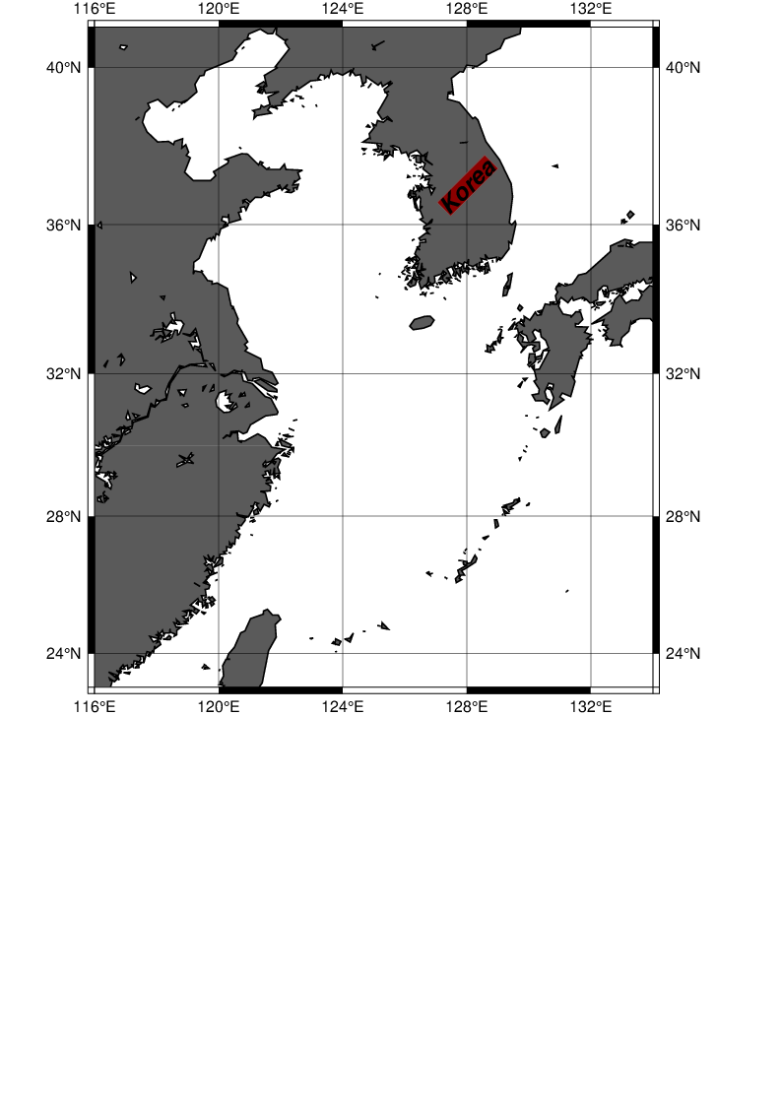

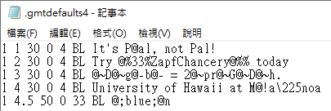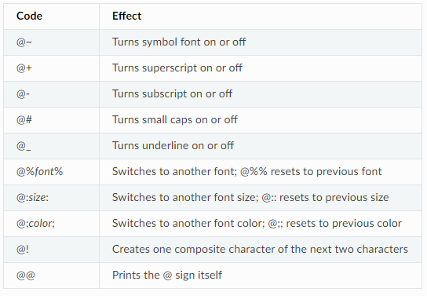

user@meicc-006 /cygdrive/e/GMT_1091_JT

$ pstext .gmtdefaults4.txt -R0/7/0/5 -Jx1i -P -B1g1 -Gwhite > W11_1a.ps

pstext [COMPATIBILITY]: Use of old style pstext input is deprecated.

PSL: Warning: Font-color change not terminated [@;0.000000/0.000000/255.000000;@n]

PSL: Warning: Font-color change not terminated [(null)]

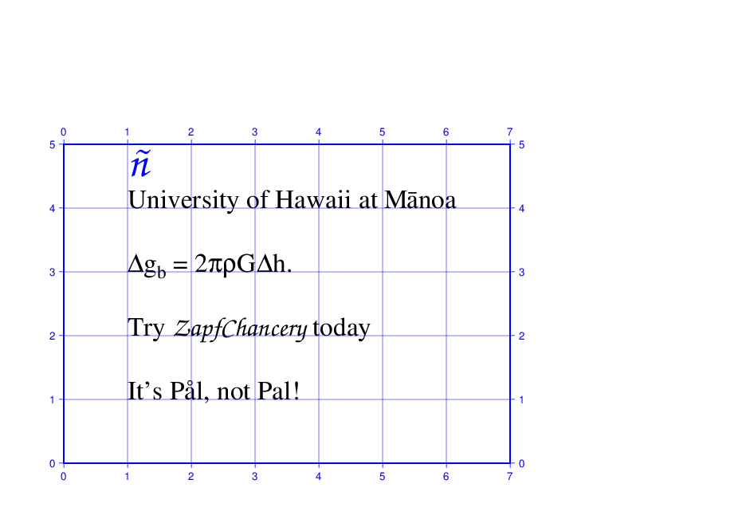

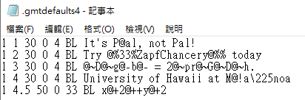

user@meicc-006 /cygdrive/e/GMT_1091_JT

$ pstext .gmtdefaults4.txt -R0/7/0/5 -Jx1i -P -B1g1 -Gwhite > W11_1a.ps

pstext [COMPATIBILITY]: Use of old style pstext input is deprecated.

PSL: Warning: Super-scripting not terminated [x@+2@++y@+2]

PSL: Warning: Super-scripting not terminated [(null)]

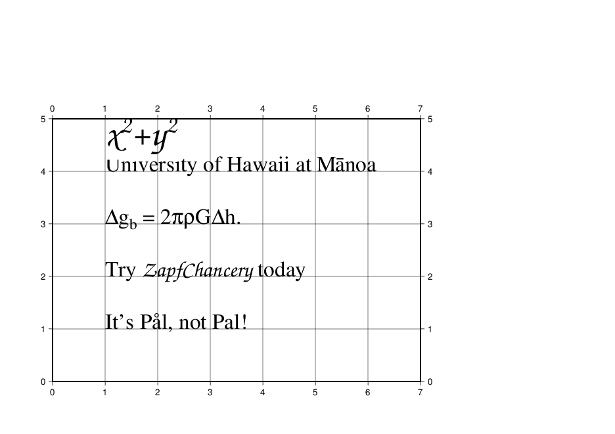

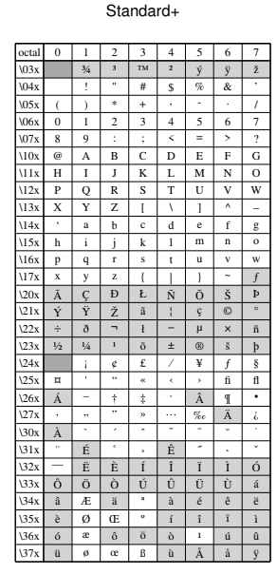 GMT_Docs.pdf p.188

## W12

user@meicc-006 /cygdrive/e/GMT_1091_JT

$ pstext -R0/7/0/7 -Jx1i -B1g1 -GDarkOrange << ! > W12_map1.ps

> 2 4 60 0 3 CM EL@nino

> !

pstext [COMPATIBILITY]: Use of old style pstext input is deprecated.  
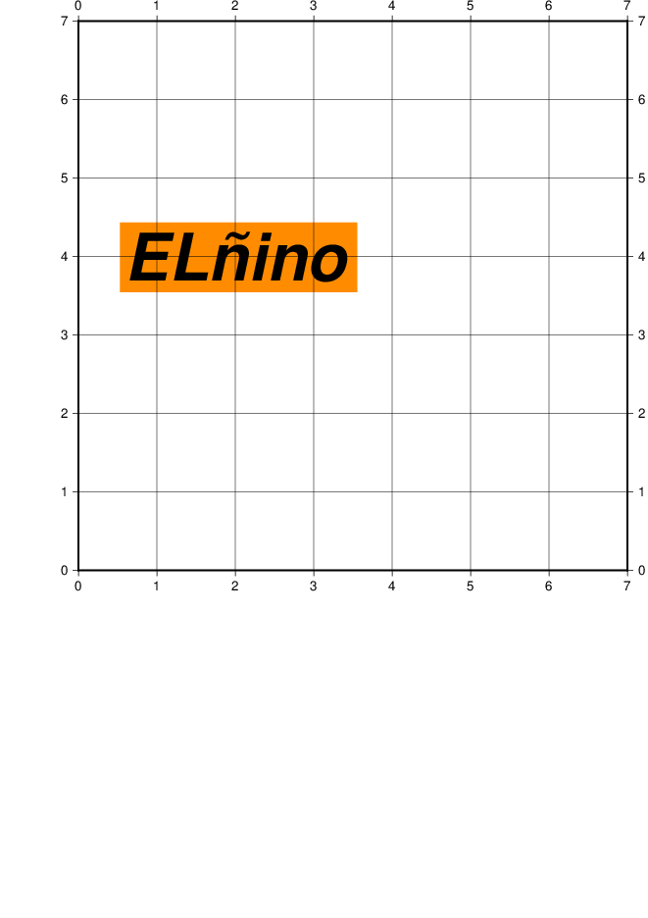

user@meicc-006 /cygdrive/e/GMT_1091_JT

$ pstext -R0/7/0/7 -Jx1i -B1g1 -P << ! > W12_map1.ps

> 2 4 60 0 3 CM EL@nino

> !

pstext [COMPATIBILITY]: Use of old style pstext input is deprecated.  
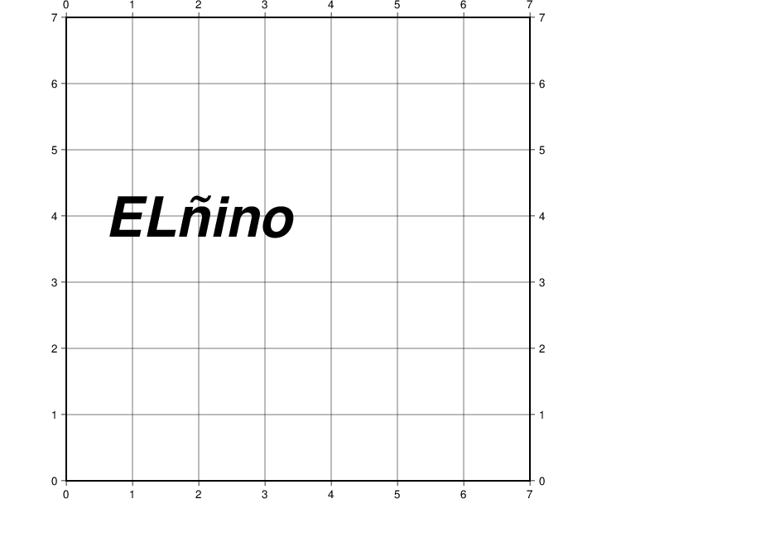

user@meicc-006 /cygdrive/e/GMT_1091_JT

$ pstext W12_map1.txt -R0/7/0/7 -Jx1i -B1g1 -GDarkcyan << ! > W12_map1.ps

> !

pstext [COMPATIBILITY]: Use of old style pstext input is deprecated.  
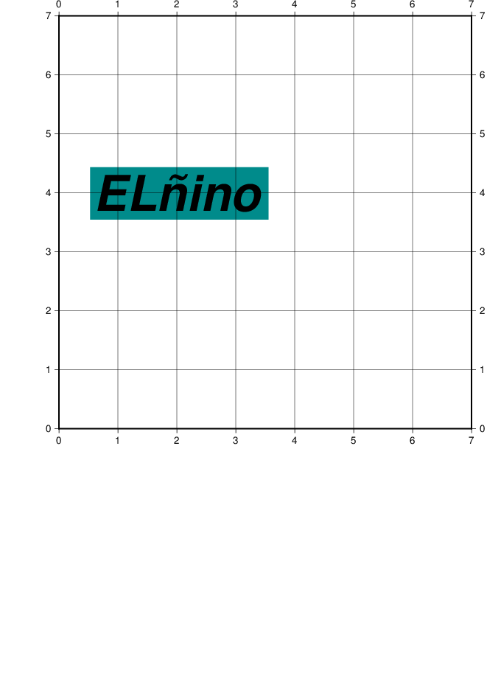

user@meicc-006 /cygdrive/e/GMT_1091_JT

$ pstext -R0/7/0/7 -Jx1i -B1g1 -Darkcyan << ! > W12_map1.ps

> 2 4 60 0 3 CM EL@aino

> !

pstext [COMPATIBILITY]: Use of old style pstext input is deprecated.  
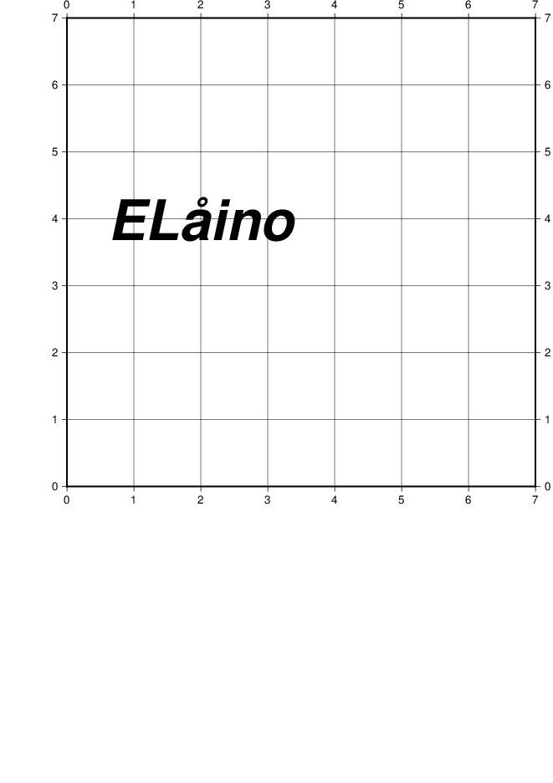

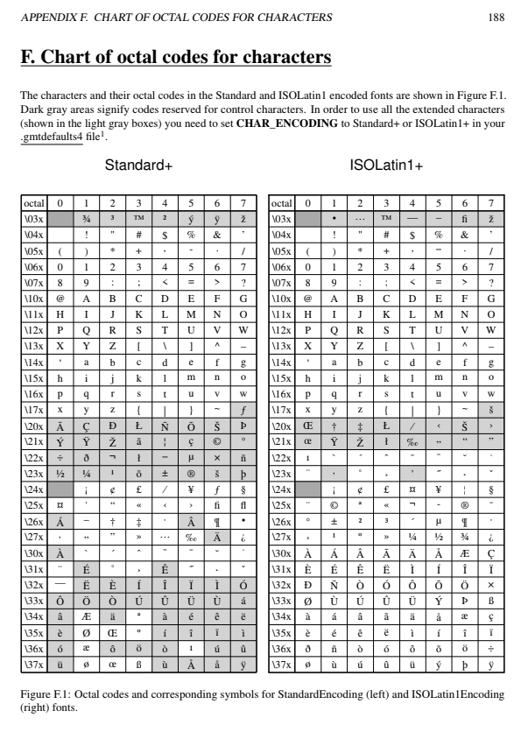

user@meicc-006 /cygdrive/e/GMT_1091_JT

$ gmtset PS_CHAR_ENCODING Standard+

user@meicc-006 /cygdrive/e/GMT_1091_JT

$ pstext -R0/7/0/7 -Jx1i -B1g1 -P << ! > W12_map2.ps

> 4 4 60 0 3 CM @!a\304

> !

pstext [COMPATIBILITY]: Use of old style pstext input is deprecated.  
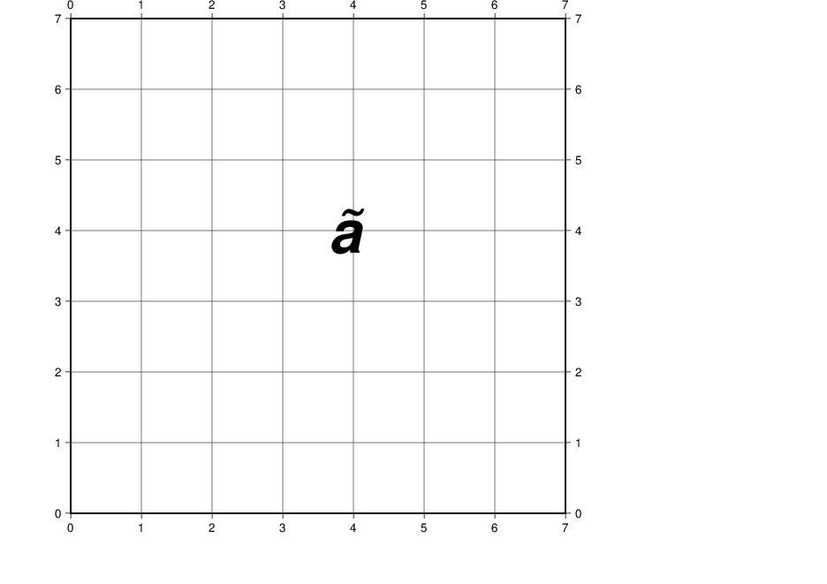

user@meicc-006 /cygdrive/e/GMT_1091_JT

$ pstext -R0/7/0/7 -Jx1i -B1g1 -P << ! > W12_map3.ps

> 4 4 60 0 3 CM @!j\303map

> !

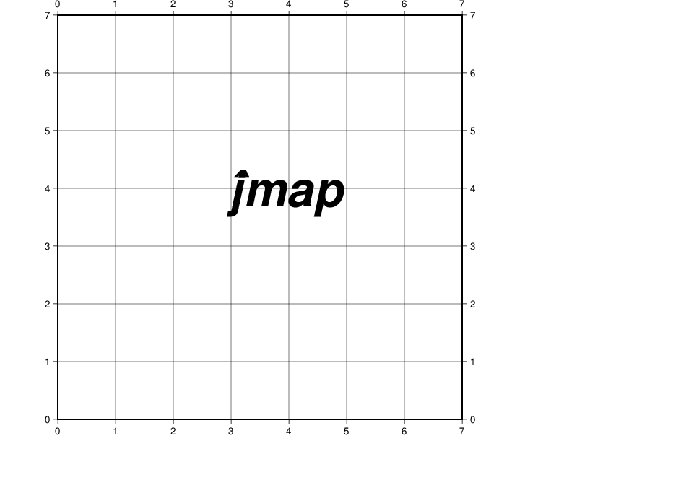

user@meicc-006 /cygdrive/e/GMT_1091_JT

$ pstext -R0/7/0/7 -Jx1i -B1g1 -P << ! > W12_map3.ps

> 4 4 60 0 3 CM @!\242\306

> !

pstext [COMPATIBILITY]: Use of old style pstext input is deprecated.  
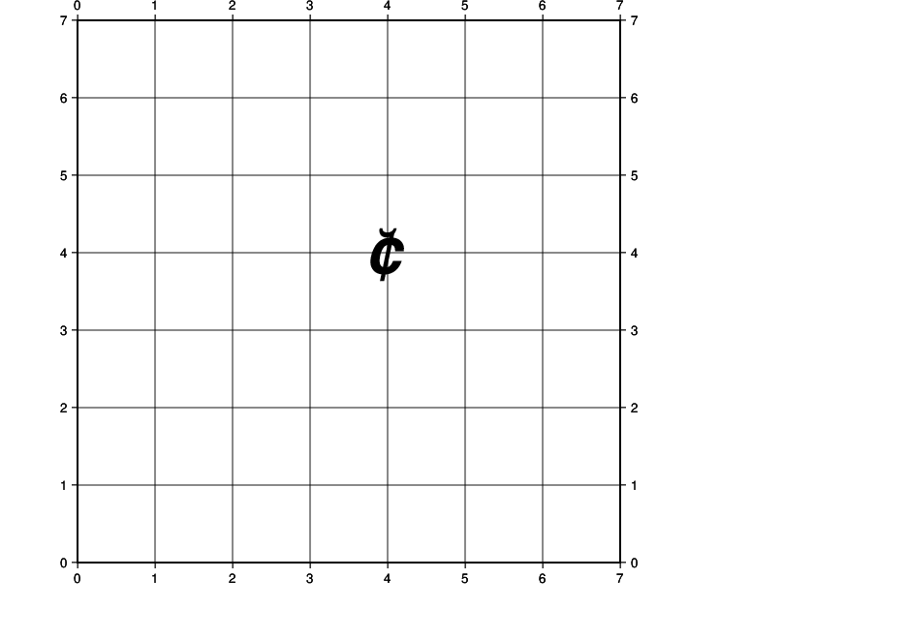

user@meicc-006 /cygdrive/e/GMT_1091_JT

$ gmtset PS_CHAR_ENCODING ISOLatin1+

user@meicc-006 /cygdrive/e/GMT_1091_JT

$ pstext -R0/7/0/7 -Jx1i -B1g1 -P << ! > W12_map4.ps

> 4 4 60 0 3 CM @\214

> !

pstext [COMPATIBILITY]: Use of old style pstext input is deprecated.  
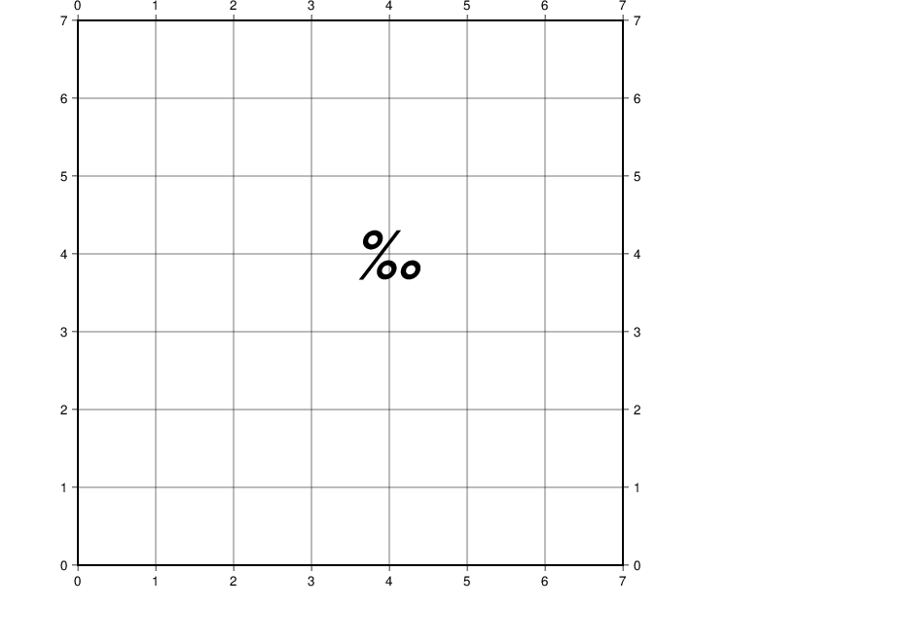

user@meicc-006 /cygdrive/e/GMT_1091_JT

$ pstext -R0/7/0/7 -JX4i -P -B1g1 -X1i -Y2i -K << ! > W12_samepage.ps

> 4 4 60 0 3 CM \216

> !

pstext [COMPATIBILITY]: Use of old style pstext input is deprecated.

user@meicc-006 /cygdrive/e/GMT_1091_JT

$ pscoast -R116/134/23/41 -JM4i -B5g5 -W1 -Ggray -O -X6i >> W12_samepage.ps

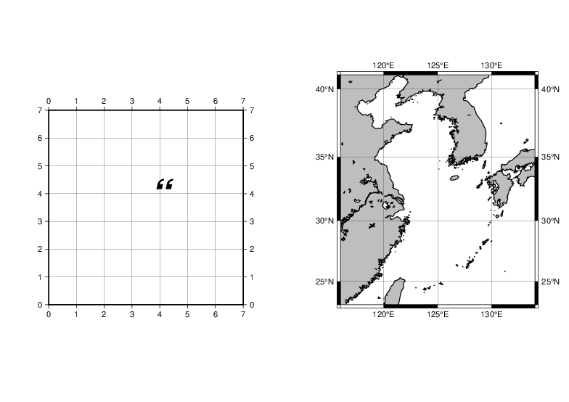

## W13

小考試 : 2021/1/5

期末考 : 2021/1/12斷網路連線openbook

user@meicc-006 ~

$ cd e:\GMT_1091_JT

user@meicc-006 /cygdrive/e/GMT_1091_JT

$ gmt begin

user@meicc-006 /cygdrive/e/GMT_1091_JT

$ gmt text -R0/7/0/5 -Jx1i -B -F+f30p,Times-Roman,Darkorange+jBL << EOF

> 1 3 It's P@al, not Pal!

> 1 2 Try @%33%ZChancery@%% today

> EOF

user@meicc-006 /cygdrive/e/GMT_1091_JT

$ gmt end show

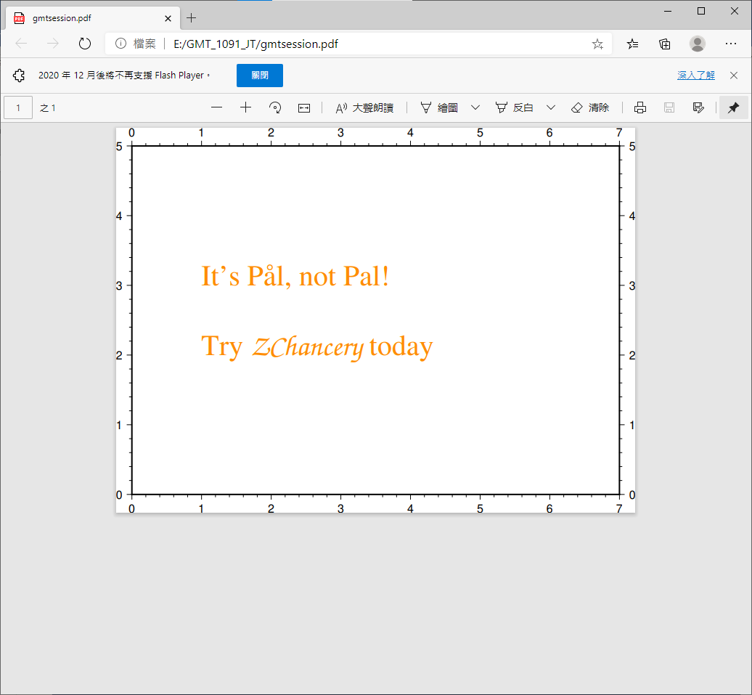

# Tutorial : [SESSION 3](https://docs.generic-mapping-tools.org/6.1/tutorial/session-3.html)

# 3.1 Contouring gridded data sets

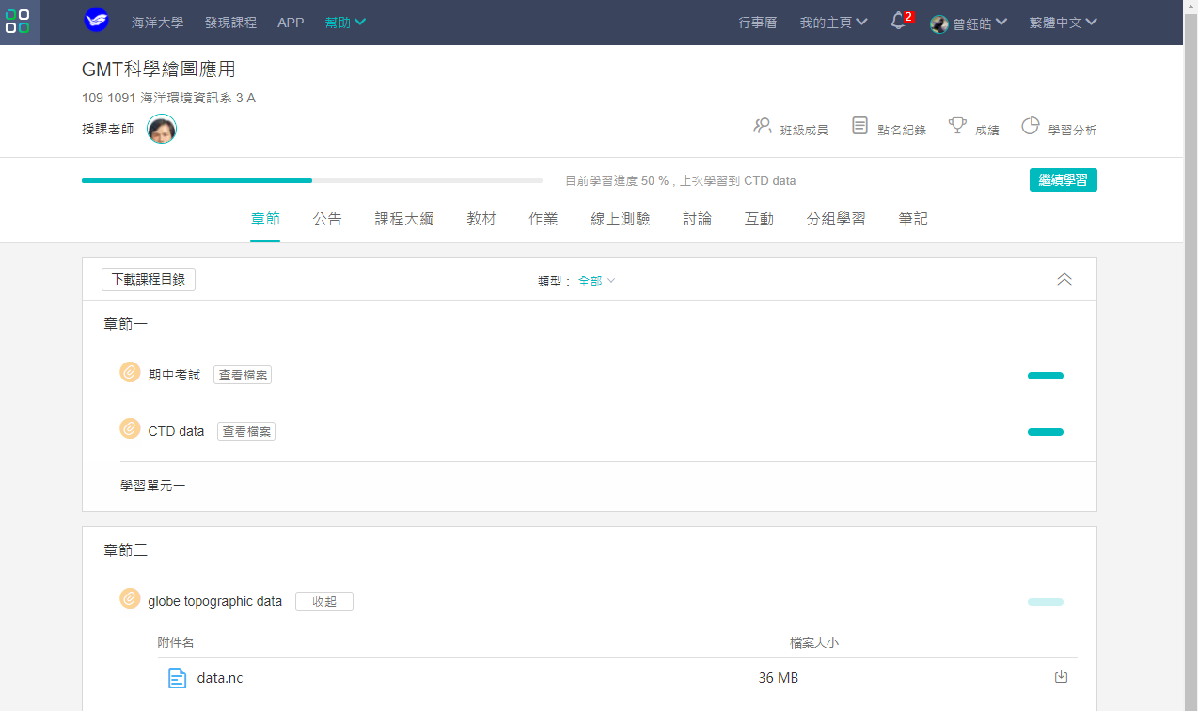  
globe topographic data [data.nc](https://tronclass.ntou.edu.tw/course/77624/learning-activity/full-screen#/245753)

user@meicc-006 /cygdrive/e/GMT_1091_JT

$ ls data.nc

data.nc

user@meicc-006 /cygdrive/e/GMT_1091_JT

$ grdinfo data.nc

data.nc: Title: topography

data.nc: Command:

data.nc: Remark: ETOPO5 5x5 minute Navy bathymetry

data.nc: Gridline node registration used [Cartesian grid]

data.nc: Grid file format: nf = GMT netCDF format (32-bit float), CF-1.7

data.nc: x_min: 0 x_max: 359.916656494 x_inc: 0.083333330978 name: n_columns: 4

320

data.nc: y_min: -90 y_max: 90 y_inc: 0.0833333333333 name: n_rows: 2161

data.nc: z_min: 0 z_max: 0 name: topography [m]

data.nc: scale_factor: 1 add_offset: 0

data.nc: format: classic

grd2xyz data.nc -R106/123/5/23 > scs.txt

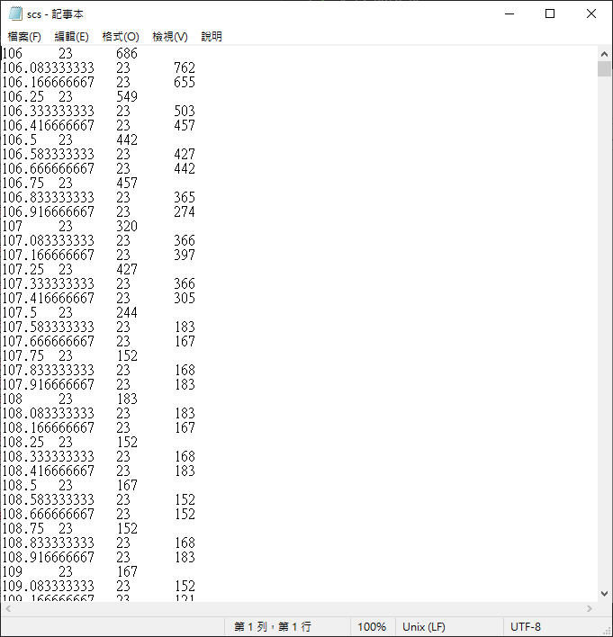

minmax scs.txt

unknown [COMPATIBILITY]: Module minmax is deprecated; use gmtinfo.

scs.txt: N = 44485 <106/123> <5/23> <-5492/2591>

grd2xyz data.nc -R294/300/30/35 > bermuda.txt

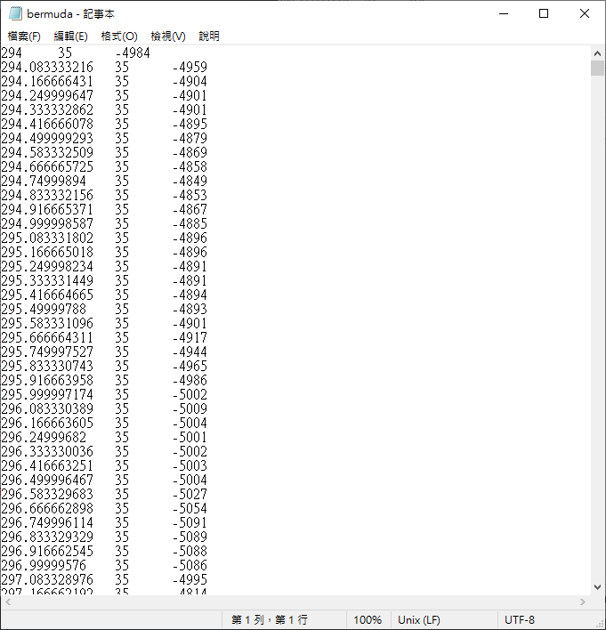

minmax bermuda.txt

unknown [COMPATIBILITY]: Module minmax is deprecated; use gmtinfo.

bermuda.txt: N = 4453 <294/299.999991521> <30/35> <-5475/-89>

xyz2grd bermuda.txt -R294/300/30/35 -I5m -Gbermuda.nc

製造一個grid檔案 [bermuda.nc](http://bermuda.nc)  
grdcontour : Make contour map using a grid  
5m : 5 minute

grdcontour bermuda.nc -R294/300/30/35 -JM15c -C500 -A1000+f12 -P -K -B5 > bermuda.ps

-C500 : contour 間隔  
-A1000f12 : 間隔1000才標數字，字體大小為12

pscoast -R -J -B -G150 -Wthinnest -O >> bermuda.ps

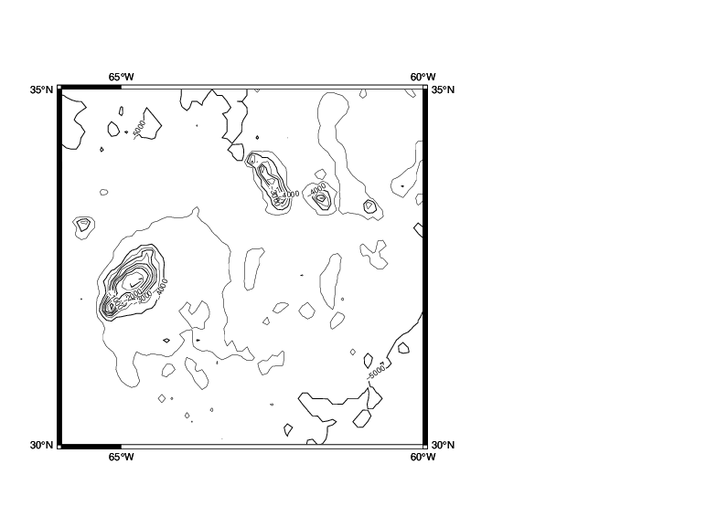

xyz2grd bermuda.txt -R294/300/30/35 -I2.5m -Gbermuda.nc

vi bermuda.txt

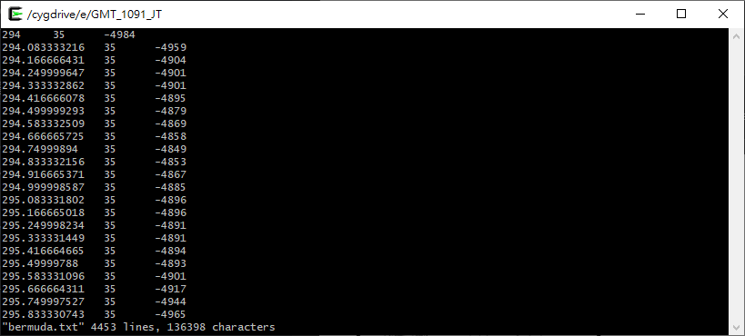

grdcontour data.nc -R294/300/30/35 -JM15c -C500 -A1000+f12 -Q50 -P -K -B5 > bermuda.ps

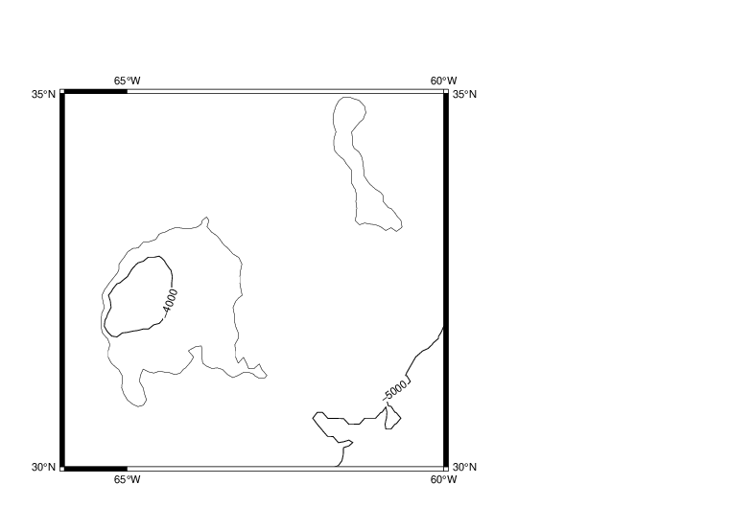

grdcontour data.nc -R294/300/30/35 -JM15c -C500 -A1000+f12 -S30 -Q50 -P -K -B5 > bermuda.ps

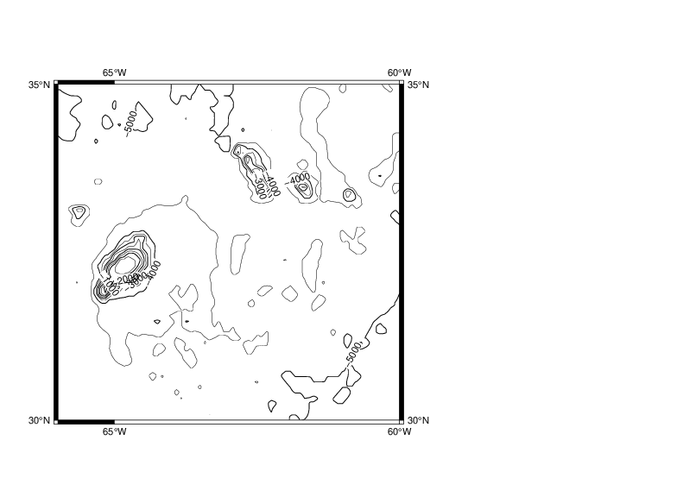

grdcontour data.nc -R106/123/5/23 -JM15c -C500 -A1000+f12 -P -K -B5 > W13_data.ps

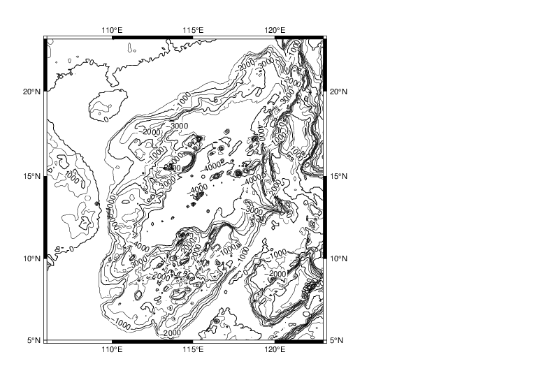

pscoast -R -J -B -G150 -Wthinnest -O >> W13_data.ps

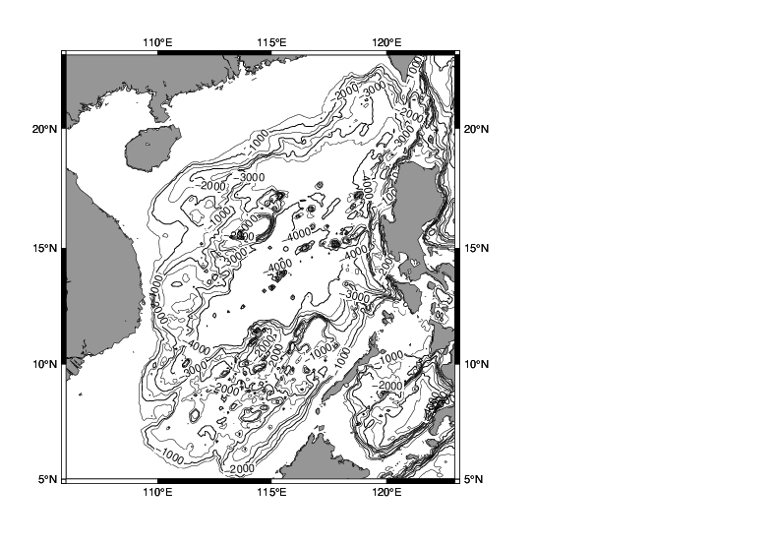

### 畫海底地形圖

user@meicc-006 /cygdrive/e/GMT_1091_JT

$ grd2xyz data.nc -R106/123/5/23 > w13_scs.txt

user@meicc-006 /cygdrive/e/GMT_1091_JT

$ minmax w13_scs.txt

unknown [COMPATIBILITY]: Module minmax is deprecated; use gmtinfo.

w13_scs.txt: N = 44485 <106/123> <5/23> <-5492/2591>

user@meicc-006 /cygdrive/e/GMT_1091_JT

$ xyz2grd w13_scs.txt -R106/123/5/23 -I5m -Gw13_scs.nc

user@meicc-006 /cygdrive/e/GMT_1091_JT

$ grdcontour w13_scs.nc -R106/123/5/23 -JM15c -C500 -A1000+f12 -P -K -B5 > w13_scs.ps

user@meicc-006 /cygdrive/e/GMT_1091_JT

$ pscoast -R -J -B -GChocolate -Wthinnest -O >> w13_scs.ps

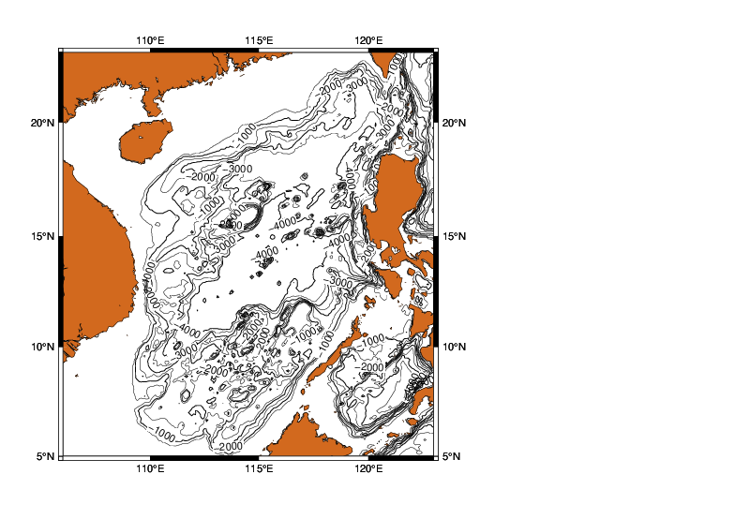

## W14

[3.2 Gridding of arbitrarily spaced data](https://docs.generic-mapping-tools.org/6.1/tutorial/session-3.html#gridding-of-arbitrarily-spaced-data)

下載 ship_5m.xyz  
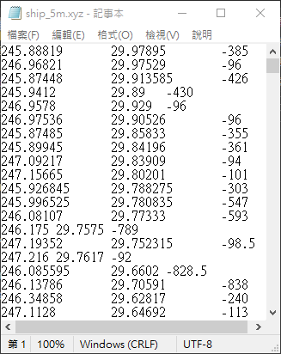

[3.2.1Nearest neighbor gridding](https://docs.generic-mapping-tools.org/6.1/tutorial/session-3.html#nearest-neighbor-gridding)

user@meicc-006 /cygdrive/e/GMT_1091_JT

$ minmax ship_5m.xyz

unknown [COMPATIBILITY]: Module minmax is deprecated; use gmtinfo.

ship_5m.xyz: N = 5850 <245.00309/254.681025> <20.00149/29.97895> <-7392/-19>

user@meicc-006 /cygdrive/e/GMT_1091_JT

$ nearneighbor

輸出nearneighbor的menu

gmt nearneighbor [core] 6.0.0 [64-bit] [MP] - Grid table data using a "Nearest neighbor" algorithm

### 將ship_5m.xyz切出經緯度範圍後，以nearneighbor指令儲存為ship.nc檔，再以grdcontour畫出海底地形圖 W14_ship.ps

user@meicc-006 /cygdrive/e/GMT_1091_JT

$ nearneighbor ship_5m.xyz -R245/255/20/30 -I5m -S40k -Gship.nc

user@meicc-006 /cygdrive/e/GMT_1091_JT

$ grdcontour ship.nc -JM6i -P -B2 -C250 -A1000+f12 > W14_ship.ps

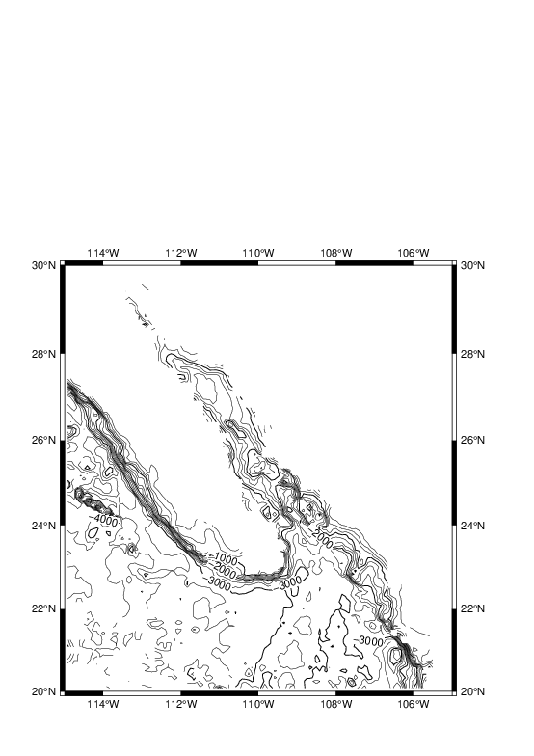

### -S100k (W14_ship.ps)

user@meicc-006 /cygdrive/e/GMT_1091_JT

$ nearneighbor ship_5m.xyz -R245/255/20/30 -I5m -S100k -Gship.nc

user@meicc-006 /cygdrive/e/GMT_1091_JT

$ grdcontour ship.nc -JM6i -P -B2 -C250 -A1000+f12 > W14_ship.ps

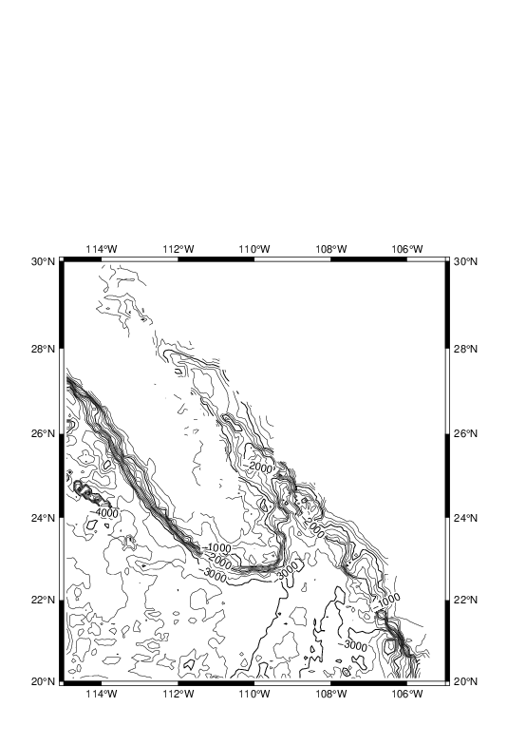

### -Q50

user@meicc-006 /cygdrive/e/GMT_1091_JT

$ nearneighbor ship_5m.xyz -R245/255/20/30 -I5m -S100k -Gship.nc

user@meicc-006 /cygdrive/e/GMT_1091_JT

$ grdcontour ship.nc -JM6i -R -P -B2 -C250 -A1000+f12 -Q50 > W14_ship.ps

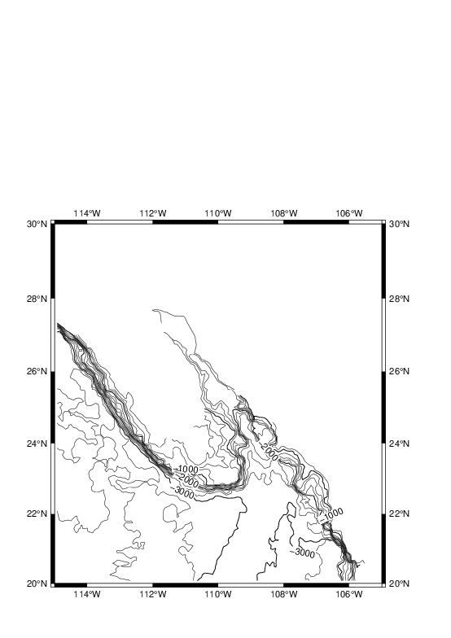

### -I10m -S40k

nearneighbor ship_5m.xyz -R245/255/20/30 -I10m -S40k -Gship.nc

grdcontour ship.nc -JM6i -R -P -B2 -C250 -A1000+f12 -Q50 > W14_ship.ps

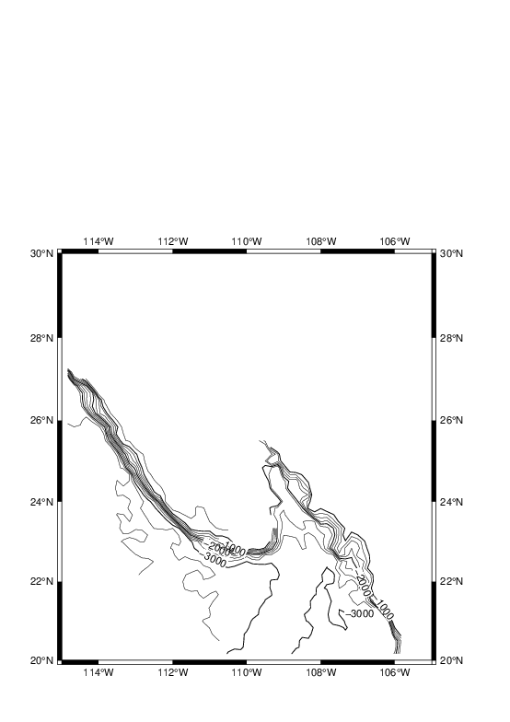

### -S100k

nearneighbor ship_5m.xyz -R245/255/20/30 -I10m -S100k -Gship.nc

grdcontour ship.nc -JM6i -R -P -B2 -C250 -A1000+f12 -Q50 > W14_ship.ps

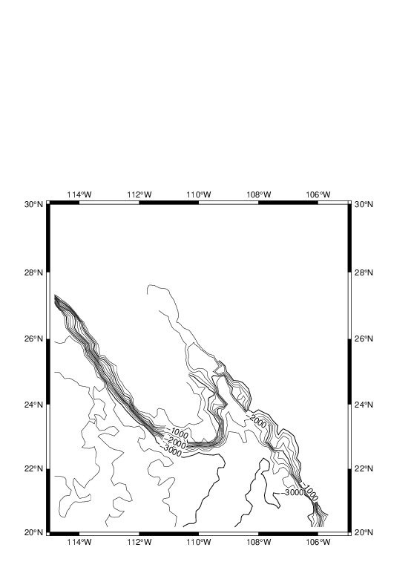

### -I5m -N5/5 -S40k

nearneighbor ship_5m.xyz -R245/255/20/30 -I5m -N5/5 -S40k -Gship.nc

grdcontour ship.nc -JM6i -P -B2 -C250 -A1000+f12 > W14_ship.ps

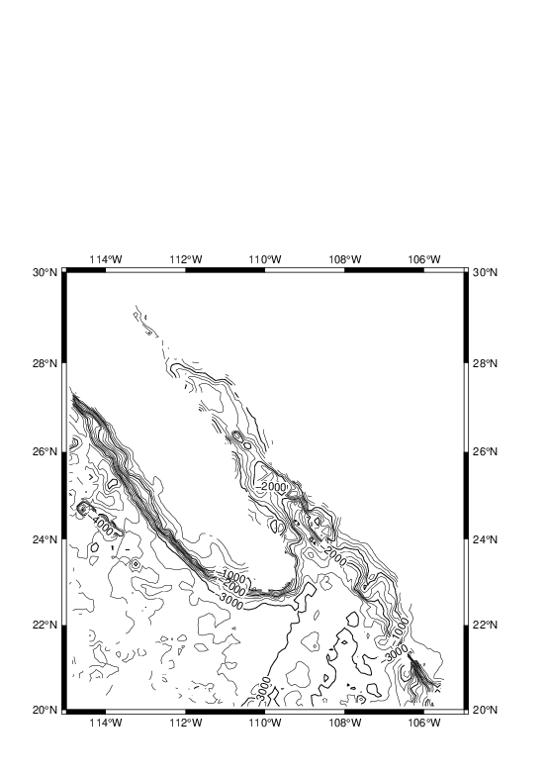

user@meicc-006 /cygdrive/e/GMT_1091_JT

$ nearneighbor ship_5m.xyz -R245/255/20/30 -I5m -E-500 -S40k -Gship.nc

user@meicc-006 /cygdrive/e/GMT_1091_JT

$ grdcontour ship.nc -JM6i -P -B2 -C250 -A1000+f12 > W14_ship.ps

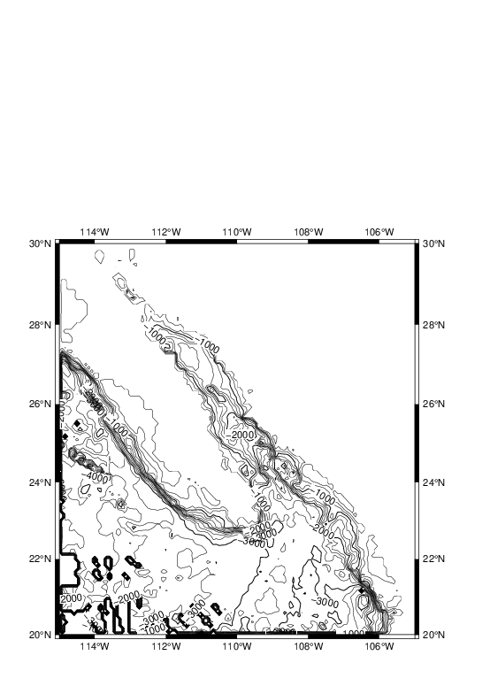

user@meicc-006 /cygdrive/e/GMT_1091_JT

$ nearneighbor ship_5m.xyz -R245/255/20/30 -I5m -S40k -Gship.nc

user@meicc-006 /cygdrive/e/GMT_1091_JT

$ grdcontour ship.nc -JM6i -P -B2 -C500 -A1000+f12 > W14_ship.ps

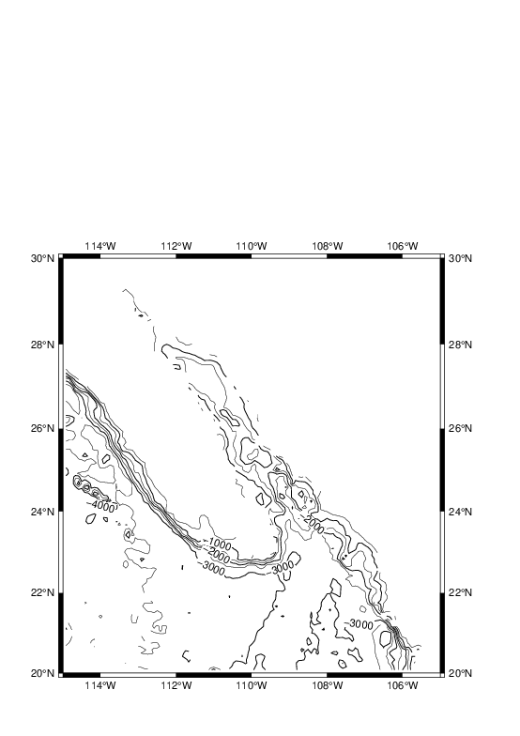

user@meicc-006 /cygdrive/e/GMT_1091_JT

$ nearneighbor ship_5m.xyz -R245/255/20/30 -I5m -S40k -Gship.nc

user@meicc-006 /cygdrive/e/GMT_1091_JT

$ grdcontour ship.nc -JM6i -P -B2 -C500 -A1000+f12 -K > W14_ship.ps

user@meicc-006 /cygdrive/e/GMT_1091_JT

$ pscoast -R -J -B -G140 -Wthinnest -O >> W14_ship.ps

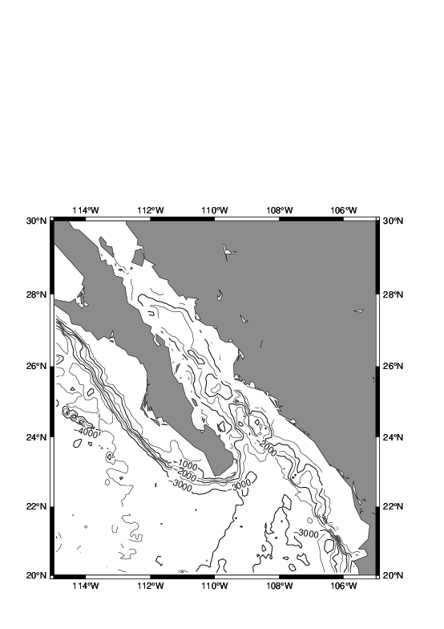

user@meicc-006 /cygdrive/e/GMT_1091_JT

$ nearneighbor ship_5m.xyz -R245/255/20/30 -I5m -S40k -Gship.nc

user@meicc-006 /cygdrive/e/GMT_1091_JT

$ grdcontour ship.nc -JM6i -P -B2 -C500 -A1000+f12 -Tl+d0.1c -Q10 -K > W14_ship.ps

user@meicc-006 /cygdrive/e/GMT_1091_JT

$ pscoast -R -J -B -G140 -Wthinnest -O >> W14_ship.ps

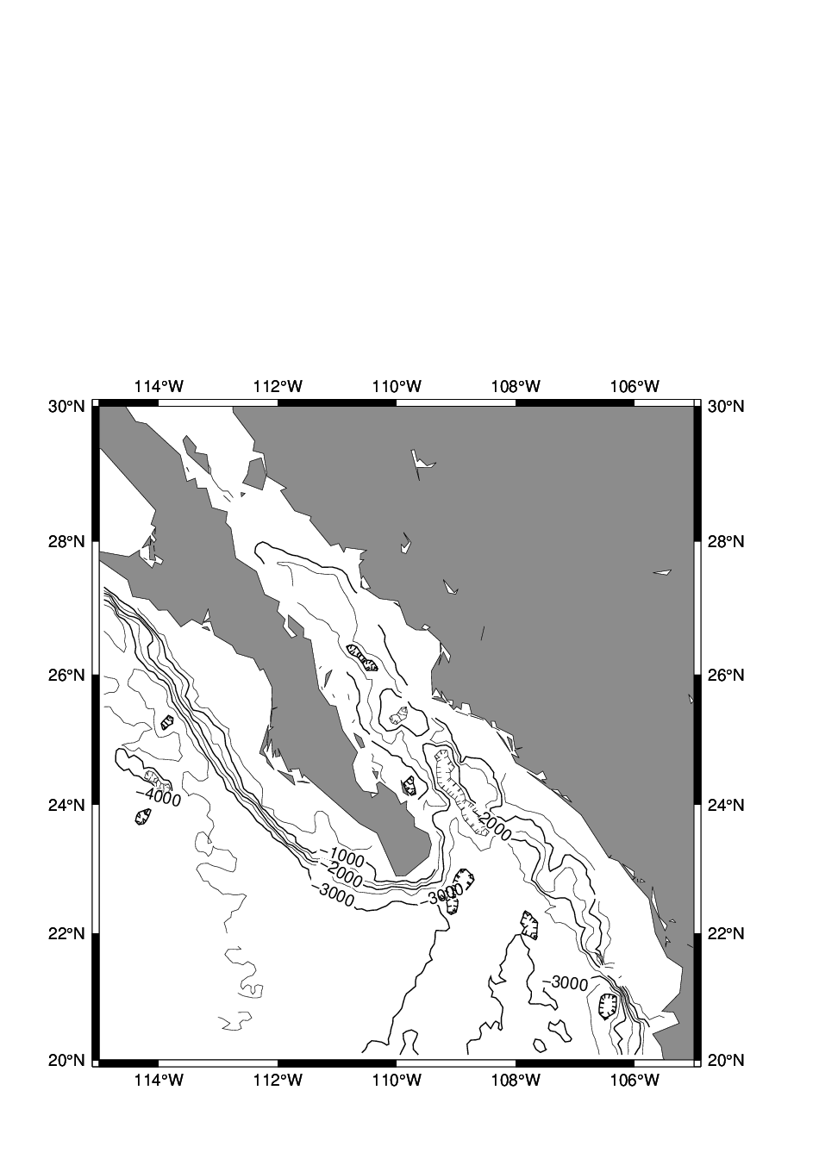

user@meicc-006 /cygdrive/e/GMT_1091_JT

$ nearneighbor ship_5m.xyz -R245/255/20/30 -I5m -S40k -Gship.nc

user@meicc-006 /cygdrive/e/GMT_1091_JT

$ grdcontour ship.nc -JM6i -P -B2 -C500 -A1000+f12 -Th+d0.1c -Q10 -K > W14_ship.ps

user@meicc-006 /cygdrive/e/GMT_1091_JT

$ pscoast -R -J -B -G140 -Wthinnest -O >> W14_ship.ps

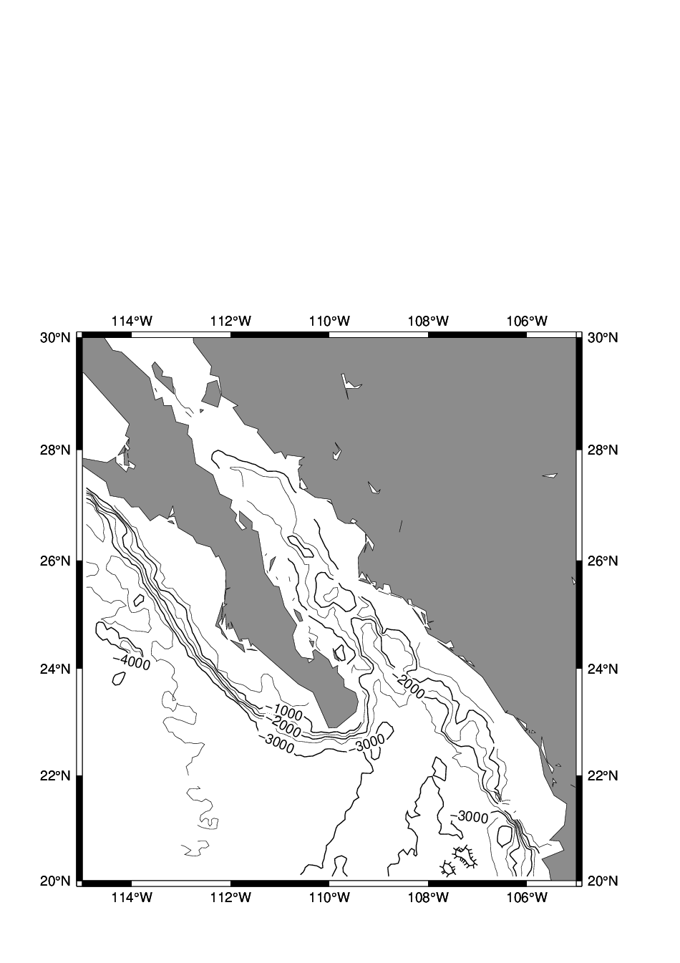

user@meicc-006 /cygdrive/e/GMT_1091_JT

$ nearneighbor ship_5m.xyz -R245/255/20/30 -I5m -S40k -Gship.nc

user@meicc-006 /cygdrive/e/GMT_1091_JT

$ grdcontour ship.nc -JM6i -P -B2 -C500 -A1000+f12 -Th+d0.1c -Q10 -S10 -K > W14_ship.ps

user@meicc-006 /cygdrive/e/GMT_1091_JT

$ pscoast -R -J -B -G140 -Wthinnest -O >> W14_ship.ps

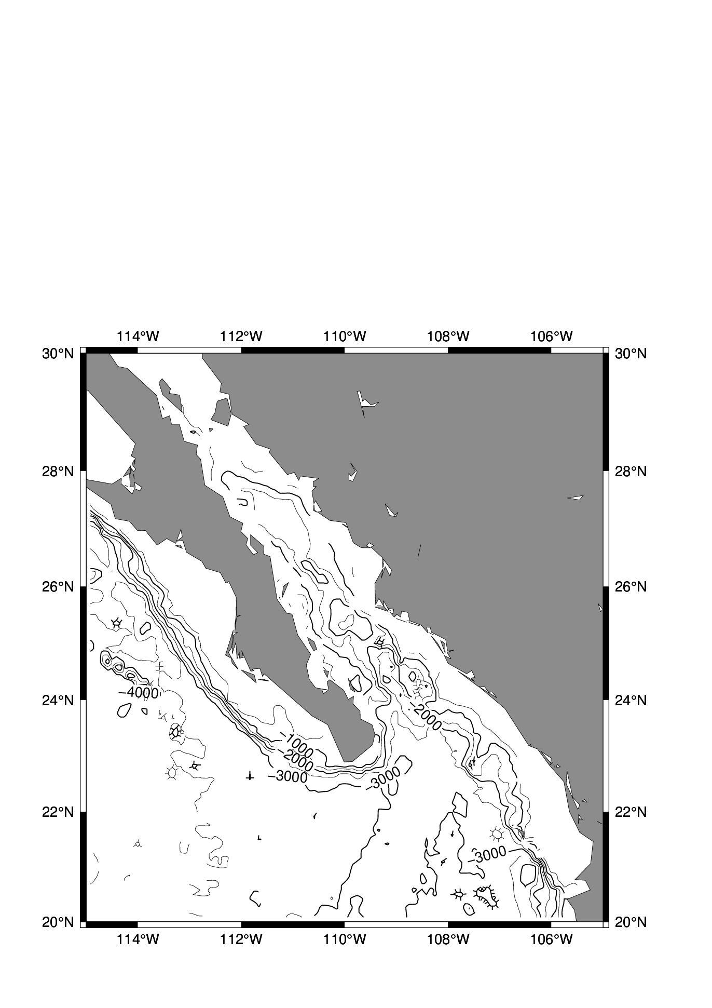

user@meicc-006 /cygdrive/e/GMT_1091_JT

$ xyz2grd ship_5m.xyz -R245/255/20/30 -I5m -Gship.nc

user@meicc-006 /cygdrive/e/GMT_1091_JT

$ grdcontour ship.nc -JM6i -P -B2 -C500 -A1000+f12 -Th+d0.1c -Q10 -S10 > W14_ship.ps

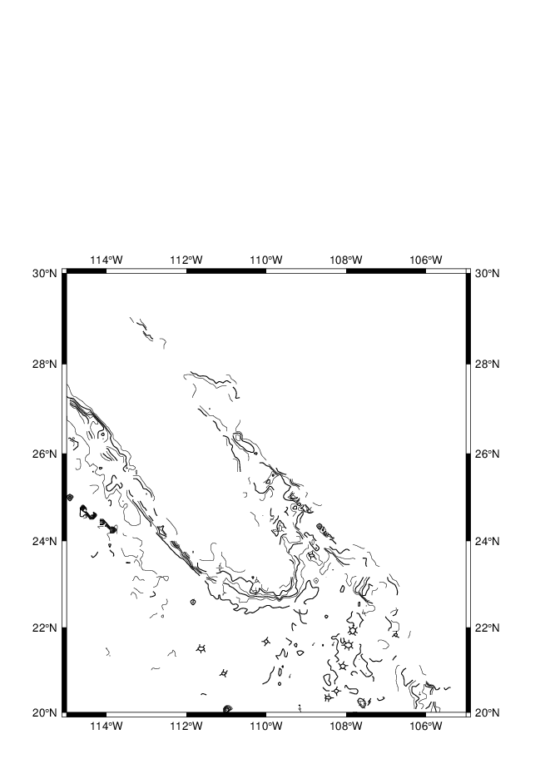

user@meicc-006 /cygdrive/e/GMT_1091_JT

$ xyz2grd ship_5m.xyz -R245/255/20/30 -I10m -Gship.nc

user@meicc-006 /cygdrive/e/GMT_1091_JT

$ grdcontour ship.nc -JM6i -P -B2 -C500 -A1000+f12 -Th+d0.1c -Q10 -S10 > W14_ship.ps

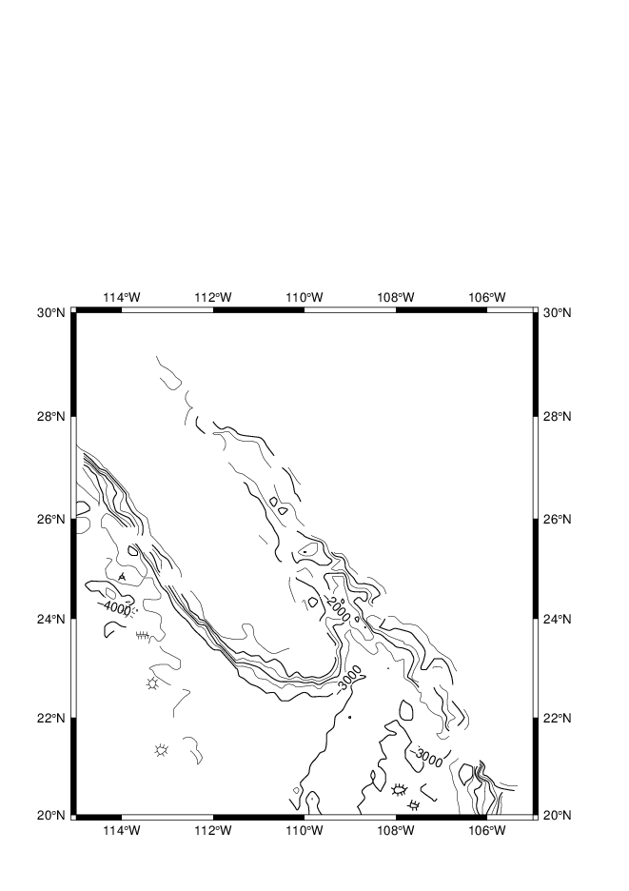

user@meicc-006 /cygdrive/e/GMT_1091_JT

$ xyz2grd ship_5m.xyz -R245/255/20/30 -I20m -Gship.nc

user@meicc-006 /cygdrive/e/GMT_1091_JT

$ grdcontour ship.nc -JM6i -R -P -B2 -C500 -A1000+f12 -Th+d0.1c -Q10 -S10 > W14_ship.ps

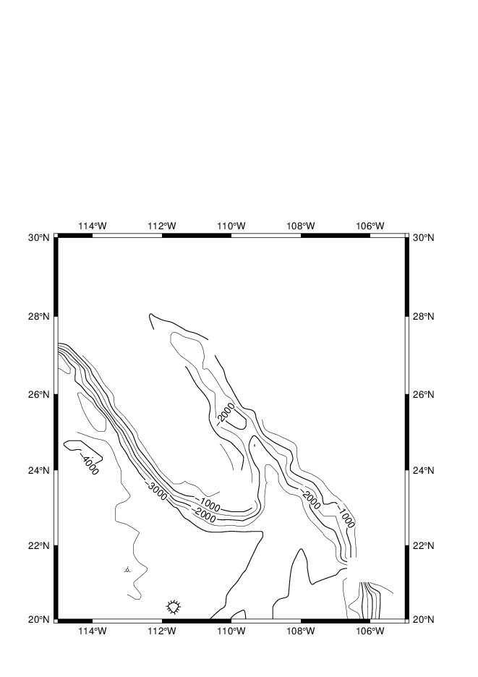

#### [3.2.3 Preprocessing](https://docs.generic-mapping-tools.org/6.1/tutorial/session-3.html#preprocessing)

xyz2grd, nearneighbor 和 surface 是畫格點的三大天王，畫contour要經過這三個指令。

user@meicc-006 /cygdrive/e/GMT_1091_JT

$ blockmean ship_5m.xyz -R245/255/20/30 -I5m -V > W14_ship_5m.b

user@meicc-006 /cygdrive/e/GMT_1091_JT

$ surface W14_ship_5m.b -R245/255/20/30 -I5m -Gship.nc

user@meicc-006 /cygdrive/e/GMT_1091_JT

$ grdcontour ship.nc -JM6i -R -P -B2 -C500 -A1000+f12 -Th+d0.1c -Q10 -S10 > W14_ship.ps

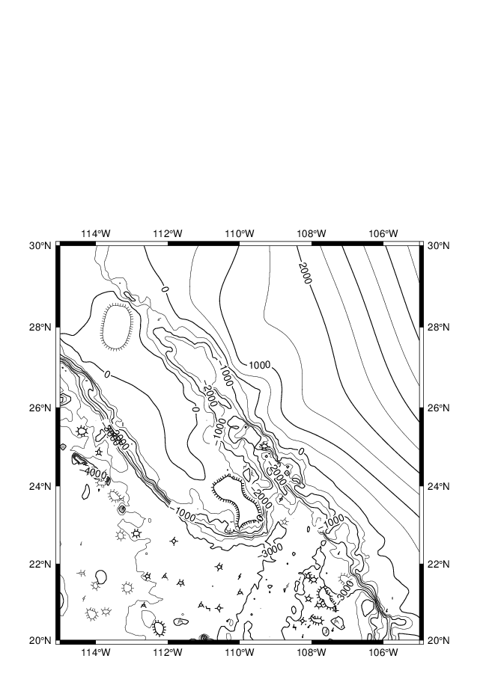

user@meicc-006 /cygdrive/e/GMT_1091_JT

$ blockmean ship_5m.xyz -R245/255/20/30 -I5m -V > W14_ship_5m.b

user@meicc-006 /cygdrive/e/GMT_1091_JT

$ surface W14_ship_5m.b -R245/255/20/30 -I2.5m -Gship.nc

user@meicc-006 /cygdrive/e/GMT_1091_JT

$ grdcontour ship.nc -JM6i -R -P -B2 -C500 -A1000+f12 -Th+d0.1c -Q10 -S10 -K > W14_ship.ps

user@meicc-006 /cygdrive/e/GMT_1091_JT

$ pscoast -R -J -B -Gcyan -Wthinnest -O >> W14_ship.ps

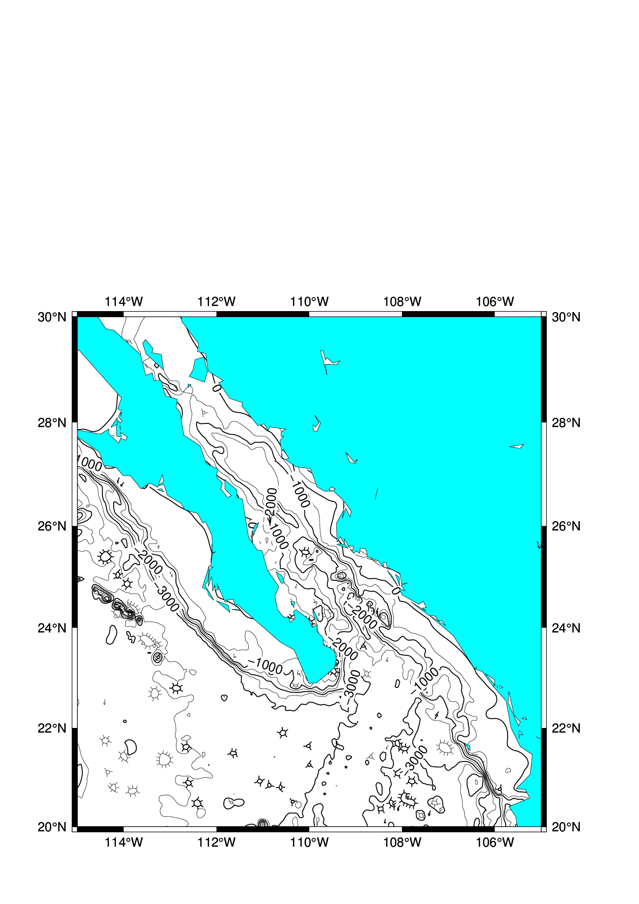

## W15

### 資料前處理選項

| **Preprocessors** | **function** | **A rule of thumb** |
| --- | --- | --- |
| blockmean | averages values inside the grid-spacing boxes | use means for most smooth data (such as potential fields) |
| blockmedian | returns median values | use medians (or modes) for rough, non-Gaussian data (such as topography) |
| blockmode | returns modal values | use modes(or medians) for rough, non-Gaussian data (such as topography) |

minmax ship_5m.xyz

unknown [COMPATIBILITY]: Module minmax is deprecated; use gmtinfo.  
ship_5m.xyz: N = 5850 <245.00309/254.681025> <20.00149/29.97895> <-7392/-19>

blockmean ship_5m.xyz -R245/255/20/30 -I5m > W15_ship_5m.txt

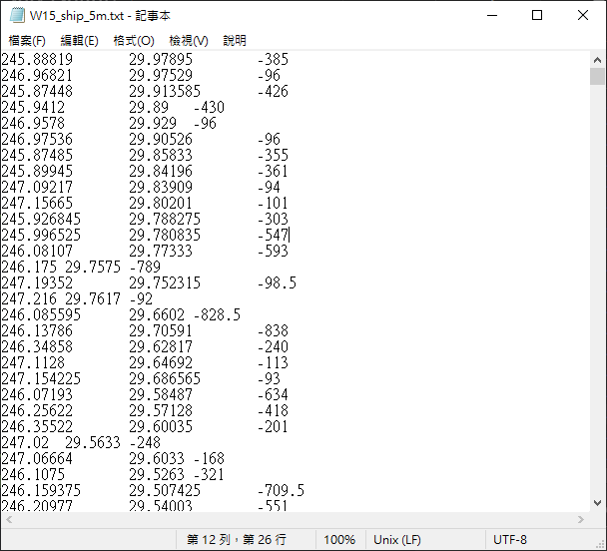

surface W15_ship_5m.txt -R245/255/20/30 -I5m -Gship.nc

存為檔案 : [ship.nc](http://ship.nc)

grdcontour ship.nc -R245/255/20/30 -JM6i -B2 -C250 -A1000 > W15_map.ps

245o等同於360o−245o=115o  
255o等同於360o−245o=105o  
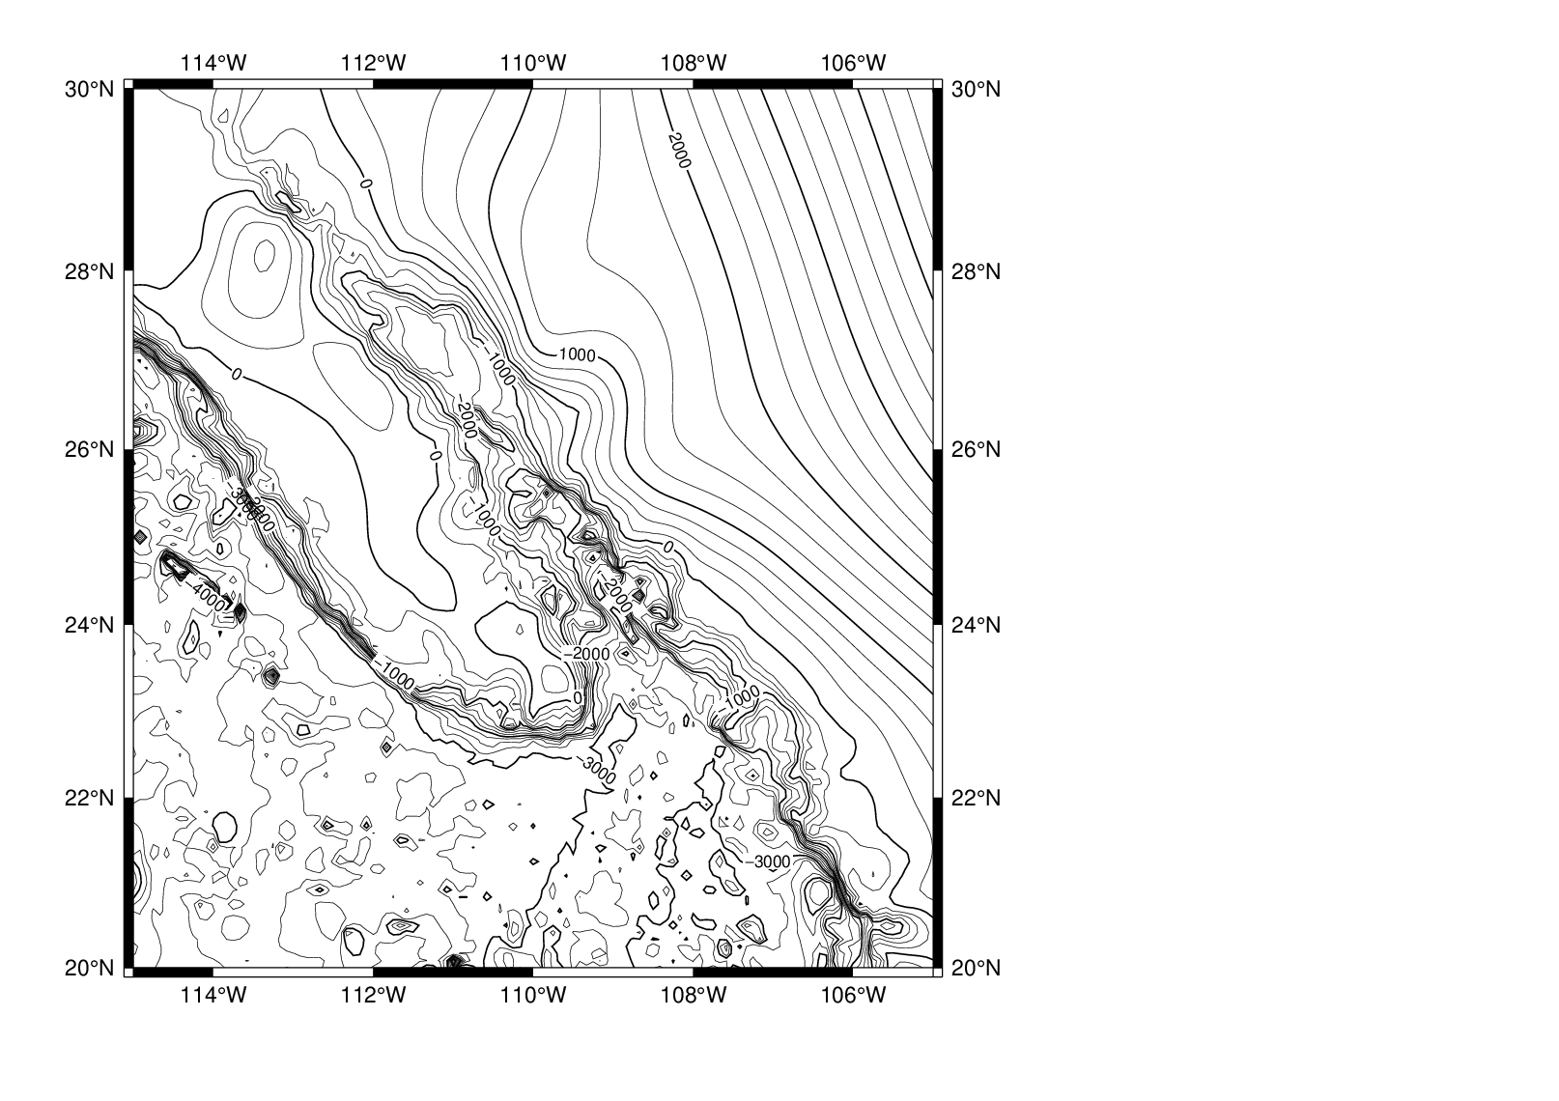

### [psmask](https://docs.generic-mapping-tools.org/6.1/psmask.html?highlight=psmask) : Clip or mask map areas with no data table coverage

user@meicc-006 /cygdrive/e/GMT_1091_JT

$ psmask W15_ship_5m.txt -R245/255/20/30 -JM6i -I5m -B2 -P -K > W15_map.ps

user@meicc-006 /cygdrive/e/GMT_1091_JT

$ grdcontour ship.nc -J -R -C250 -A1000 -Q30 -K -O >> W15_map.ps

user@meicc-006 /cygdrive/e/GMT_1091_JT

$ psmask -R -J -C -O >> W15_map.ps

-C : 取消遮罩  
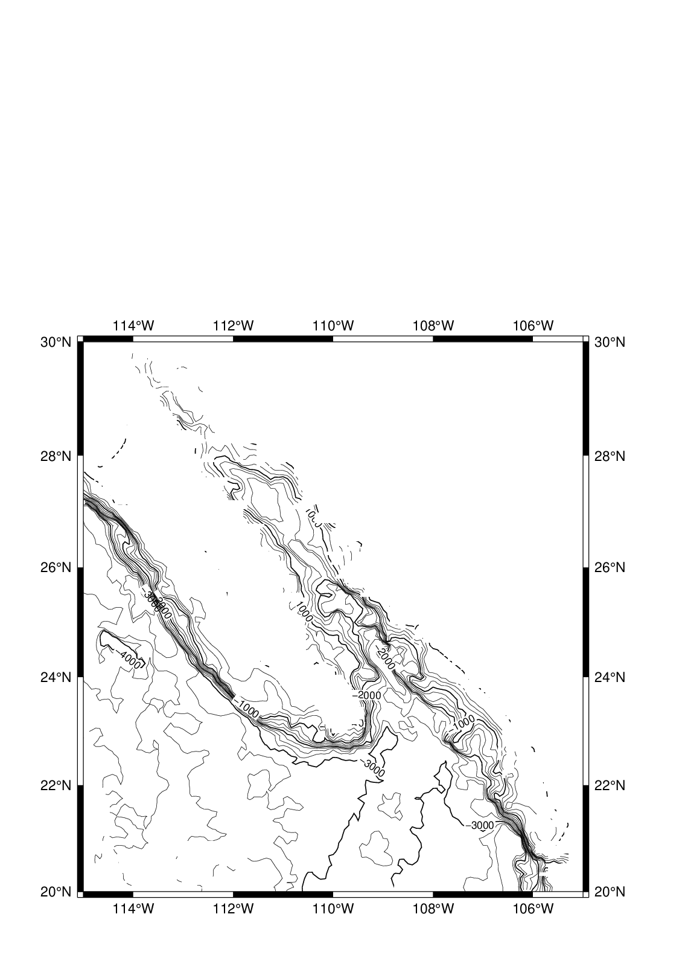

### psmask ( -Ggray )

可看出遮罩範圍

psmask W15_ship_5m.txt -R245/255/20/30 -JM6i -I5m -B2 -P -Ggray -K > W15_map.ps

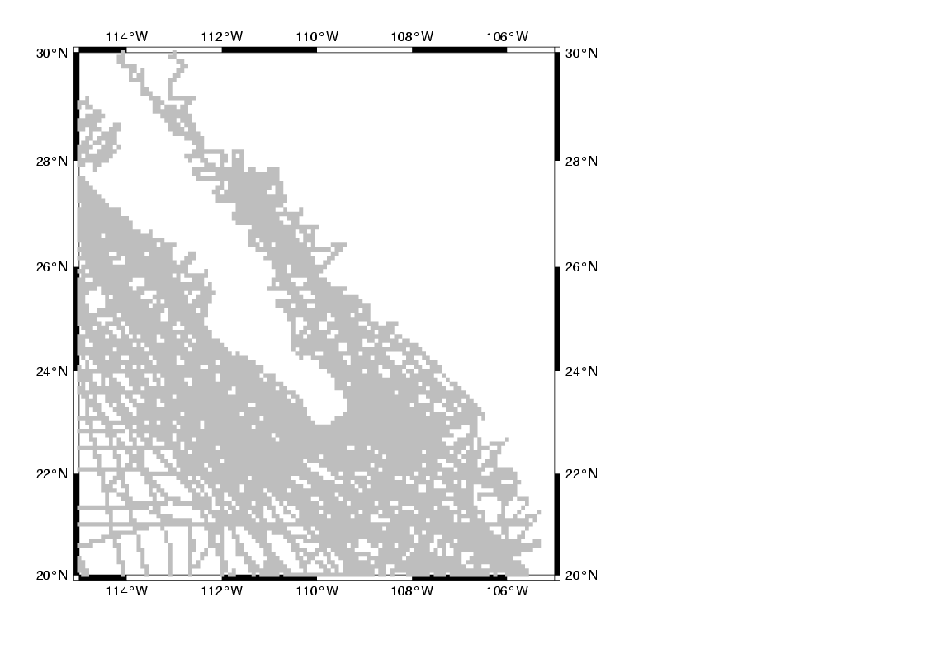

grdcontour ship.nc -J -R -C250 -A1000 -Q30 -K -O >> W15_map.ps

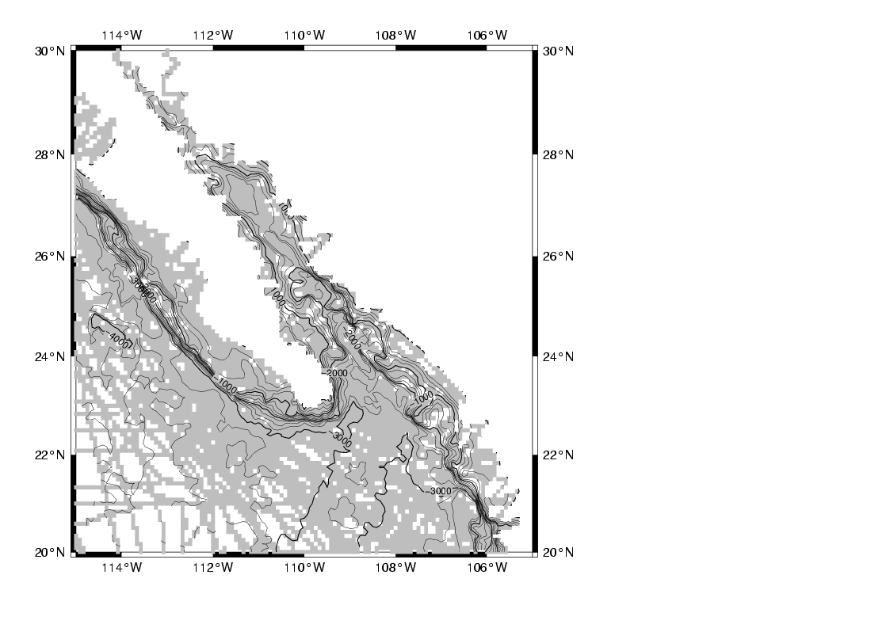

psmask -R -J -C -O >> W15_map.ps

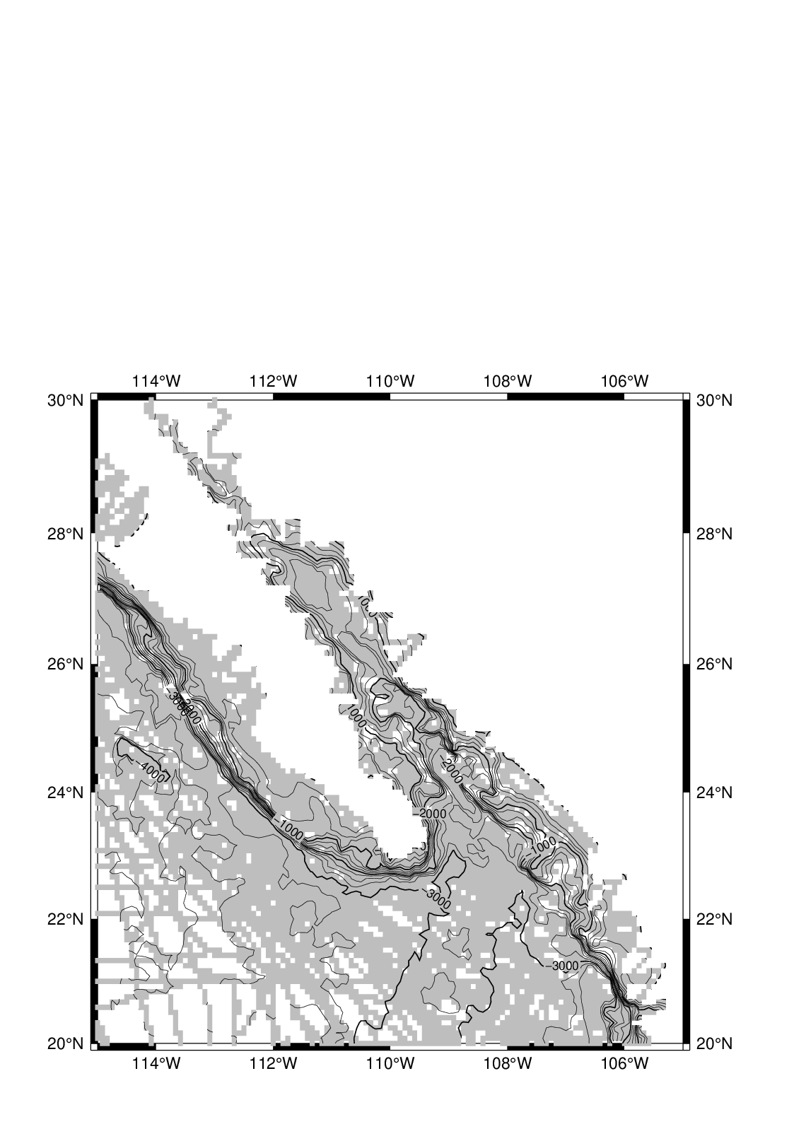

user@meicc-006 /cygdrive/e/GMT_1091_JT

$ psmask W15_ship_5m.txt -R245/255/20/30 -JM6i -I5m -B2 -P -K > W15_map.ps

user@meicc-006 /cygdrive/e/GMT_1091_JT

$ grdcontour ship.nc -J -R -C250 -A1000 -Q30 -K -O >> W15_map.ps

user@meicc-006 /cygdrive/e/GMT_1091_JT

$ psmask -R -J -C -O -K >> W15_map.ps

user@meicc-006 /cygdrive/e/GMT_1091_JT

$ pscoast -R -J -B -Gcyan -Wthinnest -O >> W15_map.ps

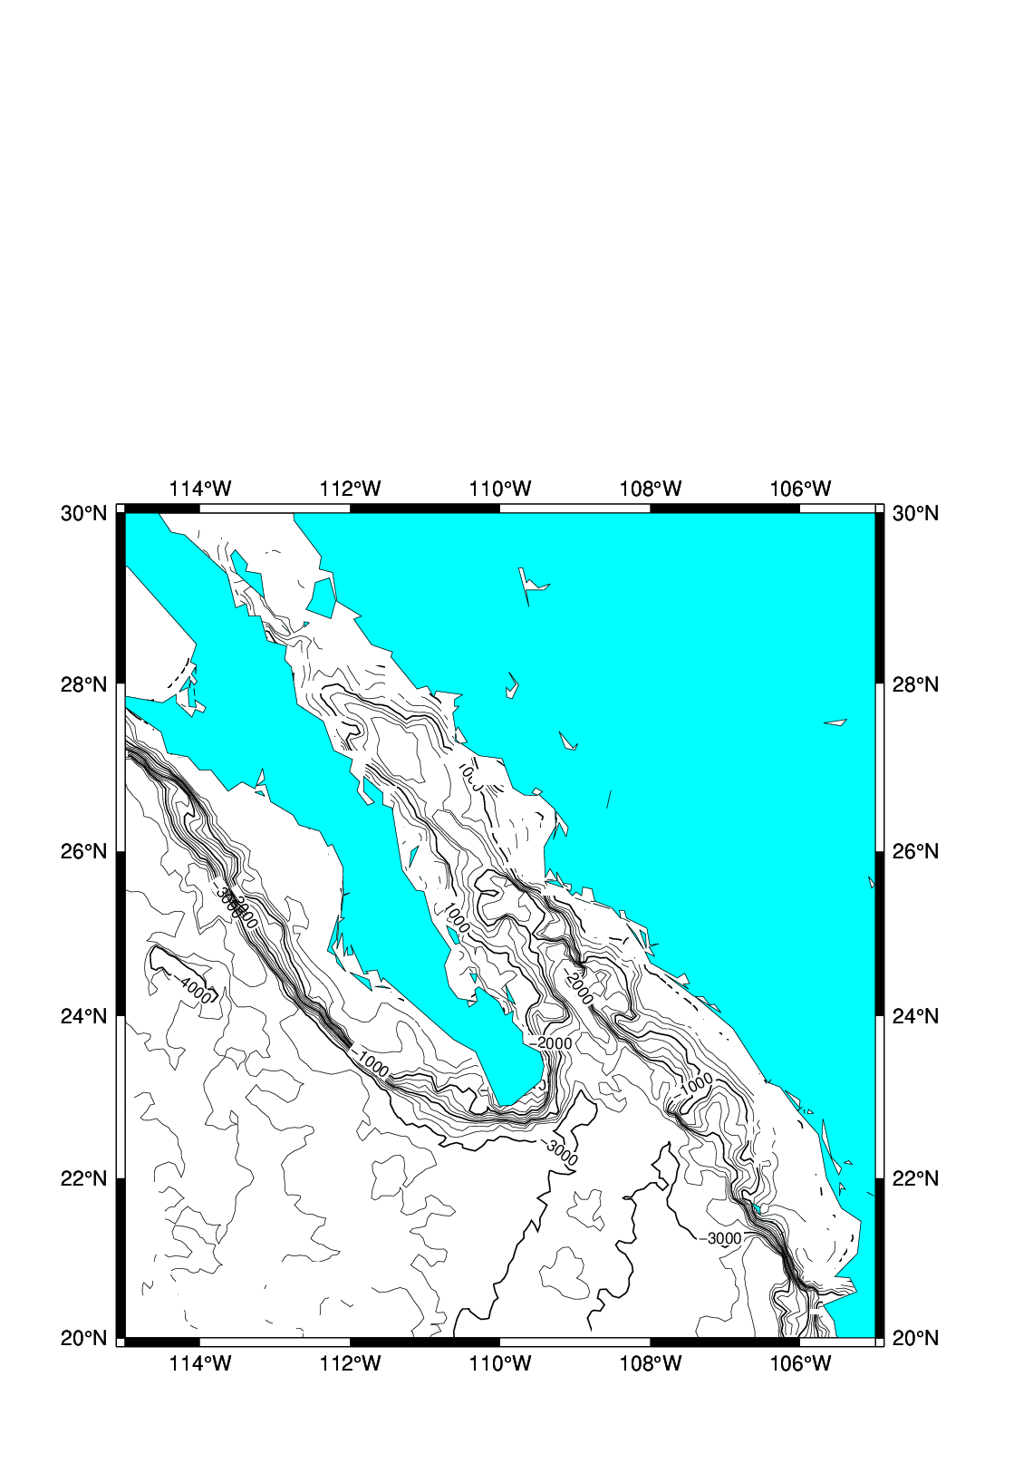

### 巨集指令 : 存成bat檔(W15_map.bat)

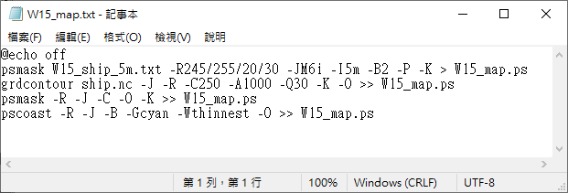  
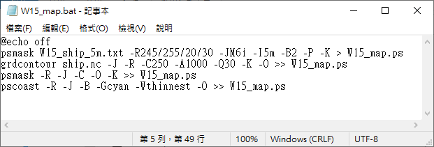

user@meicc-006 /cygdrive/e/GMT_1091_JT

$ ./W15_map.bat



### 巨集指令 : 存成bat檔 (W15_map_ship.bat)

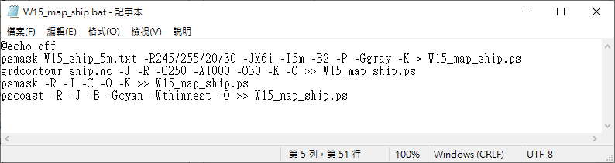

user@meicc-006 /cygdrive/e/GMT_1091_JT

$ ./W15_map_ship.bat

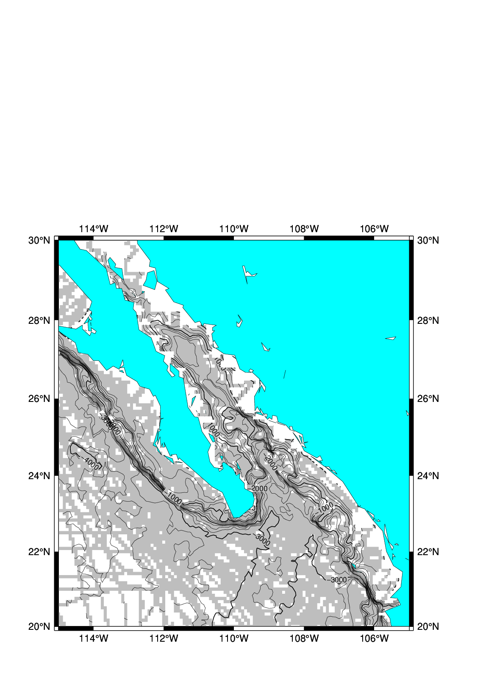

### W15_map_ship_all.bat

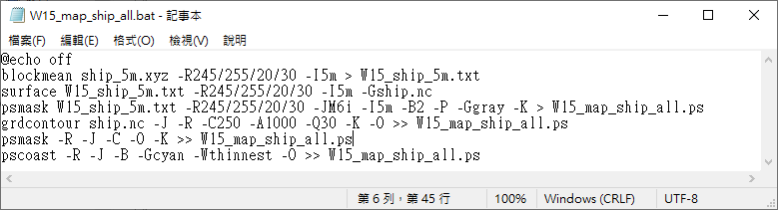

user@meicc-006 /cygdrive/e/GMT_1091_JT

$ ./W15_map_ship_all.bat

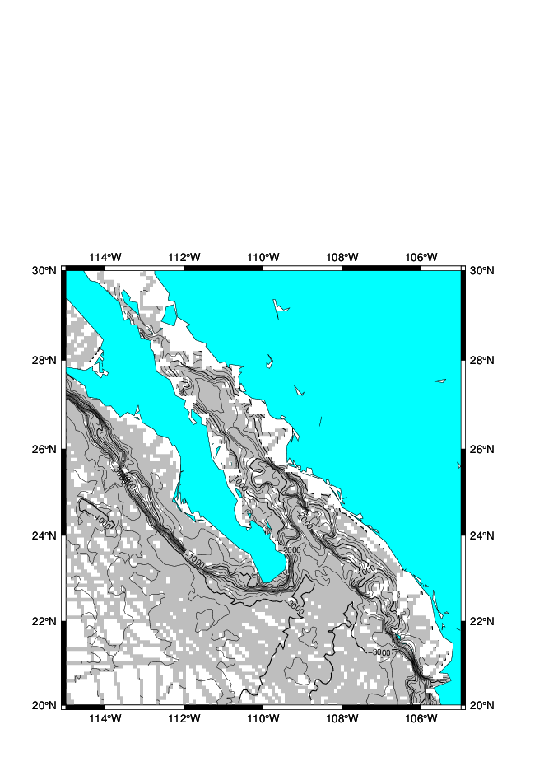

### 色階指令(makecpt)

<https://docs.generic-mapping-tools.org/6.1/tutorial/session-4.html#session-four>

user@meicc-006 /cygdrive/e/GMT_1091_JT

$ makecpt -Crainbow -T-20/60/10 > W15_disc.cpt

預設 : 分段色階(discrete)  
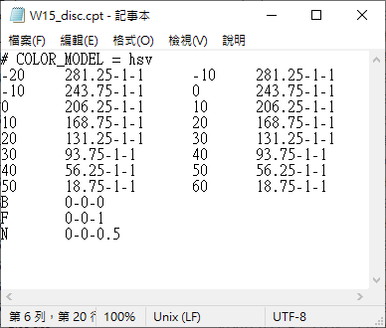

### 色階指令(makecpt)，加上-Z

user@meicc-006 /cygdrive/e/GMT_1091_JT

$ makecpt -Crainbow -T-20/60/10 -Z > W15_cont.cpt

-Z : 連續色階(continuous)  
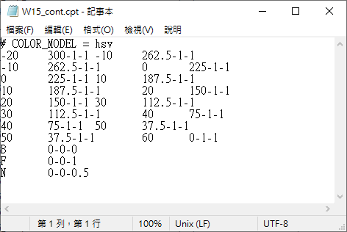

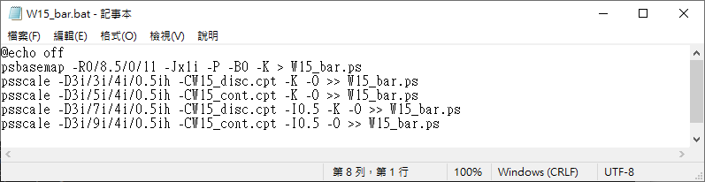

user@meicc-006 /cygdrive/e/GMT_1091_JT

$ ./W15_bar.bat

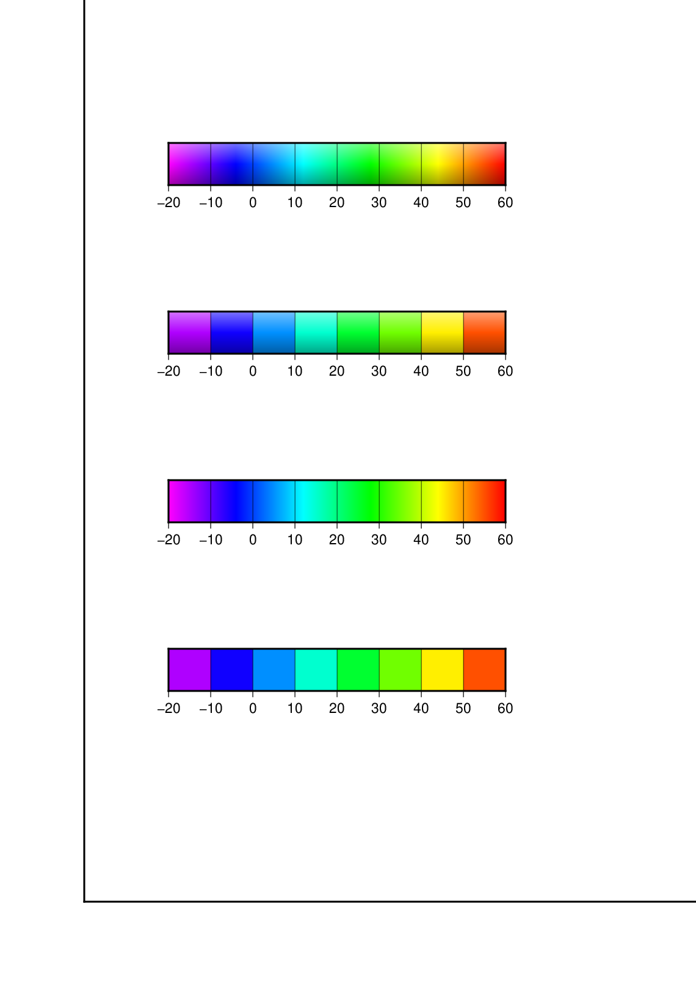

### 將等深線加上色階

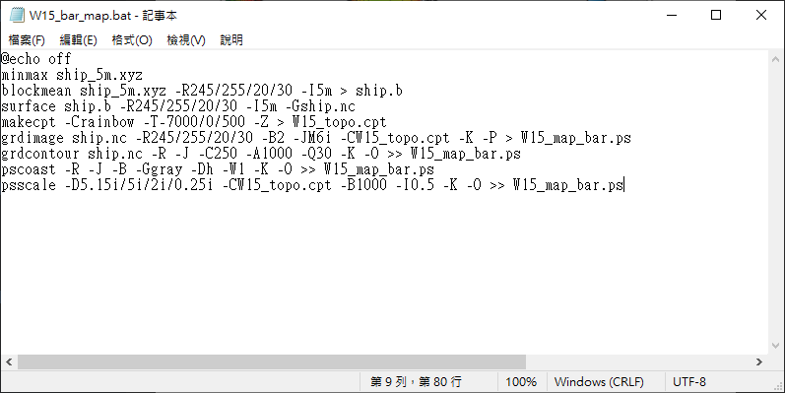

user@meicc-006 /cygdrive/e/GMT_1091_JT

$ ./W15_bar_map.bat

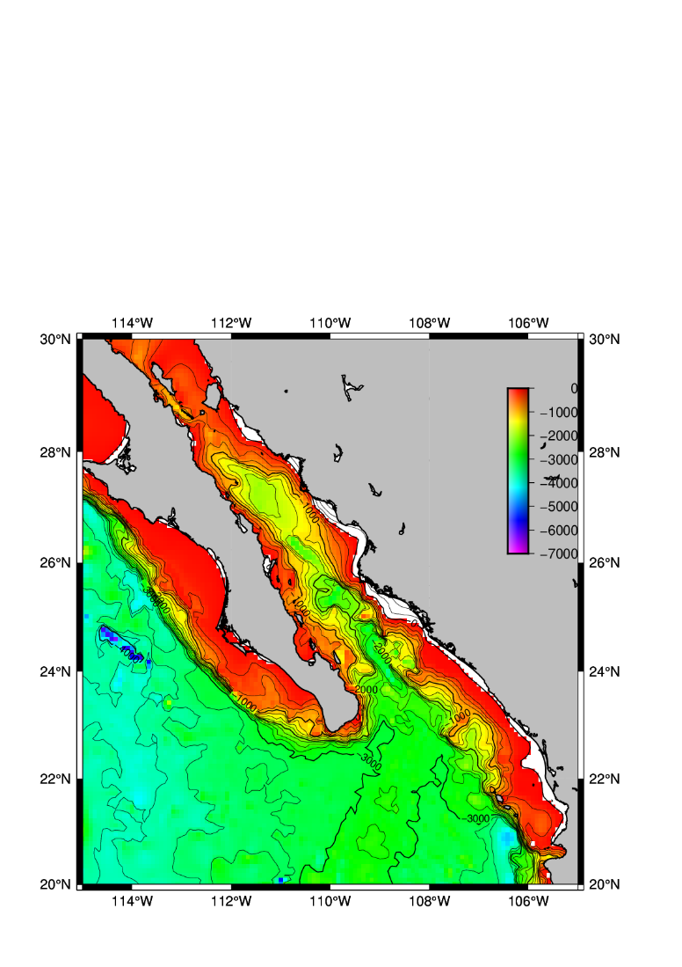

## W16

### :star: gmtset PROJ_LENGTH_UNIT inch

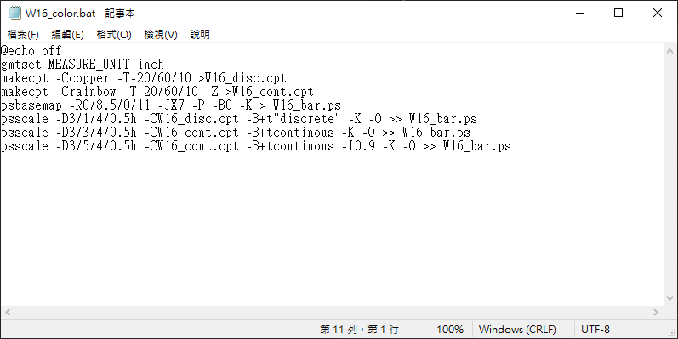

$ ./W16_color.bat

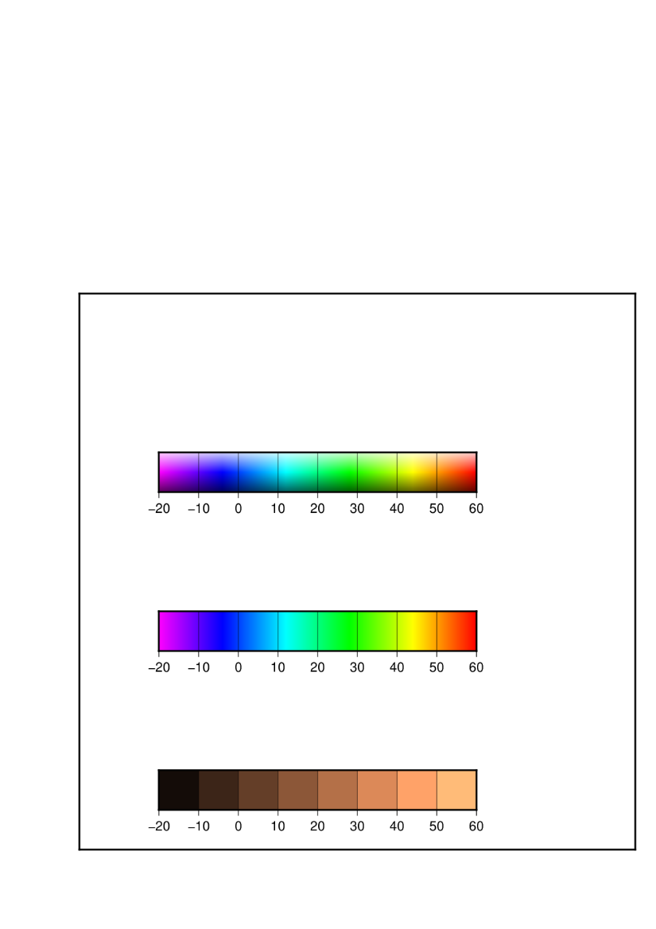

### :star: gmtset MEASURE_UNIT inch

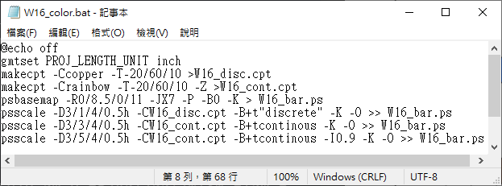

$ ./W16_color.bat

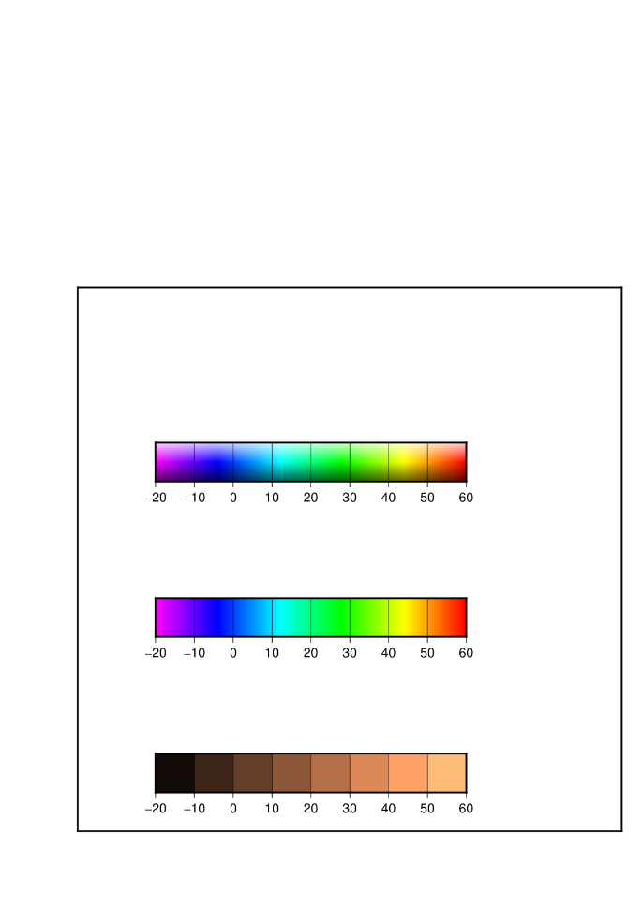

### :star: 加州海底地形

user@meicc-006 /cygdrive/e/GMT_1091_JT

$ minmax ship_5m.xyz

unknown [COMPATIBILITY]: Module minmax is deprecated; use gmtinfo.

ship_5m.xyz: N = 5850 <245.00309/254.681025> <20.00149/29.97895> <-7392/-

19>

user@meicc-006 /cygdrive/e/GMT_1091_JT

$ blockmean ship

ship.b ship.nc ship_5m.b ship_5m.xyz

user@meicc-006 /cygdrive/e/GMT_1091_JT

$ blockmean ship_5m.xyz -R245/255/20/30 -I5m > W16_ship_5m.b

user@meicc-006 /cygdrive/e/GMT_1091_JT

$ surface W16_ship_5m.b -R245/255/20/30 -I5m -Gship.nc -T0.75

user@meicc-006 /cygdrive/e/GMT_1091_JT

$ makecpt -Crainbow -T-7000/0 -Z > W16_ship.cpt

user@meicc-006 /cygdrive/e/GMT_1091_JT

$ gridimage ship.nc -R245/255/20/30 -JM15c -B2WSne -CW16_ship.cpt -P -K > W16_ship.ps

-bash: gridimage：命令找不到

user@meicc-006 /cygdrive/e/GMT_1091_JT

$ grdimage ship.nc -R245/255/20/30 -JM15c -B2WSne -CW16_ship.cpt -P -K > W16_ship.ps

user@meicc-006 /cygdrive/e/GMT_1091_JT

$ pscoast -J -R -Dh -Wthinnest -G155 -B -O >> W16_ship.ps

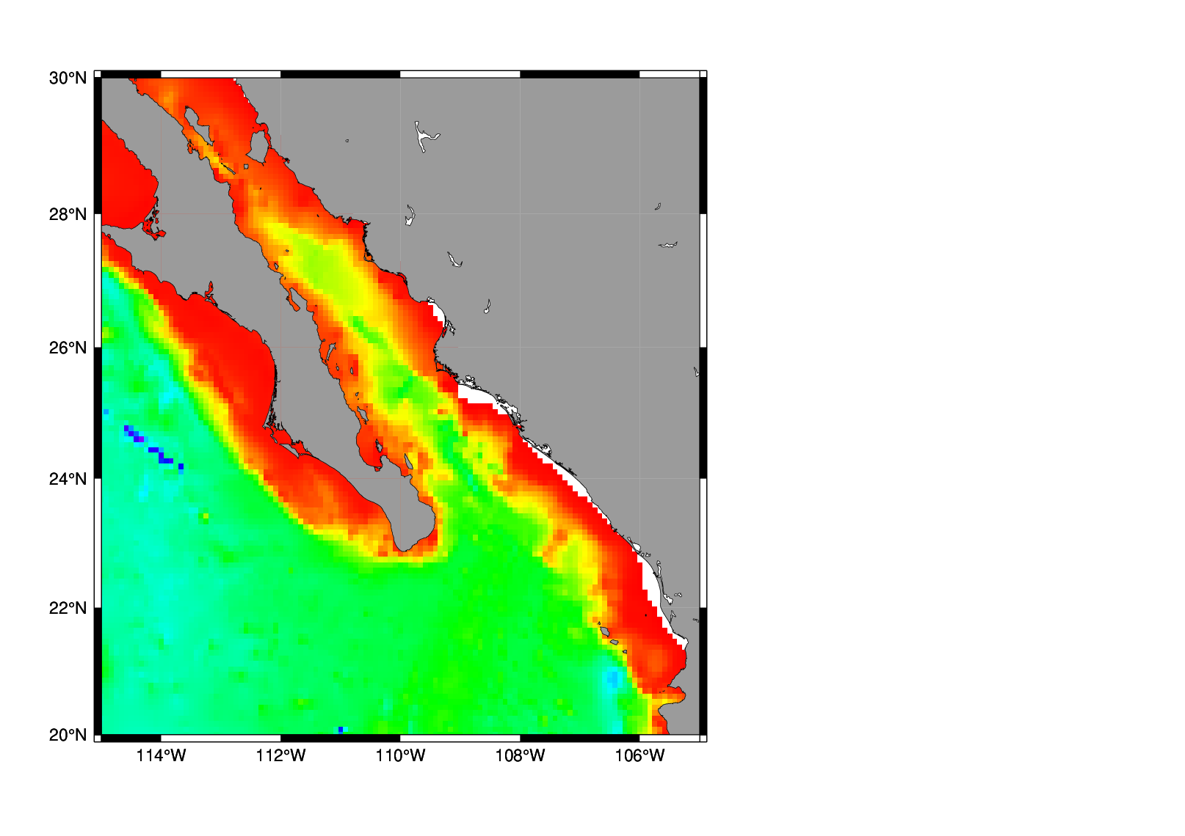

### :star: 加州海底地形，陸地上加上文字

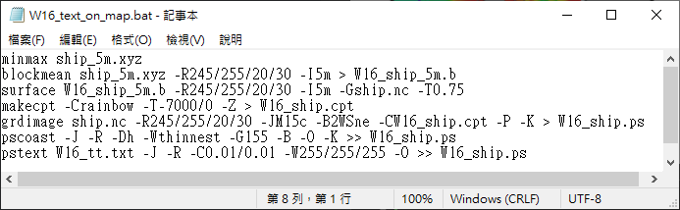

$ ./W16_text_on_map.bat

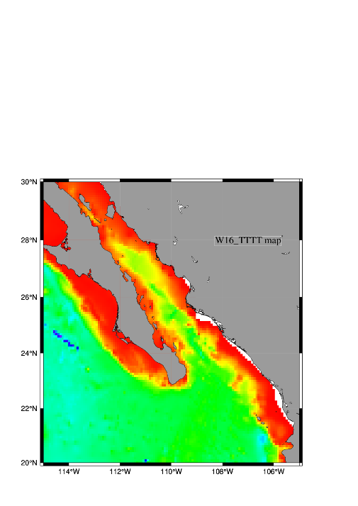

### :star:s0w.txt

user@meicc-006 /cygdrive/e/GMT_1091_JT

$ minmax s0w.txt

unknown [COMPATIBILITY]: Module minmax is deprecated; use gmtinfo.

s0w.txt: N = 11881 <1/109> <1/109> <-0.00214761007/0.0347473696>

user@meicc-006 /cygdrive/e/GMT_1091_JT

$ gawk '{if($3>0) print ($1-1)/6+116 " " ($2-1)/6+23 " " $3*1000}' s0w.txt > W16_s0w_1.txt

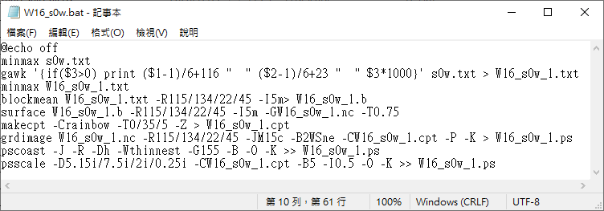

$ ./W16_s0w.bat

